|  |  |
| --- | --- |
| **Radiocommunication Study Groups** |  |
|  |  |
|  |  |
| Received: 27 November 2019 | **Document 5D/3-E** |
| **28 November 2019** |
| **English only  TECHNOLOGY ASPECTS** |
| Alliance for Telecommunications Industry Solutions | |
| INITIAL EVALUATION REPORT FROM ATIS WTSC IMT-2020 EVALUATION GROUP FOR 3GPP PROPONENT SUBMISSIONS OF SRIT (DOC. [IMT-2020/13](https://www.itu.int/md/meetingdoc.asp?lang=en&parent=R15-IMT.2020-C-0013)) & RIT (DOC. [IMT-2020/14](https://www.itu.int/md/meetingdoc.asp?lang=en&parent=R15-IMT.2020-C-0014)) | |
|  | |

In accordance to the ITU-R Submission, Evaluation Process and Consensus Building for IMT-2020 (Doc. [IMT-2020/2](https://www.itu.int/md/meetingdoc.asp?lang=en&parent=R15-IMT.2020-C-0002)), Alliance for Telecommunications Industry Solutions (ATIS) has established the ATIS WTSC Independent Evaluation Group. This is an interim report of the Group.

**INITIAL EVALUATION REPORT**

**FROM**

**ATIS WTSC IMT-2020 EVALUATION GROUP**

**FOR 3GPP PROPONENT SUBMISSIONS**

**OF**

**SRIT (DOC.** [**IMT-2020/13**](https://www.itu.int/md/meetingdoc.asp?lang=en&parent=R15-IMT.2020-C-0013)**)**

**&**

**RIT (DOC.** [**IMT-2020/14**](https://www.itu.int/md/meetingdoc.asp?lang=en&parent=R15-IMT.2020-C-0014)**)**

**November 27, 2019**

**Table of Contents**

1 Scope 10

2 References 10

3 Abbreviations 10

4 Introduction 12

5 Evaluation of eMBB technical performance 13

5.1 Peak spectral efficiency 13

5.2 Peak Data Rate 13

5.3 5th percentile and Average spectral efficiency 13

5.3.1 Simulation Results (NR) 13

5.3.2 Simulation Assumptions 15

5.3.2.1 Indoor Hotspot – eMBB 15

5.3.2.1.1 Evaluation configuration A (Carrier Frequency = 4 GHz) 15

5.3.2.1.1.1 Downlink (DL) 15

5.3.2.1.1.2 Uplink (UL) 16

5.3.2.1.2 Evaluation configuration B (Carrier Frequency = 30 GHz) 18

5.3.2.1.2.1 Downlink (DL) 18

5.3.2.1.2.2 Uplink (UL) 19

5.3.2.2 Dense Urban – eMBB 21

5.3.2.2.1 Evaluation configuration A (Carrier Frequency = 4 GHz) 21

5.3.2.2.1.1 Downlink 21

5.3.2.2.1.2 Uplink 22

5.3.2.3 Rural – eMBB 24

5.3.2.3.1 Evaluation configuration A (Carrier Frequency = 700 MHz) 24

5.3.2.3.1.1 Downlink 24

5.3.2.3.1.2 Uplink 25

5.3.2.3.2 Evaluation configuration B (Carrier Frequency = 4 GHz) 26

5.3.2.3.2.1 Downlink 26

5.3.2.3.2.2 Uplink 28

5.3.2.3.3 Evaluation configuration C (LMLC, 700MHz, 6km ISD) 29

5.3.2.3.3.1 Downlink 29

5.3.2.3.3.2 Uplink 30

5.4 User Experienced Data Rate 31

5.4.1 Evaluation results (NR) 32

5.5 Area traffic capacity 32

5.5.1 Evaluation results (NR) 33

5.6 Latency 33

5.6.1 Control Plane Latency 33

5.6.1.1 Definition 33

5.6.1.2 Control-plane signalling 34

5.6.1.3 Processing delay 34

5.6.1.4 Achievable latency in FDD 34

5.6.1.5 Achievable FDD latency in ms 35

5.6.1.6 Achievable latency in TDD 35

5.6.1.7 Achievable TDD latency in ms 36

5.6.1.8 Conclusion 37

5.6.2 User Plane Latency 37

5.6.2.1 Assumptions 37

5.6.2.2 FDD 39

5.6.2.3 TDD 40

5.6.2.4 Conclusion 41

6 Evaluation of Urban Macro URLLC technical performance 41

6.1 Requirements on reliability 41

6.2 Discussion 42

6.2.1 System-level simulations 42

6.3 Link-level simulations 46

6.4 Total reliability 48

6.5 Reliability estimate urLLC configuration B, UMa B 49

6.6 Packet size 51

6.7 Total latency 51

6.8 Summary and conclusion 52

7 Evaluation of Urban Macro mMTC technical performance 52

7.1 Connection density – Full Buffer 52

7.1.1 System simulation procedure 52

7.1.2 Test environment 53

7.1.2.1 System-level 53

7.1.2.2 Link-level 54

7.1.3 Simulation Configurations 55

7.1.4 Connection density evaluation 56

7.1.4.1 Full buffer system-level performance 56

7.1.4.1.1 Full buffer link-level performance 58

7.1.4.1.2 Performance 59

7.1.4.1.3 Conclusion 60

7.2 Connection density – Non-Full Buffer 60

7.2.1 System simulation procedure 60

7.2.2 Test environment 61

7.2.3 Simulation Configuration 62

7.2.4 Channel model 64

7.2.5 Connection density evaluation 65

7.2.6 Conclusion 67

8 Mobility 67

8.1 Discussion of Evaluation Methods 67

8.2 Results 68

8.3 System Simulation Parameters 71

8.4 Conclusions 72

9 TPR (Technical Performance Requirements - General) 73

9.1 TPR (Technical Performance Requirements - General) 73

9.2 Other Requirements (From: Annex 1 – Modifications to Compliance  
template for SRIT and NR RIT) 76

9.3 Additional Frequency Bands 77

9.4 Energy Efficiency (NR) 82

9.4.1 Power model 82

9.4.2 LTE idle-mode reference case 84

9.4.3 DTX duration and DTX ratio comparison between LTE and NR 85

9.4.4 NR idle-mode power consumption 86

9.4.5 Conclusion 88

10 Link Budget Analysis 89

Annex A: Detailed Simulation Results 95

**Table of Figures**

[Figure 1 – Illustration of CP signalling during transition from Inactive  
to Active states 34](#_Toc25668232)

Figure 2 – Illustration of latency components for DL and UL data. 39

Figure 3 – Total gain for urLLC configuration A 43

Figure 4 – SINR distribution for urLLC configuration A 43

Figure 5 – SINR distribution at 5th percentile for urLLC configuration A 44

Figure 6 – Total gain for urLLC configuration B

Figure 7 – SINR distribution for urLLC configuration B 45

Figure 8 – SINR distribution at 5th percentile for urLLC configuration B 45

[Figure 9 – Sequence selection Short PUCCH and PDCCH BLER  
as function of SNR 47](#_Toc25668240)

[Figure 10 – 4OS-Data (1st attempt) LDPC BLER for QPSK with different MCS  
as function of SNR 47](#_Toc25668241)

[Figure 11 – 7OS-Data (1st attempt) LDPC BLER for QPSK with different MCS  
as function of SNR 48](#_Toc25668242)

[Figure 12 – Total reliability for 4OS – DL data with 1-3 HARQ transmissions  
at lowest percentiles assuming correlated transmissions 49](#_Toc25668243)

[Figure 13 – Total reliability for 7OS – DL data with 1-3 HARQ transmissions  
at lowest percentiles assuming correlated transmissions 50](#_Toc25668244)

[Figure 14 – Total reliability for 4OS UL data with 1-2 HARQ transmissions  
at lowest percentiles with SPS-based scheduling assuming correlated  
transmissions 50](#_Toc25668245)

[Figure 15 – Total reliability for 7OS UL data with 1-2 HARQ transmissions  
at lowest percentiles with SPS-based scheduling assuming correlated  
transmissions 51](#_Toc25668246)

Figure 16 – NR UL SINR CDFs. 57

Figure 17 – LTE-M UL SINR CDFs. 57

Figure 18 – NB-IoT UL SINR CDFs. 58

Figure 19 – NR, LTE-M and NB-IoT link spectral efficiency (SPEFF) 59

[Figure 20 – Data and signalling flow used to model RRC Resume latency  
performance 64](#_Toc25668251)

[Figure 21 – Coupling gain distribution for test environment Urban Macro  
mMTC based on the settings of (Note that input and discussion  
for the non-full buffer methodology are provided in 7.2.) 65](#_Toc25668252)

Figure 22 – LTE-M and NB-IoT service latency at the 99th percentile 66

[Figure 23 – Indoor Hotspot – eMBB post-processing SINR distribution  
at 10 km/h (4 GHz carrier frequency). 69](#_Toc25668254)

[Figure 24 – Dense Urban – eMBB post-processing SINR distribution  
at 30 km/h (4 GHz carrier frequency). 69](#_Toc25668255)

[Figure 25 – Rural – eMBB post-processing SINR distribution for 700 MHz  
and 4 GHz carrier frequencies. 70](#_Toc25668256)

Figure 26 – Principle of the power model used in this evaluation 82

Figure 27 – Power models including sleep states for different base-station types 83

Figure 28 – An examination of the relative numbers in the power model 84

[Figure 29 – The instantaneous load of the power amplifier (PA) in an “empty”  
LTE radio frame (i.e. a radio frame with no user plane data) 85](#_Toc25668260)

[Figure 30 – Instantaneous power consumption of a 3-sector “macro 2 × 2”  
base-station using the power model depicted in Figure 23 85](#_Toc25668261)

[Figure 31 – Instantaneous power consumption for NR with a 1 SSB configuration,  
20 ms SSB periodicity using the power model “macro 2 × 2” 87](#_Toc25668262)

[Figure 32 – Average idle power consumption for NR when applying the power  
models in Figure 23 as function of the SSB periodicity 87](#_Toc25668263)

[Figure 33 – Power consumption gain with NR versus LTE for different power  
consumption models and SS Block periodicities 88](#_Toc25668264)

**Table of Tables**

Table 1 – Summary of simulation results for Average spectral efficiency (bit/s/Hz/TRxP) 13

Table 2 – Summary of simulation results for User (5%-ile) spectral efficiency (bit/s/Hz) 14

Table 3 – Simulation Assumptions for Indoor Hotspot eMBB Eval Config A DL 15

Table 4 – Simulation Assumptions for Indoor Hotspot eMBB Eval Config A UL 16

Table 5 – Simulation Assumptions for Indoor Hotspot eMBB Eval Config B DL 18

Table 6 – Simulation Assumptions for Indoor Hotspot eMBB Eval Config B UL 19

Table 7 – Simulation Assumptions for Dense Urban eMBB Eval Config A DL 21

Table 8 – Simulation Assumptions for Dense Urban eMBB Eval Config A UL 22

Table 9 – Simulation Assumptions for Rural eMBB Eval Config A DL 24

Table 10 – Simulation Assumptions for Rural eMBB Eval Config A UL 25

Table 11 – Simulation Assumptions for Rural eMBB Eval Config B DL 26

Table 12 – Simulation Assumptions for Rural eMBB Eval Config B UL 28

Table 13 – Simulation Assumptions for Rural eMBB Eval Config C DL 29

Table 14 – Simulation Assumptions for Rural eMBB Eval Config C UL 30

Table 15 – Evaluation results for User data rate, in eMBB Dense Urban, at 4GHz 32

Table 16 – Evaluation configuration and parameters 33

Table 17 – Area traffic capacity in the eMBB InH scenario 33

Table 18 – CP latency in TTIs in NR Rel-15 FDD 35

Table 19 – Achievable CP latency for NR Rel-15 in ms 35

Table 20 – CP latency in TTIs in NR Rel-15 TDD 36

Table 21 – Achievable CP latency for NR Rel-15 in ms for TDD with alternating UL-DL pattern 37

Table 22 – Achievable CP latency for NR Rel-15 in ms for TDD with UL-DL-DL-DL pattern. 37

Table 23 – Processing time (in # of OFDM symbols) assumptions for gNB. 38

[Table 24 – PDSCH processing time in OFDM symbols for the UE capabilities  
with front-loaded DM-RS. 39](#_Toc25668288)

Table 25 – PUSCH preparation procedure time. 39

Table 26 – FDD UP one-way latency for data transmission with HARQ-based retransmission, compared to the 1ms (green) and 4ms (orange) requirements. 40

Table 27 – TDD UP one-way latency for data transmission with alternating DL-UL slot pattern, compared to the 1ms (green) and 4ms (orange) requirements. 41

Table 28 – Assumptions of the system-level simulations 42

Table 29 – Assumptions on the link-level simulations 46

Table 30 – Success probabilities for calculating total reliability 48

Table 31 – Required #PRBs for 32 B packet and 1 OFDM symbol overhead, at different coding rates. 51

Table 32 – Maximum #transmissions, including retransmissions, in FDD within 1ms. 52

Table 33 – Full buffer system-level simulation procedure 53

Table 34 – Urban Macro-mMTC test environment definition 53

Table 35 – Urban Macro-mMTC link-level definition 55

Table 36 – System-level simulation configuration 55

Table 37 – Link-level simulation configuration 56

Table 38 – 99th percentile delay D recorded in Step 3 59

Table 39 – Connection density C recorded in Step 7 59

Table 40 – Non-full buffer system-level simulation procedure from ITU-R M.2412 60

Table 41 – Definition of mMTC-UMa test environment (from M.2412) 61

Table 42 – Simulation Configuration 62

Table 43 – RRC Resume message sizes 64

Table 44 – LTE-M and NB-IoT performance metrics 66

Table 45 – Spectral Efficiency Requirements in IMT-2020 for Mobility evaluations. 67

Table 46 – Extracted 50th Percentile SINR , Link SE, and Residual BLER Values 71

Table 47 – System Simulation Parameters 71

Table 48 – Link Simulation Parameters 72

# 1 Scope

This document provides an initial evaluation results and activities of ATIS WTSC IMT-2020 Independent Evaluation Group (referred to as ATIS IEG from here on).

# 2 References

[1] Report ITU-R [M.2410](https://www.itu.int/pub/R-REP-M/publications.aspx?lang=en&parent=R-REP-M.2410), “Minimum requirements related to technical performance for IMT-2020 radio interface(s)”

[2] Report ITU-R [M.2412](https://www.itu.int/pub/R-REP-M/publications.aspx?lang=en&parent=R-REP-M.2412), “Guidelines for evaluation of radio interface technologies for IMT-2020”

# 3 Abbreviations

3GPP 3rd Generation Partnership Project

AL Aggregation level

AP Access point

BLER Block error ratio

BS Base-station

BW Bandwidth

CCE Control channel element

CF Carrier frequency

CP Control-plane or Cyclic Prefix

CRC Cyclic redundancy check

CRS Cell-specific reference signal (cell reference signal)

CSI Channel state information

CSI-RS Channel state information reference signal

DC Dual connectivity

DCI Downlink control information

DL Downlink

DMRS Demodulation reference signal

DU Dense Urban

eMBB enhanced mobile broadband

FDD Frequency division duplexing

FDM Frequency division multiplexing

gNB g-NodeB

GoS Grade-of-service

HARQ Hybrid automatic repeat request

InH Indoor Hotspot

ITU International Telecommunication Union

LDPC Low-density parity code

LMLC Low-Mobility Large-Cell

LoS Line-of-sight

MAC Medium access control

MIMO Multiple-Input Multiple-Output

mMTC massive Machine-Type Communications

NB-IoT Narrowband-Internet of Things

NLoS non-Line-of-sight

NR New Radio

OFDM Orthogonal frequency division multiplexing

PBCH Primary broadcast channel

PDCCH Physical downlink control channel

PDSCH Physical downlink shared channel

PDCP Packet data convergence protocol

PDU Protocol data unit

PRB Physical resource block

PSS Primary synchronisation signal

PT-RS Phase tracking reference signal

PUCCH Physical uplink control channel

PUSCH Physical uplink shared channel

QoS Quality-of-service

RAN Radio access network

RB Resource block

RE Resource element

RIT Radio-interface technology

RLC Radio link control

RU Rural

SCM Stochastic channel model

SCS Sub-carrier spacing

SDU Service data unit

SINR/SNR Signal-to-interference noise ratio/Signal-to-noise ratio

SR Scheduling request

SRIT Set of RITs

SRS Sounding reference symbol

SSB Synchronisation signal block

SSS Secondary synchronisation signal

TBS Transport block size

TDD Time division duplexing

TRS Tracking reference signal

TRxP Transmission and reception point

TTI Transmission time interval

UCI Uplink control information

UE User equipment

UL Uplink

UMa Urban-macro

UP User-plane

URLLC Ultra reliable and low latency communication

# 4 Introduction

This document describes the initial evaluation results and activities identified for IMT-2020 candidate technology submissions by Proponent 3GPP from ATIS WTSC IMT-2020 Independent Evaluation Group (referred to as ATIS IEG from here on).

The following were collectively evaluated:

– 3GPP PROPONENT SUBMISSION OF SRIT (Doc. [IMT-2020/13](https://www.itu.int/md/meetingdoc.asp?lang=en&parent=R15-IMT.2020-C-0013))[1]

– 3GPP PROPONENT SUBMISSION OF RIT (Doc. [IMT-2020/14](https://www.itu.int/md/meetingdoc.asp?lang=en&parent=R15-IMT.2020-C-0014))[2]

# 5 Evaluation of eMBB technical performance

## 5.1 Peak spectral efficiency

## 5.2 Peak Data Rate

## 5.3 5th percentile and average spectral efficiency

This section covers the simulation-based evaluation of the following two TPRs (as defined in Report ITU-R M.2410).

**– 5th percentile user spectral efficiency**: is the 5% point of the CDF of the normalized user throughput. The normalized user throughput is defined as the number of correctly received bits, i.e. the number of bits contained in the SDUs delivered to Layer 3, over a certain period of time, divided by the channel bandwidth and is measured in bit/s/Hz.

**– Average spectral efficiency**:is the aggregate throughput of all users (the number of correctly received bits, i.e. the number of bits contained in the SDUs delivered to Layer 3, over a certain period of time) divided by the channel bandwidth of a specific band divided by the number of TRxPs and is measured in bit/s/Hz/TRxP.

As required by Report ITU-R M.2412, average spectral efficiency and 5th percentile user spectral efficiency should be evaluated jointly, using the same system level simulation(s). Therefore, their results are captured together in this section.

The following paragraphs include summaries of evaluation results and assumptions, based on inputs provided by different companies. The evaluation has been performed for NR, covering all three eMBB test environments, and different evaluation configurations.

Details of individual simulation results are captured in Annex A. Detailed simulation assumptions and parameters are captured in the attached XLS files (one for each evaluated test environment).

### 5.3.1 Simulation Results (NR)

An overall summary of simulation results is captured in the following tables, for Average and User Spectral Efficiency.

*Note: few contributing companies provided results for multiple assumptions/options (e.g. FDD/TDD, CM A/B, SU-MU/MIMO, Tx/Rx config.); in those cases, the best values are reported. Details in Annex X.A.*

Table 1

Summary of simulation results for Average spectral efficiency (bit/s/Hz/TRxP)

|  |  |  |  |  |  |  |  |  |  |  |
| --- | --- | --- | --- | --- | --- | --- | --- | --- | --- | --- |
| TE | Eval. config. | DL/ UL | IMT-2020 Target | 3GPP  Results (NR RIT) | ATI S IEG results | | | | | |
| A | B | C | D | E | F |
|  |  |  |  |  | TDD  (CM B) | FDD/TDD (CM A) | FDD (CM A) | TDD (CM B) | FDD/TDD, (CM A/B) | FDD/TDD (DL only) |
| Indoor Hotspot - eMBB | A (4 GHz) | DL | 9 | 8.77~16.88 |  | 14.01 | 10.55 |  | 13.5 |  |
| UL | 6.75 | 6.95~15.17 |  | 8.18 | 7.20 |  | 9.44 |  |
| B (30 GHz) | DL | 9 | 8.5~19.91 | 13.37 | 10.31 |  | 14.8 | 11.6 |  |
| UL | 6.75 | 6.9~11.44 | 6.9 | 9.08 |  | 10.54 | 7.04 |  |
| Dense Urban - eMBB | A (4 GHz) | DL | 7.8 | 7.87~22.33 | 11.06 | 16.49 | 11.83 | 12.99 | 16.1 | 11.6 |
| UL | 5.4 | 5.51~22.48 | 5.76 | 10.31 | 7.15 | 7.53 | 7.04 |  |
| Rural - eMBB | A (700 MHz) | DL | 3.3 | 5.04~17.37 | 6.78 | 17.01 |  |  | 9.22 | 12 |
| UL | 1.6 | 3.75~15.55 | 4.37 | 10.7 |  |  | 4.76 |  |
| B (4 GHz) | DL | 3.3 | 5.96~21.11 | 10.63 | 20.05 | 15.32 | 18.5 | 15.35 | 9.62 |
| UL | 1.6 | 2.7~21.3 | 9.610 | 11.66 | 9.96 | 11.1 | 5.73 |  |
| C (LMLC) | DL | 3.3 | 3.9~19.29 |  | 14.08 | 8.15 | 6.4 | 8.83 |  |
| UL | 1.6 | 3.31~10.59 |  | 7.28 | 5.27 | 4.99 | 4.03 |  |

Table 2

Summary of simulation results for User (5%-ile) spectral efficiency (bit/s/Hz)

|  |  |  |  |  |  |  |  |  |  |  |
| --- | --- | --- | --- | --- | --- | --- | --- | --- | --- | --- |
| TE | Eval. config. | DL/ UL | IMT-2020 Target | 3GPP  Results (NR RIT) | ATI S IEG results | | | | | |
| A | B | C | D | E | F |
|  |  |  |  |  | TDD  (CM B) | FDD/TDD (CM A) | FDD (CM A) | TDD (CM B) | FDD/TDD, (CM A/B) | FDD/TDD (DL only) |
| **Indoor Hotspot - eMBB** | **A (4 GHz)** | DL | 0.3 | 0.31~0.59 |  | 0.45 | 0.363 |  | 0.32 |  |
| UL | 0.21 | 0.27~0.63 |  | 0.36 | 0.270 |  | 0.59 |  |
| **B (30 GHz)** | DL | 0.3 | 0.31~1.18 | 0.54 | 0.41 |  | 0.37 | 0.31 |  |
| UL | 0.21 | 0.30~0.43 | 0.3 | 0.53 |  | 0.323 | 0.4 |  |
| **Dense Urban - eMBB** | **A (4 GHz)** | DL | 0.225 | 0.23~0.81 | 0.37 | 0.6 | 0.334 | 0.315 | 0.49 | 0.32 |
| UL | 0.15 | 0.16~0.60 | 0.18 | 0.3 | 0.246 | 0.169 | 0.36 |  |
| **Rural - eMBB** | **A (700 MHz)** | DL | 0.12 | 0.13~0.57 | 0.14 | 0.52 |  |  | 0.22 | 0.5 |
| UL | 0.045 | 0.09~0.63 | 0.23 | 0.44 |  |  | 0.1 |  |
| **B (4 GHz)** | DL | 0.12 | 0.12~2.11 | 0.13 | 0.52 | 0.267 | 0.453 | 0.38 | 0.29 |
| UL | 0.045 | 0.02~0.34 | 0.12 | 0.25 | 0.083 | 0.076 | 0.18 |  |
| **C (LMLC)** | DL | *No target* | *-* |  | 0.47 | 0.265 | *-* | 0.22 |  |
| UL | *-* |  | 0.23 | 0.132 | *-* | 0.6 |  |

### 5.3.2 Simulation assumption

This clause captures a summary of simulation assumptions used for the evaluation of eMBB Spectral Efficiency (SE) for NR RIT (see corresponding SLS results above, and in annex).

The SLS assumptions listed here refer to a set of specific NR technology characteristics/parameters and other SLS settings, comparable with those used by 3GPP in their self-evaluation report. Those assumptions, and all other TE/configuration parameters, align with Report ITU-R M.2412.

The tables provided below show SLS assumptions that are “common” (same value used by different companies), and whether they are aligned with “3GPP reference values”, as well as assumptions for which different settings have been used (by same/different companies). In the latter case, multiple options/values are listed, and highlighted (blue font).

#### 5.3.2.1 Indoor Hotspot – eMBB

##### 5.3.2.1.1 Evaluation configuration A (Carrier Frequency = 4 GHz)

###### 5.3.2.1.1.1 Downlink (DL)

Table 3

Simulation Assumptions for Indoor Hotspot eMBB Eval Config A DL

|  |  |  |
| --- | --- | --- |
| Technical parameters/assumptions | 3GPP Reference value  *(from 3GPP self-eval report)* | ATIS IEG Assumption(s) |
| Duplexing | FDD/TDD | FDD, TDD |
| Multiple access | OFDMA | Aligned with reference |
| Network synchronization | Synchronized | Aligned with reference |
| Modulation | Up to 256 QAM | Aligned with reference |
| Coding on PDSCH | LDPC; Max code-block size=8448bit [BP decoding] | Aligned with reference |
| Numerology | 15KHz / 30kHz SCS; 14 OFDM symbol slot | 15kHz, 30 kHz SCS |
| Frame structure |  | DDDSU, DSUUD, FDD full downlink |
| Transmission scheme | Closed SU/MU-MIMO, with rank adaptation | Aligned with reference |
| DL CSI measurement |  | Non-precoded CSI-RS based |
| DL codebook |  | Type II codebook; |
| PRB bundling |  | 4 PRBs |
| MU dimension |  | Up to 12 layers |
| SU dimension |  | Up to 4 layers |
| Codeword (CW)-to-layer mapping | For 1~4 layers, CW1; For 5 layers or more, two CWs | Aligned with reference |
| SRS transmission |  | Non-precoded SRS, 4/8 ports.  2/4 symbols per 5 slots for 30/15kHz SCS |
| CSI feedback |  | PMI, CQI: every 5 slot; RI: every 5/10 slot; Sub-band based |
| Interference measurement |  | SU-CQI; CSI-IM for inter-cell interference measurement |
| Max CBG number | 1 | Aligned with reference |
| ACK/NACK delay | UE capability 1 | Aligned with reference |
| Re-transmission delay |  | The next available DL slot after receiving NACK |
| Antenna configuration at TRxP | (M, N, P, Mg, Ng; Mp, Np)  (Note) | For 12TRxP; 32T = (4,4,2,1,1;4,4) For 36TRxP; 32T = (8,16,2,1,1; 2,8) (dH,dV) = (0.5, 0.5)λ |
| Antenna configuration at UE | 4R= (1,2,2,1,1; 1,2), (1,4,2,1,1; 1,4) (dH,dV) = (0.5, 0.5)λ |
| Scheduling | PF | Aligned with reference |
| Receiver | MMSE-IRC | Aligned with reference |
| Channel estimation | Non-ideal | Non-ideal |
| Guard band ratio on simulation bandwidth | FDD: 6.4%  TDD: 8.2% (51 RB for 30kHz SCS), or  4.6% (106 RB for 15kHz SCS) | Aligned with reference |
| Total RE Overhead (%) |  | ~32% (FDD), ~ 44% (TDD), … |
| **Other assumptions** | Reference Value |  |
| Mechanic tilt | 0 | Aligned with reference |
| Electronic tilt | 90° in LCS | Aligned with reference |
| Handover margin (dB) |  | 1 |
| UT attachment | Based on RSRP (TR36.873), from port 0 | Aligned with reference |
| Selection of serving TRxP | Maximizing RSRP (digital BF not considered) | Aligned with reference |
| Channel Model | A/B | A, B |

*(Note) 3GPP notation, common for DL&UL, TRxP&UE: - M: # of vertical antenna elements within a panel, on one polarization; - N: # of horizontal ant. elements within a panel, on one polarization; - P: # of polarizations; - Mg: # of panels in a column; Ng: # of panels in a row; Mp: # of vertical TXRUs within a panel, on one polarization; Np: # of horizontal TXRUs within a panel, on one polarization. This applies to all tables below.*

###### 5.3.2.1.1.2 Uplink (UL)

Table 4

Simulation Assumptions for Indoor Hotspot eMBB Eval Config A UL

|  |  |  |
| --- | --- | --- |
| Technical parameters/assumptions | 3GPP Reference value | ATIS IEG Assumption(s) |
| Duplexing | FDD/TDD | FDD, TDD |
| Multiple access | OFDMA | Aligned with reference |
| Network synchronization | Synchronized | Aligned with reference |
| Modulation | Up to 256QAM | Aligned with reference |
| Coding on PUSCH | LDPC; Max code-block size=8448bit  [with BP decoding] | Aligned with reference |
| Numerology | 15KHz / 30kHz SCS; 14 OFDM symbol slot | 15kHz, 30 kHz SCS |
| Frame structure |  | DDDSU, DSUUD, FDD full uplink |
| Transmission scheme | Closed SU/MU-MIMO, with rank adaptation | Aligned with reference |
| UL codebook |  | For 2Tx: NR 2Tx codebook; For 4Tx: NR 4Tx codebook |
| MU dimension |  | Up to 6 users |
| SU dimension |  | Up to 2, 4 layers |
| Codeword (CW)-to-layer mapping | For 1~4 layers, CW1; For 5 layers or more, two CWs | Aligned with reference |
| SRS transmission |  | Non-precoded SRS, 2/4 SRS ports (with 2/4 SRS resources); 2/4 symbols every 5 slots, 8 PRBs per symbol |
| Antenna configuration at TRxP | (M, N, P, Mg, Ng; Mp, Np) | 12TRxP: 32R = (4,4,2,1,1;4,4); 128R = (8,8,2,1,1;8,8)  36TRxP: 32R = (8,16,2,1,1; 2,8)  (dH,dV) = (0.5, 0.5)λ |
| Antenna configuration at UE | 2T = (1,1,2,1,1; 1,1); 4T = (1,2,2,1,1; 1,2) |
| Max CBG number | 1 | Aligned with reference |
| UL re-transmission delay |  | Next available UL slot after receiving retransmission indication |
| Scheduling | PF | Aligned with reference |
| Receiver | MMSE-IRC | Aligned with reference |
| Channel estimation |  | Non-ideal |
| Power control parameter |  | P0=-60/-90, alpha = 0.6/0.8/0.9 |
| Power backoff model |  | Continuous/Non continuous RB allocation |
| Guard band ratio on simulation bandwidth | FDD: 6.4%; TDD: 8.2% (51 RB for 30 kHz), or  4.6% (106 RB for 15 kHz) | Aligned with reference |
| Total RE Overhead (%) |  | ~16% (FDD); ~22% (TDD), … |
| **Other assumptions** | Reference Value |  |
| Mechanic tilt | Based on #TRxPs per site (1/3 TRxP => 180/110° in GCS) | Aligned with reference |
| Electronic tilt | 90° in LCS | Aligned with reference |
| Handover margin (dB) |  | 1 |
| UT attachment | Based on RSRP (TR36.873) from port 0 | Aligned with reference |
| Criteria for selection of serving TRxP | Maximizing RSRP (digital beamforming not considered) | Aligned with reference |
| Channel Model | A/B | A, B |

##### 5.3.2.1.2 Evaluation configuration B (Carrier Frequency = 30 GHz)

###### 5.3.2.1.2.1 Downlink (DL)

Table 5

Simulation Assumptions for Indoor Hotspot eMBB Eval Config B DL

|  |  |  |
| --- | --- | --- |
| Technical parameters/assumptions | 3GPP Reference value | ATIS IEG Assumption(s) |
| Multiple access | OFDMA | Aligned with reference |
| Duplexing | TDD | Aligned with reference |
| Network synchronization | Synchronized | Aligned with reference |
| Modulation | Up to 256 QAM | Aligned with reference |
| Coding on PDSCH | LDPC; Max code-block size=8448bit [BP decoding] | Aligned with reference |
| Numerology | 60KHz / 120kHz, 14 OFDM symbol slot | 60kHz, 120kHz SCS, 14 OFDM symbol slot |
| Frame structure |  | DDDSU, DDDU, DSUUD |
| Transmission scheme | Closed SU/MU-MIMO, with rank adaptation | Aligned with reference |
| DL CSI measurement |  | Precoded, Non-Precoded CSI-RS based, no-PMI |
| DL codebook |  | Ideal, Type I, II codebook |
| PRB bundling |  | 4 PRBs |
| MU dimension |  | Up to 6, 8 layers |
| SU dimension |  | Up to 2, 4 layers |
| CW-to-layer mapping | For 1~4 layers, CW1;For 5+ layers, two CWs | Aligned with reference |
| SRS transmission |  | Non-precoded SRS, 2, 4 SRS ports |
| CSI feedback |  | CQI: every 5, 8 slot; RI: every 5, 8 slot, CRI: every 5 slot; Subband based |
| Interf. measurement |  | SU-CQI; CSI-IM for inter-cell interference |
| Max CBG number | 1 | Aligned with reference |
| ACK/NACK delay |  | The next available UL slot |
| Re-transmission delay |  | The next available DL slot after receiving NACK |
| Antenna configuration at TRxP | (M, N, P, Mg, Ng; Mp, Np) | 12TRxP: 8T = (16,8,2,1,1;2,2); 32T = (4,4,2,1,1;4,4), (8,8,2,1,1;4,4); 64T = (4,32,2,1,1;1,32);  36 TRxP: 32T = (8,16,2,1,1;2,8)  (dH,dV) = (0.5, 0.5)λ |
| Antenna configuration at UE | 2R = (4,4,2,1,1; 1,2); 4R = (1,4,2,1,2; 1,4), (2,4,2,1,2; 1,1); 8R = (2,4,2,1,2; 1,2);  (dH,dV) = (0.5, 0.5)λ |
| Scheduling | PF | Aligned with reference |
| Receiver | MMSE-IRC | Aligned with reference |
| Channel estimation |  | Non-ideal |
| GB ratio on sim. BW |  | 5, 5.5% (for 80 MHz) |
| Total RE Overhead (%) |  | ~29%, ~40%, … |
| **Other assumptions** |  |  |
| Mechanic tilt | Based on #TRxPs per site (1/3 => 180/110° in GCS) | Aligned with reference |
| Electronic tilt | (According to Zenith angle in "Beam set at TRxP") | Aligned with reference |
| Handover margin (dB) |  | 0, 1, 3 |
| UT attachment | Based on RSRP ( RP-180524) from port 0. UE panel with the best receive SNR (no combining) | Aligned with reference |
| Beam set at TRxP |  | Azimuth φi = [0]; Zenith θj = [pi/2, pi/4, 3*pi/4];  DFT Beam selection |
| Beam set at UE |  | Azimuth angle φi = [-pi/4, pi/4], [-25, 25] Zenith angle θj = [pi/4, 3*pi/4], [80, 110];  DFT Beam selection |
| Criteria for selection for serving TRxP | Maximizing RSRP with best analog beam pair (digital beamforming is not considered) | Aligned with reference |
| Criteria for analog beam selection for serving TRxP | Select the best beam pair among the limited set of DFT analog beams, based on max. receive power after beamforming. | Aligned with reference |
| Criteria for analog beam selection for interf.TRxP | Based on the analog beam selection according to scheduling results of non-serving TRxP | Aligned with reference |

###### 5.3.2.1.2.2 Uplink (UL)

Table 6

Simulation Assumptions for Indoor Hotspot eMBB Eval Config B UL

|  |  |  |
| --- | --- | --- |
| Technical parameters/assumptions | 3GPP Reference value | ATIS IEG Assumption(s) |
| Multiple access | OFDMA | Aligned with reference |
| Duplexing | TDD | Aligned with reference |
| Network synchronization | Synchronized | Aligned with reference |
| Modulation | Up to 256QAM | Aligned with reference |
| Coding on PUSCH | LDPC. Max code-block size=8448bit [with BP decoding] | Aligned with reference |
| Numerology | 60KHz / 120kHz, 14 OFDM symbol slot | 60kHz, 120kHz SCS, 14 OFDM symbol slot |
| Frame structure |  | DDDSU, DDDU, DSUUD |
| Transmission scheme | Closed SU/MU-MIMO, with rank adaptation | Aligned with reference |
| UL codebook |  | 4Tx codebook, Ideal |
| MU dimension |  | Up to 4, 6 Layers at gNB |
| SU dimension |  | Up to 2 layers |
| (CW)-to-layer mapping | For 1~4 layers, CW1; For 5+ layers, two CWs | Aligned with reference |
| SRS transmission |  | 2, 4 Tx ports: Non-precoded SRS, 2, 4 SRS ports |
| Antenna configuration at TRxP | (M, N, P, Mg, Ng; Mp, Np) | 2R = (16,8,2,1,1;1,1); 16R = (4,8,2,1,1;2,4) 32R = (4,4,2,1,1;4,4); 64R = (4,32,2,1,1;1,32) (dH,dV) = (0.5, 0.5)λ |
| Antenna configuration at UE | 2T = (4,4,2,1,1; 1,2); 8T = (2;,4,2,1,2; 1,2), (1,4,2,1,1; 1,4); … (dH,dV) = (0.5, 0.5)λ; (dg,V,dg,H) = (0, 0)λ |
| Max CBG number | 1 | Aligned with reference |
| UL re-transmission delay |  | Next available UL slot after receiving retransmission indication |
| Scheduling | PF | Aligned with reference |
| Receiver | MMSE-IRC | Aligned with reference |
| Channel estimation |  | Non-ideal |
| Power control parameter |  | P0=-60, -70, -80; alpha = 0.6, 0.8, 0.9 |
| Power backoff model |  | Continuous/Non continuous RB allocation |
| GB ratio on sim. BW |  | 5, 5.5% |
| Total RE Overhead (%) |  | ~21%, ~25%, … |
| **Other assumptions** |  |  |
| Mechanic tilt | Based on #TRxPs per site (1/3 TRxP => 180/110° in GCS) | Aligned with reference |
| Electronic tilt | (According to Zenith angle in "Beam set at TRxP") | Aligned with reference |
| Handover margin (dB) |  | 0, 1, 3 |
| UT attachment | Based on RSRP (formula as shown in Appendix 3 of RP-180524) from port 0. The UE panel with the best receive SNR is chosen. i.e. no combining. | Aligned with reference |
| Beam set at TRxP |  | 16R/32R: Azimuth φi = [-pi/4, pi/4] / φi = [0] Zenith angle θj = [pi/2]  DFT Beam selection |
| Beam set at UE |  | Azimuth angle φi = [-pi/4, pi/4]. Zenith angle θj = [pi/4, 3*pi/4];  DFT Beam selection |
| Criteria for selection for serving TRxP | Maximizing RSRP with best analog beam pair, where the digital beamforming is not considered | Aligned with reference |
| Criteria for analog beam selection for serving TRxP | Select the best beam pair among the limited set of DFT analog beams, based on the criteria of maximizing receive power after beamforming. | Aligned with reference |
| Criteria for analog beam selection for interf. TRxP | Based on the analog beam selection according to scheduling results of non-serving TRxP | Aligned with reference |

#### 5.3.2.2 Dense Urban – eMBB

##### 5.3.2.2.1 Evaluation configuration A (Carrier Frequency = 4 GHz)

###### 5.3.2.2.1.1 Downlink

Table 7

Simulation Assumptions for Dense Urban eMBB Eval Config A DL

|  |  |  |
| --- | --- | --- |
| Technical parameters/assumptions | 3GPP Reference value | ATIS IEG Assumption(s) |
| Multiple access | OFDMA | Aligned with reference |
| Duplexing | FDD/TDD | FDD, TDD |
| Network synchronization | Synchronized | Aligned with reference |
| Modulation | Up to 256 QAM | Aligned with reference |
| Coding on PDSCH | LDPC, Max code-block size=8448bit [BP decoding] | Aligned with reference |
| Numerology | 15KHz / 30kHz, 14 OFDM symbol slot | 15KHz, 30kHz 14 OFDM symbol slot |
| Frame structure |  | DDDSU, DDSU, DSUUD, FDD full downlink |
| Transmission scheme | Closed SU/MU-MIMO, with rank adaptation | Aligned with reference |
| DL CSI measurement |  | Non-precoded, precoded CSI-RS based, SRS-based, non-PMI feedback |
| DL codebook |  | Type I, II codebook |
| PRB bundling |  | 4 PRBs |
| MU dimension |  | Up to 8, 12 layers |
| SU dimension |  | Up to 1, 2, 4 layers |
| (CW)-to-layer mapping | For 1~4 layers, CW1; For 5+ layers, two CWs | Aligned with reference |
| SRS transmission |  | Non-precoded SRS, 2, 4 SRS ports; 2, 4 symbols per frame |
| CSI feedback |  | Every 5,10 slot; Every S/U subframe Subband based |
| Interference measurement |  | SU-CQI; CSI-IM |
| Max CBG number | 1 | Aligned with reference |
| ACK/NACK delay | UE capability 1 | Aligned with reference |
| Re-transmission delay |  | next available DL slot after NACK, 3 slots |
| Antenna configuration at TRxP | (M, N, P, Mg, Ng; Mp, Np) | For 32T= (8,8,2,1,1;2,8), (16,8,2,1,1;2,8), (8,16,2,1,1;1,16) For 64T= (12,8,2,1,1;4,8), (4,32,2,1,1;1,32) For 128T= (8, 16, 2, 1, 1, 4, 16) (dH, dV)=(0.5, 0.8)λ; |
| Antenna configuration at UE | (M, N, P, Mg, Ng; Mp, Np) | For 4R = (1,2,2,1,1; 1,2) For 8R = (1,4,2,1,1; 1,4) (dH, dV)=(0.5, N/A)λ |
| Scheduling | PF | Aligned with reference |
| Receiver | MMSE-IRC | Aligned with reference |
| Channel estimation | Non-ideal | Non-ideal |
| Guard band ratio on simulation bandwidth | FDD: 6.4% (for 10 MHz) TDD: 8.2% (51 RB for 30kHz SCS), or 4.6% (106 RB for 15kHz SCS) | Aligned with reference |
| Total RE Overhead (%) |  | ~ 32% (FDD), ~ 32%, 44% (TDD), … |
| **Other assumptions** | Reference Value |  |
| Mechanic tilt | 90° in GCS (pointing to horizontal direction) | Aligned with reference |
| Electronic tilt |  | 100, 102, 104, 105 deg. |
| Handover margin (dB) |  | 1 |
| UT attachment | Based on RSRP (TR36.873) from port 0 | Aligned with reference |
| Wrapping around method | Geographical distance based wrapping | Aligned with reference |
| Criteria for selection for serving TRxP | Maximizing RSRP where the digital beamforming is not considered | Aligned with reference |
| Channel Model | A/B | A, B |

###### 5.3.2.1.2.2 Uplink

Table 8

Simulation Assumptions for Dense Urban eMBB Eval Config A UL

|  |  |  |
| --- | --- | --- |
| Technical parameters/assumptions | 3GPP Reference value | ATIS IEG Assumption(s) |
| Multiple access | OFDMA | Aligned with reference |
| Duplexing | FDD/TDD | FDD, TDD |
| Network synchronization | Synchronized | Aligned with reference |
| Modulation | Up to 256QAM | Aligned with reference |
| Coding on PUSCH | LDPC; Max code-block size=8448bit [BP decoding] | Aligned with reference |
| Numerology | 15KHz / 30kHz, 14 OFDM symbol slot | 15kHz, 30kHz SCS, 14 OFDM symbol slot |
| Frame structure (TDD) |  | DDDSU, DDSU, DSUUD, FDD full uplink |
| Transmission scheme | Closed SU/MU-MIMO, with rank adaptation | Aligned with reference |
| UL codebook |  | For 2Tx: NR 2Tx codebook; For 4Tx: NR 4Tx codebook; |
| MU dimension |  | Up to 6, 12 layers |
| SU dimension |  | Up to 2, 4 layers |
| (CW)-to-layer mapping | For 1~4 layers, CW1; For 5+ layers, two CWs | Aligned with reference |
| SRS transmission |  | Non precoded SRS, 2, 4 SRS ports, 2,4 symbols x frame; Explicit CSI + impairments |
| Antenna configuration at TRxP |  | 16R= (8,8,2,1,1; 1,8); 32R= (8,8,2,1,1; 2,8), (8,16,2,1,1;1,16); 64R= (12,8,2,1,1; 4,8) 128R= (8, 16, 2, 1, 1, 4, 16) (dH, dV)=(0.5, 0.8)λ; |
| Antenna configuration at UE |  | For 2T= (1,1,2,1,1; 1,1) For 4T= (1,2,2,1,1; 1,2); 8T = (1,4,2,1,1; 1,4) (dH, dV)=( 0.5, N/A)λ |
| Max CBG number | 1 | Aligned with reference |
| UL re-transmission delay |  | Next available UL slot after re-tx indication, after 2 slot |
| Scheduling | PF | Aligned with reference |
| Receiver | MMSE-IRC | Aligned with reference |
| Channel estimation |  | Non-ideal |
| Power control parameter |  | P0= -70, -80, -86; -95, -105 alpha = 0.8, 0.9 |
| Power backoff model |  | Continuous/Non continuous RB allocation |
| Guard band ratio on simulation bandwidth | FDD: 6.4% (for 10 MHz) TDD: 8.2% (51 RB for 30 kHz 20 MHz) TDD: 4.6% (106 RB for 15 kHz 20 MHz) | Aligned with reference |
| Total RE Overhead (%) |  | ~16% (FDD), ~ 22%, 37% (TDD),… |
| **Other assumptions** | Reference Value |  |
| Mechanic tilt | 90° in GCS (pointing to horizontal direction) | Aligned with reference |
| Electronic tilt |  | 99, 100, 102, 104, 105 deg. |
| Handover margin (dB) |  | 1 |
| UT attachment | Based on RSRP (formula (8.1-1) in TR36.873) from port 0 | Aligned with reference |
| Wrapping around method | Geographical distance based wrapping | Aligned with reference |
| Criteria for selection for serving TRxP | Maximizing RSRP where the digital beamforming is not considered | Aligned with reference |
| Channel Model | A/B | A, B |

#### 5.3.2.2 Rural – eMBB

##### 5.3.2.2.1 Evaluation configuration A (Carrier Frequency = 700 MHz)

###### 5.3.2.2.1.1 Downlink

Table 9

Simulation Assumptions for Rural eMBB Eval Config A DL

|  |  |  |
| --- | --- | --- |
| Technical parameters/assumptions | Reference value (from 3GPP self-eval) | ATIS IEG Assumption(s) |
| Duplexing | FDD/TDD | FDD,TDD |
| Multiple access | OFDMA | Aligned with reference |
| Network synchronization | Synchronized | Aligned with reference |
| Modulation | Up to 256 QAM | Aligned with reference |
| Coding on PDSCH | LDPC; Max code-block size=8448bit, [BP decoding] | Aligned with reference |
| Numerology | 15KHz / 30kHz, 14 OFDM symbol slot | 15, 30 kHz SCS, 14 OFDM symbol slot |
| Frame structure |  | Full downlink, DDDSU, DDSU, DSUUD |
| Transmission scheme | Closed SU/MU-MIMO, with rank adaptation | Aligned with reference |
| DL CSI measurement |  | Non-precoded CSI-RS |
| DL codebook |  | Type II codebook; |
| PRB bundling |  | 4 PRBs |
| MU dimension |  | Up to 8, 12 layers |
| SU dimension |  | Up to 2, 4 layers |
| Codeword (CW)-to-layer mapping | For 1~4 layers, CW1; For 5 layers or more, two CWs | Aligned with reference |
| SRS transmission |  | Non-precoded CSI-RS, 2,4 SRS ports; 4 symbols per 5 slots; every S/U slot |
| CSI feedback |  | every 5 slot; every S/U slot Subband based |
| Interference measurement |  | SU-CQI; CSI-IM for inter-cell interference measurement |
| Max CBG number | 1 | Aligned with reference |
| ACK/NACK delay | UE capability 1 | The next available UL slot, 1slot |
| Re-transmission delay |  | Next available DL slot after NACK, 3 slots |
| Antenna configuration at TRxP | (M,N,P,Mg,Ng; Mp,Np) | For 8T = (8,4,2,1,1;1,4); For 16T = (8,4,2,1,1;2,4), (4,8,2,1,1,1,8) (dH, dV)=(0.5, 0.8)λ |
| Antenna configuration at UE | (M,N,P,Mg,Ng; Mp,Np) | For 2R = (1,1,2,1,1; 1,1) For 4R = (1,2,2,1,1,1,2) |
| Scheduling | PF | Aligned with reference |
| Receiver | MMSE-IRC | Aligned with reference |
| Channel estimation | Non-ideal | Non-ideal |
| Guard band ratio on simulation bandwidth | FDD: 6.4% (for 10 MHz) TDD: 8.2% (51 RB for 30kHz SCS), or 4.6% (106 RB for 15kHz SCS) | Aligned with reference |
| Total RE Overhead (%) |  | ~ 32% (FDD), ~ 32%, 44% (TDD), … |
| **Other assumptions** | Reference Value |  |
| Mechanic tilt | 90° in GCS (pointing to horizontal direction) | Aligned with reference |
| Electronic tilt |  | 96, 100 degree |
| Handover margin (dB) |  | 1 |
| UT attachment | Based on RSRP (TR36.873) from port 0 | Aligned with reference |
| Wrapping around method | Geographical distance based wrapping | Aligned with reference |
| Criteria for selection for serving TRxP | Maximizing RSRP (digital beamf. not considered) | Aligned with reference |
| Channel Model | A/B | A, B |

###### 5.3.2.2.1.2 Uplink

Table 10

Simulation Assumptions for Rural eMBB Eval Config A UL

|  |  |  |
| --- | --- | --- |
| Technical parameters/assumptions | Reference value | ATIS IEG Assumption(s) |
| Duplexing | FDD/TDD | FDD,TDD |
| Multiple access | OFDMA | Aligned with reference |
| Network synchronization | Synchronized | Aligned with reference |
| Modulation | Up to 256QAM | Aligned with reference |
| Coding on PUSCH | LDPC; Max code-block size=8448bit, [BP decoding] | Aligned with reference |
| Numerology | 15KHz / 30kHz, 14 OFDM symbol slot | 15, 30 kHz SCS, 14 OFDM symbol slot |
| Frame structure |  | Full uplink, DDDSU, DDSU, DSUUD |
| Transmission scheme | Closed SU/MU-MIMO, with rank adaptation | Aligned with reference |
| UL codebook |  | Non-codebook based, 4 Tx codebook |
| MU dimension |  | Up to 12 layers at gNB |
| SU dimension |  | Up to 1, 2, 4 layers |
| Codeword (CW)-to-layer mapping | For 1~4 layers, CW1; For 5 layers or more, two CWs | Aligned with reference |
| SRS transmission |  | Non-precoded SRS, 1, 2, 4 SRS ports. 2 symbols every 5 slots, 1 symbol per S/U subframe |
| Antenna configuration at TRxP | (M,N,P,Mg,Ng; Mp,Np) | 8R = (8,4,2,1,1; 1,4) 16R = (4, 8, 2, 1, 1, 1, 8) (dH, dV)=(0.5, 0.8)λ |
| Antenna configuration at UE | (M,N,P,Mg,Ng; Mp,Np) | 1T = (1,1,1,1,1; 1,1); 2T = (1,1,2,1,1; 1,2), (1, 1, 2, 1, 1, 1, 1)  4T = (1,2,2,1,1; 1,2) (dH, dV)=( N/A, N/A)λ |
| Max CBG number | 1 | Aligned with reference |
| UL re-transmission delay |  | Next available UL slot after re-tx indication, 2 slots |
| Scheduling | PF | Aligned with reference |
| Receiver | MMSE-IRC | Aligned with reference |
| Channel estimation |  | Non-ideal |
| Power control parameter |  | P0=-76, -90, -96 alpha = 0.8, 0.9 |
| Power backoff model |  | Continuous/Non continuous RB allocation |
| Guard band ratio on simulation bandwidth | FDD: 6.4% (for 10 MHz) TDD: 8.2% (51 RB for 30 kHz 20 MHz) TDD: 4.6% (106 RB for 15 kHz 20 MHz) | Aligned with reference |
| Total RE Overhead (%) |  | ~16% (FDD), ~ 22%, 37% (TDD),… |
| **Other assumptions** | Reference Value |  |
| Mechanic tilt | 90° in GCS (pointing to horizontal direction) | Aligned with reference |
| Electronic tilt |  | 96, 100 degree |
| Handover margin (dB) |  | 1 |
| UT attachment | Based on RSRP (TR36.873) from port 0 | Aligned with reference |
| Wrapping around method | Geographical distance based wrapping | Aligned with reference |
| Criteria for selection for serving TRxP | Maximizing RSRP where the digital beamforming is not considered | Aligned with reference |
| Channel Model | A/B | A, B |

##### 5.3.2.2.2 Evaluation configuration B (Carrier Frequency = 4 GHz)

###### 5.3.2.2.2.1 Downlink

Table 11

Simulation Assumptions for Rural eMBB Eval Config B DL

|  |  |  |
| --- | --- | --- |
| Technical parameters/assumptions | Reference value | ATIS IEG Assumption(s) |
| Duplexing | FDD/TDD | FDD, TDD |
| Multiple access | OFDMA | Aligned with reference |
| Network synchronization | Synchronized | Aligned with reference |
| Modulation | Up to 256 QAM | Aligned with reference |
| Coding on PDSCH | LDPC; Max code-block size=8448bit, [BP decoding] | Aligned with reference |
| Numerology | 15KHz / 30kHz, 14 OFDM symbol slot | 15, 30 kHz SCS, 14 OFDM symbol slot |
| Frame structure |  | Full downlink, DDDSU, DDSU, DSUUD |
| Transmission scheme | Closed SU/MU-MIMO, with rank adaptation | Aligned with reference |
| DL CSI measurement |  | Non-precoded CSI-RS based, SRS based, Non-PMI feedback |
| DL codebook |  | Type I, II codebook |
| PRB bundling |  | 4 PRBs |
| MU dimension |  | Up to 8, 12 layers |
| SU dimension |  | Up to 1, 4 layers |
| Codeword (CW)-to-layer mapping | For 1~4 layers, CW1; For 5 layers or more, two CWs | Aligned with reference |
| SRS transmission |  | Non-precoded SRS, 2, 4,8 SRS ports; 4 symbols per frame |
| CSI feedback |  | PMI, CQI, RI: every 5, 20, S/U slot Subband based |
| Interference measurement |  | SU-CQI; CSI-IM for inter-cell interference |
| Max CBG number | 1 | Aligned with reference |
| ACK/NACK delay | UE capability 1 | Aligned with reference |
| Re-transmission delay |  | the next available DL slot after receiving NACK, after 3 slots |
| Antenna configuration at TRxP |  | 32T = (8,8,2,1,1;2,8), (8,16,2,1,1;1,16) 64T = (4,32,2,1,1;1,32) 128 T = (4,32,2,1,1,2,32) (dH, dV)=(0.5, 0.8)λ |
| Antenna configuration at UE |  | 4R = (1,2,2,1,1; 1,2) 8R = (1,4,2,1,1; 1,4) (dH, dV)=(0.5, N/A)λ |
| Scheduling | PF | Aligned with reference |
| Receiver | MMSE-IRC | Aligned with reference |
| Channel estimation | Non-ideal | Non-ideal |
| Guard band ratio on simulation bandwidth | FDD: 6.4% (for 10 MHz) TDD: 8.2% (51 RB for 30kHz SCS), or 4.6% (106 RB for 15kHz SCS) | Aligned with reference |
| Total RE Overhead (%) |  | ~ 32% (FDD), ~ 32%, 44% (TDD), … |
| **Other assumptions** | Reference Value |  |
| Mechanic tilt | 90° in GCS (pointing to horizontal direction) | Aligned with reference |
| Electronic tilt |  | 95, 96, 100 degree |
| Handover margin (dB) |  | 1 |
| UT attachment | Based on RSRP (TR36.873) from port 0 | Aligned with reference |
| Wrapping around method | Geographical distance based wrapping | Aligned with reference |
| Criteria for selection for serving TRxP | Maximizing RSRP where the digital beamforming is not considered | Aligned with reference |
| Channel Model | A/B | A, B |

###### 5.3.2.2.2.2 Uplink

Table 12

Simulation Assumptions for Rural eMBB Eval Config B UL

|  |  |  |
| --- | --- | --- |
| Technical parameters/assumptions | Reference value | ATIS IEG Assumption(s) |
| Duplexing | FDD/TDD | FDD,TDD |
| Multiple access | OFDMA | Aligned with reference |
| Network synchronization | Synchronized | Aligned with reference |
| Modulation | Up to 256QAM | Aligned with reference |
| Coding on PUSCH | LDPC; Max code-block size=8448bit, [BP decoding] | Aligned with reference |
| Numerology | 15KHz / 30kHz, 14 OFDM symbol slot | 15, 30 kHz SCS, 14 OFDM symbol slot |
| Frame structure |  | Full Uplink, DDDSU, DDSU, DSUUD |
| Transmission scheme | Closed SU/MU-MIMO, with rank adaptation | Aligned with reference |
| UL codebook |  | UL 4Tx Codebook |
| MU dimension |  | Up to 6, 12 layers |
| SU dimension |  | Up to 1, 2, 4 layers |
| Codeword (CW)-to-layer mapping | For 1~4 layers, CW1; For 5 layers or more, two CWs | Aligned with reference |
| SRS transmission |  | Non-precoded SRS; 1, 2, 4, 8 SRS ports; 2 symbols every 5 slots, 4 symbols every 10ms, 1 symbol per S/U subframe |
| Antenna configuration at TRxP | (M,N,P,Mg,Ng; Mp,Np) | 32R = (8,8,2,1,1; 2,8), (8,16,2,1,1;1,16) 64R = (4,32,2,1,1;1,32) 128R = (8, 16, 2, 1, 1, 4, 16) (dH, dV)=(0.5, 0.8)λ |
| Antenna configuration at UE | (M,N,P,Mg,Ng; Mp,Np) | 1T = (1,1,1,1,1; 1,1) 2T = (1, 1, 2, 1, 1, 1, 1) 4T = (1,2,2,1,1; 1,2) 8T = (1,4,2,1,1; 1,4) (dH, dV)=( 0.5, N/A)λ; |
| Max CBG number | 1 | Aligned with reference |
| UL re-transmission delay |  | Next available UL slot after retr. indication, after 2 slots |
| Scheduling | PF | Aligned with reference |
| Receiver | MMSE-IRC | Aligned with reference |
| Channel estimation |  | Non-ideal |
| Power control parameter |  | P0=-60, -80, -90, -95, -105 alpha = 0.6, 0.8, 0.9 |
| Power backoff model |  | Continuous/Non continuous RB allocation |
| Guard band ratio on simulation bandwidth | FDD: 6.4% (for 10 MHz) TDD: 8.2% (51 RB for 30 kHz 20 MHz) TDD: 4.6% (106 RB for 15 kHz 20 MHz) | Aligned with reference |
| Total RE Overhead (%) |  | ~16% (FDD), ~ 22%, 37% (TDD),… |
| **Other assumptions** | Reference Value |  |
| Mechanic tilt | 90° in GCS (pointing to horizontal direction) | Aligned with reference |
| Electronic tilt |  | 95, 96, 100 degree |
| Handover margin (dB) |  | 1, 3 |
| UT attachment | Based on RSRP (TR36.873) from port 0 | Aligned with reference |
| Wrapping around method | Geographical distance based wrapping | Aligned with reference |
| Criteria for selection for serving TRxP | Maximizing RSRP (digital beamforming not considered) | Aligned with reference |
| Channel Model | A/B | A, B |

##### 5.3.2.2.3 Evaluation configuration C (LMLC, 700MHz, 6km ISD)

###### 5.3.2.2.3.1 Downlink

Table 13

Simulation Assumptions for Rural eMBB Eval Config C DL

|  |  |  |
| --- | --- | --- |
| Technical parameters/assumptions | Reference value (from 3GPP self-eval) | ATIS IEG Assumption(s) |
| Duplexing | FDD/TDD | FDD,TDD |
| Multiple access | OFDMA | Aligned with reference |
| Network synchronization | Synchronized | Aligned with reference |
| Modulation | Up to 256 QAM | Aligned with reference |
| Coding on PDSCH | LDPC; Max code-block size=8448bit, [BP decoding] | Aligned with reference |
| Numerology | 15KHz / 30kHz, 14 OFDM symbol slot | 15, 30 kHz SCS, 14 OFDM symbol slot |
| Frame structure |  | Full downlink, DDDSU, DSUUD |
| Transmission scheme | Closed SU/MU-MIMO, with rank adaptation | Aligned with reference |
| DL CSI measurement |  | Non-precoded CSI-RS based, SRS based |
| DL codebook |  | Type II codebook |
| PRB bundling |  | 4 PRBs |
| MU dimension |  | Up to 8,12 layers |
| SU dimension |  | Up to 1, 4 layers |
| Codeword (CW)-to-layer mapping | For 1~4 layers, CW1; For 5 layers or more, two CWs | Aligned with reference |
| SRS transmission |  | Non-precoded SRS, 2, 4 SRS ports  2/4 symbols per 5 slots for 30/15 kHz SCS; 4 symbols every 10ms |
| CSI feedback |  | every 5, 10 slot; Subband based |
| Interference measurement |  | SU-CQI; CSI-IM for inter-cell interference measurement |
| Max CBG number | 1 | Aligned with reference |
| ACK/NACK delay | UE capability 1 | The next available UL slot |
| Re-transmission delay |  | The next available DL slot after receiving NACK |
| Antenna configuration at TRxP | (M,N,P,Mg,Ng; Mp,Np) | 8T = (8,4,2,1,1;1,4); 16T = (8,4,2,1,1;2,4), (4,8,2,1,1;1,8) (dH, dV)=(0.5, 0.8)λ |
| Antenna configuration at UE | (M,N,P,Mg,Ng; Mp,Np) | 4R = (1,2,2,1,1; 1,2) (dH, dV)=(0.5, N/A)λ |
| Scheduling | PF | Aligned with reference |
| Receiver | MMSE-IRC | Aligned with reference |
| Channel estimation | Non-ideal | Non-ideal |
| Guard band ratio on simulation bandwidth | FDD: 6.4% (for 10 MHz) TDD: 8.2% (51 RB for 30kHz SCS) TDD: 4.6% (106 RB for 15kHz SCS) | Aligned with reference |
| Total RE Overhead (%) |  | ~ 32% (FDD), ~ 44% (TDD), … |
| **Other assumptions** | Reference Value |  |
| Mechanic tilt | 90° in GCS (pointing to horizontal direction) | Aligned with reference |
| Electronic tilt |  | 92, 96 degree |
| Handover margin (dB) |  | 1 |
| UT attachment | Based on RSRP (TR36.873) from port 0 | Aligned with reference |
| Wrapping around method | Geographical distance based wrapping | Aligned with reference |
| Criteria for selection for serving TRxP | Maximizing RSRP where the digital beamforming is not considered | Aligned with reference |
| Channel Model | A/B | A, B |

###### 5.3.2.2.3.2 Uplink

Table 14

Simulation Assumptions for Rural eMBB Eval Config C UL

|  |  |  |
| --- | --- | --- |
| Technical parameters/assumptions | Reference value | ATIS IEG Assumption(s) |
| Duplexing | FDD/TDD | FDD,TDD |
| Multiple access | OFDMA | Aligned with reference |
| Network synchronization | Synchronized | Aligned with reference |
| Modulation | Up to 256QAM | Aligned with reference |
| Coding on PUSCH | LDPC; Max code-block size=8448bit, [BP decoding] | Aligned with reference |
| Numerology | 15KHz / 30kHz, 14 OFDM symbol slot | 15, 30 kHz SCS, 14 OFDM symbol slot |
| Frame structure |  | Full uplink, DDDSU, DSUUD |
| Transmission scheme | Closed SU/MU-MIMO, with rank adaptation | Aligned with reference |
| UL codebook |  | For 2Tx: NR 2Tx codebook For 4Tx: NR 4Tx codebook |
| MU dimension |  | Up to 6, 12 users |
| SU dimension |  | Up to 2, 4 layer |
| Codeword (CW)-to-layer mapping | For 1~4 layers, CW1; For 5 layers or more, two CWs | Aligned with reference |
| SRS transmission |  | 2/4Tx: Non-precoded SRS, 2,4 SRS ports; 2, 4 symbols every frame |
| Antenna configuration at TRxP | (M,N,P,Mg,Ng; Mp,Np) | 8R = (8,4,2,1,1; 1,4) 16R, 64r = (4,8,2,1,1;1,8) (dH, dV)=(0.5, 0.8)λ |
| Antenna configuration at UE | (M,N,P,Mg,Ng; Mp,Np) | For 2T = (1,1,2,1,1; 1,2) For 4T = (1,2,2,1,1; 1,2) 8T = (1,4,2,1,1; 1,4) dH, dV)=( 0.5, N/A)λ; |
| Max CBG number | 1 | Aligned with reference |
| UL re-transmission delay |  | Next available UL slot after reiving retransmission indication |
| Scheduling | PF | Aligned with reference |
| Receiver | MMSE-IRC | Aligned with reference |
| Channel estimation |  | Non-ideal |
| Power control parameter |  | P0=-76, -80, -95, -100 alpha = 0.8, 0.9 |
| Power backoff model |  | Continuous/Non continuous RB allocation |
| Guard band ratio on simulation bandwidth | FDD: 6.4% (for 10 MHz) TDD: 8.2% (51 RB for 30 kHz 20 MHz) TDD: 4.6% (106 RB for 15 kHz 20 MHz) | Aligned with reference |
| Total RE Overhead (%) |  | ~16% (FDD), ~ 22% (TDD),… |
| **Other assumptions** | Reference Value |  |
| Mechanic tilt | 90° in GCS (pointing to horizontal direction) | Aligned with reference |
| Electronic tilt |  | 92, 96 degree |
| Handover margin (dB) |  | 1, 3 |
| UT attachment | Based on RSRP (TR36.873) from port 0 | Aligned with reference |
| Wrapping around method | Geographical distance based wrapping | Aligned with reference |
| Criteria for selection for serving TRxP | Maximizing RSRP (digital beamforming not considered) | Aligned with reference |
| Channel Model | A/B | A, B |

## 5.4 User Experienced Data Rate

This section covers the analytical-based evaluation of the User Experienced Data Rate requirement (as defined in Report ITU-R M.2410).

*User experienced data rate* is defined as the 5% point of the cumulative distribution function of the user throughput, which, represents the number of correctly received bits, i.e. the number of bits contained in the service data units delivered to layer 3, over a certain period of time.

In the case of one frequency band and one layer of transmission reception points (TRxP), the user-experienced data-rate is computed as

where is the 5th percentile user spectral efficiency and denotes the channel bandwidth.

In case bandwidth is aggregated across multiple bands (one or more TRxP layers), the user-experienced data-rate will be summed over the bands.

According to Report ITU-R M.2410, the user-experienced data-rate is to be evaluated in the eMBB Dense Urban test environment. The target values are set as

– Downlink: 100 Mbit/s;

– Uplink: 50 Mbit/s.

The bandwidth assumption does not form part of the requirement; it should be reported by the proponent instead.

### 5.4.1 Evaluation results (NR)

For the given test environment, configuration A has been considered (i.e. carrier frequency of 4 GHz), taking the same parameters and assumptions used for the spectral efficiency evaluation. In such case, the obtained 5th percentile spectral efficiency is 3.15 bits/s/Hz for the downlink, and 1.69 bit/s/Hz for the uplink.

Using few example bandwidths for the calculation of , the results are summarised in Table 15.

Table 15

Evaluation results for User data rate, in eMBB Dense Urban, at 4GHz

|  |  |  |
| --- | --- | --- |
| Bandwidth, | User experienced data rate, [Mbits/s] | |
| Downlink | Uplink |
| 317 MHz | 100 | 53.7 |
| 640 MHz | 202 | 108 |
| 1 GHz | 315 | 169 |

## 5.5 Area traffic capacity

This section covers the analytical-based evaluation of the Area traffic capacity requirement (as defined in Report ITU-R M.2410).

*Area traffic capacity* is defined as the total traffic throughput served per geographic area (in Mbits/s/m2). The throughput is the number of correctly received bits, i.e. the number of bits contained in the service data units delivered to layer 3, over a certain period of time.

This can be derived for one frequency band and one transmission reception point (TR × P) layer, based on the achievable average spectral efficiency, network deployment (e.g., TR × P (site) density) and bandwidth.

Let denote the channel bandwidth and the TRxP density (TRxP/m2). The area traffic capacity is related to average spectral efficiency through the following equation

.

The requirement is defined for the purpose of evaluation in the Indoor Hotspot (InH) eMBB test environment, where the target value for the area traffic capacity on the downlink is 10 Mbits/s/m2.

### 5.5.1 Evaluation results (NR)

The evaluations herein are based on the simulation results of spectral efficiency for the eMBB-InH test environment, for configuration B (30GHz). Some of simulation assumptions are summarized in Table 16.

Table 16

Evaluation configuration and parameters

|  |  |
| --- | --- |
| Indoor Hotspot - eMBB | |
| Carrier frequency | 30 GHz |
| Channel model | 5G Indoor Office, 20m ISD, Access point (AP) height 3 m |
| Traffic model | Full buffer, 10 UE/cell |
| Number of cells | 12 |
| UE Antenna | 1x4 cross poles, 0.5λ separation, random orientation in xy-plane |
| BS Antenna | 4x32 cross poles, 0.5λ in vertical, 0.5λ in horizontal |

For the given 12-TR × P InH scenario, the TRxP density is calculated as TRxP/m2. The obtained spectral efficiency in the downlink is bit/s/Hz. The corresponding area traffic capacity is presented in below.

Table 17

Area traffic capacity in the eMBB InH scenario

|  |  |
| --- | --- |
| Bandwidth, | Area traffic capacity, [Mbits/s/m2] |
| 219 MHz | 10 |
| 1. GHz | 45 |

## 5.2 Latency

### 5.2.1 Control Plane Latency

#### 5.2.1.1 Definition

ITU has defined the CP latency and the requirement on it as follows:

*“Control-plane latency refers to the transition time from a most “battery efficient” state (e.g. Idle state) to the start of continuous data transfer (e.g. Active state).*

*This requirement is defined for the purpose of evaluation in the eMBB and urLLC usage scenarios.*

*The minimum requirement for control-plane latency is 20 ms. Proponents are encouraged to consider lower control-plane latency, e.g. 10 ms”.*

A most battery efficient state should be interpreted here as Idle or Inactive state, both of which have the same energy consumption.

The start of continuous data transfer should be interpreted as the point in time where the UE is ready to be scheduled, i.e. when it enters the Active state.

#### 5.2.1.2 Control-plane signalling

According to the definition of CP latency, it is necessary to study the transition from the RRC Inactive state to the RRC Active state, as shown in Figure 1.

Figure 1

Illustration of CP signalling during transition from Inactive to Active states

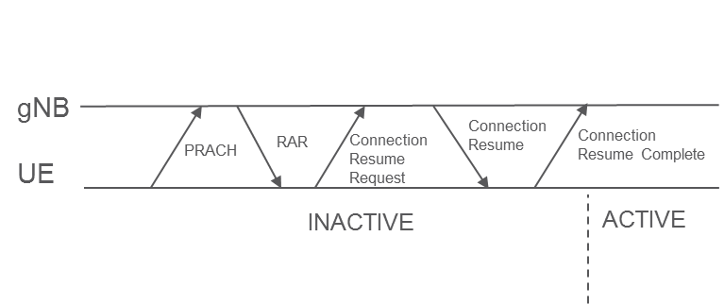

#### 5.2.1.3 Processing delay

In this paper, the assumption is that the minimum timing capabilities have been agreed for NR. With the UE capability, the minimum UL timing is set to be 3 symbols for both 15 kHz and 30 kHz SCS. For 120kHz, the assumption is made of 9 symbols timing.

With mini-slots, the TTIs can have different lengths and therefore we counted the processing in terms of the shortest considered TTI, which is 4 symbols in this paper. For simplicity, the processing delay is therefore set to 1 TTI for both 15 and 30 kHz SCS and 3 TTI at 120 kHz SCS, in both gNB and UE.

The RRC processing delays are assumed to be of a fixed value of 3 ms.

#### 5.2.1.4 Achievable latency in FDD

For the evaluation of latency, it is assumed that the UE works with n+2 timing and the gNB with n+3 timing as the fastest options, i.e. that the processing budget is 1 and 2 TTIs, respectively. This is for 15 and 30 kHz SCS. For 120 kHz, the processing delay is doubled in TTIs, giving n+3 timing for the UE and n+5 timing for gNB.

With the assumptions described above, the resulting CP latency will be as outlined in Table 18. As can be seen, the total worst-case delay sums up in the range 9-14 TTIs + 6ms for FDD.

Table 18

CP latency in TTIs in NR Rel-15 FDD

|  |  |  |  |
| --- | --- | --- | --- |
| Component | Description | Latency | |
|  |  | 15/30kHz | 120kHz |
| 1 | Worst-case delay due to RACH scheduling period (1TTI period) | 1TTI | 1TTI |
| 2 | Transmission of RACH Preamble | 1TTI | 1TTI |
| 3 | Preamble detection and processing in gNB | 1TTI | 3TTI |
| 4 | Transmission of RA response | 1TTI | 1TTI |
| 5 | UE Processing Delay (decoding of scheduling grant, timing alignment and C-RNTI assignment + L1 encoding of RRC Connection Request) | 1TTI | 2TTI |
| 6 | Transmission of RRC Connection Resume Request | 1 TTI | 1 TTI |
| 7 | Processing delay in gNB (L2 and RRC) | 3 ms | 3 ms |
| 8 | Transmission of RRC Connection Resume (and UL grant) | 1 TTI | 1 TTI |
| 9 | Processing delay in the UE (L2 and RRC) | 3 ms | 3 ms |
| 10 | Transmission of RRC Connection Resume Complete (including NAS Service Request) | 1 TTI | 1 TTI |
| 11 | Processing delay in gNB (Uu –> S1-C) | 1 TTI | 3 TTI |
|  | **Total delay** | **9 TTI + 6 ms** | **14 TTI + 6ms** |

**Observation 1 – The worst-case CP latency in NR Rel-15 FDD is estimated to 9TTI+6ms at 15/30kHz SCS and 14TTI+6ms at 120kHz SCS.**

#### 5.2.1.5 Achievable FDD latency in ms

With different TTI lengths and SCSs, the absolute delay will differ, as shown in Table 19. Here, the values calculated above have been assumed.

Table 19

Achievable CP latency for NR Rel-15 in ms

|  |  |  |  |
| --- | --- | --- | --- |
| CP latency (ms) | 15kHz SCS | 30kHz SCS | 120kHz SCS |
| **14-symbol TTI** | 15 | 10.5 | 7.8 |
| **7-symbol TTI** | 10.5 | 8.3 | 6.9 |
| **4-symbol TTI** | 8.6 | 7.3 | 6.5 |

As can be seen in the table, all considered configurations fulfil the 20ms 5G target on CP latency, and almost all configurations also reach the 10ms target.

Observation 2 – NR Rel-15 FDD can reach the 3GPP and ITU 5G targets on CP latency.

#### 5.2.1.6 Achievable latency in TDD

For the TDD slot sequence, two cases are studied: an alternating UL-DL sequence, and a DL-heavy UL-DL-DL-DL sequence. Due to the slot sequence, additional alignment delays are added.

With the assumptions described above, the resulting CP latency will be as outlined in Table 20. As can be seen, the total worst-case delay sums up in the range 12-26 TTI + 6ms for TDD.

Table 20

CP latency in TTIs in NR Rel-15 TDD

|  |  |  |  |  |  |
| --- | --- | --- | --- | --- | --- |
| Component | Description | UL-DL Latency | | UL-DL-DL-DL Latency | |
|  |  | 15/30kHz | 120kHz | 15/30kHz | 120kHz |
| 1 | Worst-case delay due to RACH scheduling period (1TTI period) | 2 TTI | 2 TTI | 4 TTI | 4 TTI |
| 2 | Transmission of RACH Preamble | 1 TTI | 1 TTI | 1 TTI | 1 TTI |
| 3 | Preamble detection and processing in gNB | 1 TTI | 3 TTI | 1 TTI | 3 TTI |
| 4 | DL slot alignment | 1 TTI | 1 TTI | 0 TTI | 1 TTI |
| 5 | Transmission of RA response | 1 TTI | 1 TTI | 1 TTI | 1 TTI |
| 6 | UE Processing Delay (decoding of scheduling grant, timing alignment and C-RNTI assignment + L1 encoding of RRC Connection Request) | 1 TTI | 3 TTI | 1 TTI | 3 TTI |
| 7 | UL slot alignment | 1 TTI | 1 TTI | 0 TTI | 3 TTI |
| 8 | Transmission of RRC Connection Resume Request | 1 TTI | 1 TTI | 1 TTI | 1 TTI |
| 9 | Processing delay in gNB (L2 and RRC) | 3 ms | 3 ms | 3 ms | 3 ms |
| 10 | DL slot alignment | 1 TTI | 1 TTI | 0 TTI | 1 TTI |
| 11 | Transmission of RRC Connection Resume (and UL grant) | 1 TTI | 1 TTI | 1 TTI | 1 TTI |
| 12 | Processing delay in the UE (L2 and RRC) | 3 ms | 3 ms | 3 ms | 3 ms |
| 13 | UL slot alignment | 1 TTI | 1 TTI | 0 TTI | 3 TTI |
| 14 | Transmission of RRC Connection Resume Complete (including NAS Service Request) | 1 TTI | 1 TTI | 1 TTI | 1 TTI |
| 15 | Processing delay in gNB (Uu –> S1-C) | 1 TTI | 3 TTI | 1 TTI | 3 TTI |
|  | **Total delay** | **14 TTI + 6 ms** | **20 TTI + 6 ms** | **12 TTI + 6 ms** | **26 TTI + 6 ms** |

Observation 3 – The worst-case CP latency in NR Rel-15 TDD with alternating UL-DL pattern is estimated to 14TTI+6ms for 15/30kHz SCS and 20TTI+6ms for 120kHz SCS.

#### 5.2.1.7 Achievable TDD latency in ms

With different TTI lengths and SCSs, the absolute delay will differ, as shown in Table 21. For the alternating UL-DL TDD pattern, the latency obtained is indicated in Table 22. and for the UL-DL-DL-DL TDD pattern, the resulting latency is shown in Table 22.

Table 21

Achievable CP latency for NR Rel-15 in ms for TDD with alternating UL-DL pattern

|  |  |  |  |
| --- | --- | --- | --- |
| CP latency (ms) | 15kHz SCS | 30kHz SCS | 120kHz SCS |
| **14-symbol TTI** | 20 | 13 | 8.5 |
| **7-symbol TTI** | 13 | 9.5 | 7.3 |
| **4-symbol TTI** | 10 | 8.0 | 6.7 |

Table 22

Achievable CP latency for NR Rel-15 in ms for TDD with UL-DL-DL-DL pattern.

|  |  |  |  |
| --- | --- | --- | --- |
| CP latency (ms) | 15kHz SCS | 30kHz SCS | 120kHz SCS |
| **14-symbol TTI** | 18 | 12 | 9.3 |
| **7-symbol TTI** | 12 | 9.0 | 7.6 |
| **4-symbol TTI** | 9.4 | 7.7 | 6.9 |

As can be seen in the tables, all considered configurations fulfil the 20ms 5G target on CP latency for the alternating UL-DL TDD pattern, and several configurations can also fulfil the 10ms requirement.

Observation 4 – The worst-case CP latency in NR Rel-15 TDD with alternating UL-DL pattern is estimated to 14TTI+6ms for 15/30kHz SCS and 20TTI+6ms for 120kHz SCS.

The observation above may be used for the discussion on CP latency.

#### 5.2.1.8 Conclusion

In the previous section, the following observations were made:

Observation 5 – The worst-case CP latency in NR Rel-15 FDD is estimated to 9TTI+6ms at 15/30kHz SCS and 14TTI+6ms at 120kHz SCS.

Observation 6 – NR Rel-15 FDD can reach the 3GPP and ITU 5G targets on CP latency.

Observation 7 – The worst-case CP latency in NR Rel-15 TDD with alternating UL-DL pattern is estimated to 14TTI+6ms for 15/30 kHz SCS and 20TTI+6ms for 120kHz SCS.

Observation 8 – NR Rel-15 TDD can reach the ITU and 3GPP 5G targets on CP latency.

These observations can be used to conclude on CP latency.

### 5.2.2 User Plane Latency

The following sub-sections analyse the worst-case UP latency after a first transmission and up to 3 re-transmissions. The ITU definition [1] of UP latency is “the one-way time taken to successfully deliver an application layer packet/message from the radio protocol layer 2/3 SDU ingress point to the radio protocol layer 2/3 SDU egress point of the radio interface in either uplink or downlink.”

#### 5.2.2.1 Assumptions

Processing delay

This is the delay caused at the transmitter by preparation of the transmission and at the receiver by reception procedures and decoding.

On the DL, the processing delay in the UE includes the reception and decoding procedure. On the UL, there is also processing delay in the UE due to reception and decoding of the uplink grant. In gNB there is also processing delay as in the UE, with the addition that processing delay in the gNB also comprises delay caused by scheduling.

Alignment delay

The alignment delay is the time required after being ready to transmit until transmission actually starts. The assumption is the worst-case latency meaning the alignment delay is assumed to be the longest possible. PDCCH and PUCCH opportunities are assumed to be every scheduled TTI.

gNB timing

The minimum response time in the gNB between SR and UL grant, and between DL HARQ and re-transmission, is assumed to be 1 TTI. For higher SCS and fewer symbols in the mini-slot, the TTI is shorter, and more TTIs should be used for processing. The processing in gNB consists of three main components:

– Reception processing (PUSCH processing, SR/HARQ-ACK processing);

– Scheduling processing (including SDU/PDU processing for DL);

– L1 preparation processing for PDSCH and PDCCH.

For simplicity the gNB processing time is referred to as the total processing time and further this processing time is equal for the cases that can occur. For example, the same processing time is assumed for scheduling first transmission and re-transmission. Same processing time is also assumed for DL and UL. The processing time is a lower limit for gNB response time, where the assumptions on gNB processing time are given in Table 23.

UE timing

The minimum response timing in the UE between DL data and DL HARQ, and between UL grant and UL data. On the DL, the UE processing time is according to N1 value (Table 24), while on the UL, the UE processing time is according to N2 value (Table 25) for UE capability #2.

UL scheduling

For UL data, the scheduling can either be based on SR or SPS UL. The assumption is that SR periodicity is 2os corresponding to the shortest periodicity allowed.

Table 23

Processing time (in # of OFDM symbols) assumptions for gNB.

|  |  |  |  |  |  |  |
| --- | --- | --- | --- | --- | --- | --- |
| Timing | 15/30kHz SCS | | | 120kHz SCS | | |
| **#Symbols** | **7os TTI** | **4os TTI** | **2os TTI** | **7os TTI** | **4os TTI** | **2os TTI** |
| **gNB processing** | 7 | 4 | 4 | 14 | 12 | 10 |

Table 24

PDSCH processing time in OFDM symbols for the UE capabilities with front-loaded DM-RS

|  |  |  |  |
| --- | --- | --- | --- |
| #Symbols |  | | |
|  | 15kHz SCS | 30kHz SCS | 120kHz SCS |
| **Capability 2** | 3 | 4.5 | 20[3] |

Table 25

PUSCH preparation procedure time.

|  |  |  |  |
| --- | --- | --- | --- |
| #Symbols |  | | |
|  | 15kHz SCS | 30kHz SCS | 120kHz SCS |
| **Capability 2** | 5 | 5.5 | 36[4] |

TTI length and pattern

In this evaluation, we studied slot lengths of 14 symbols as well as mini-slots of 7, 4, and 2 symbols. For TDD, an alternating DL-UL pattern has been assumed, to represent the most latency-optimized setup in a carrier. With TDD, slot/mini-slots of 14, 7, and 4 symbols are studied.

Figure 2

Illustration of latency components for DL and UL data.

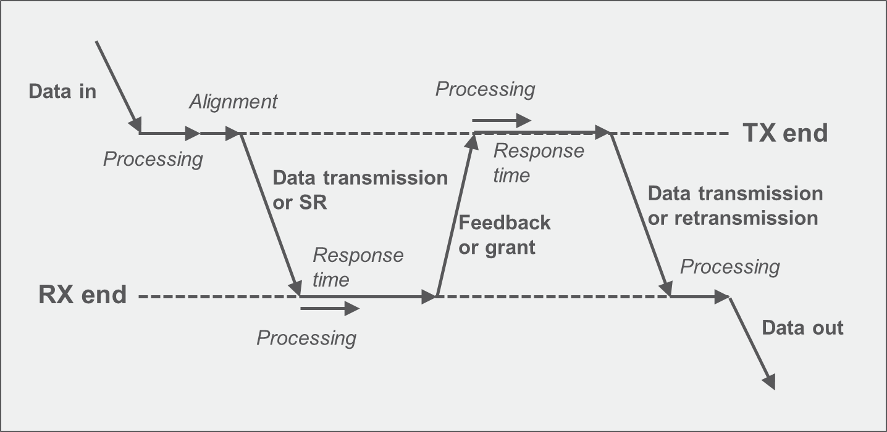

#### 5.2.2.2 FDD

For the case of FDD, the HARQ RTT is n+k TTI. The resulting UP latency for SCS of 15, 30 and 120 kHz is shown in Table 26. As can be seen, the 1ms requirement can be reached for SCS 15 kHz and up depending on mini-slot configuration. On the UL, “configured” grants reduce the latency considerably compared to SR-based scheduling.

Table 26

FDD UP one-way latency for data transmission with HARQ-based retransmission, compared to the 1ms (green) nd 4ms (orange) requirements.

|  |  |  |  |  |  |  |  |  |  |  |  |  |  |
| --- | --- | --- | --- | --- | --- | --- | --- | --- | --- | --- | --- | --- | --- |
| Latency (ms) | HARQ | 15kHz SCS | | | | 30kHz SCS | | | | 120kHz SCS | | | |
| 14-os TTI | 7-os TTI | 4-os TTI | 2-os TTI | 14-os TTI | 7-os TTI | 4-os TTI | 2-os TTI | 14-os TTI | 7-os TTI | 4-os TTI | 2-os TTI |
| DL data | 1st transmission | 3.2 | 1.7 | 1.3 | 0.86 | 1.7 | 0.91 | 0.7 | 0.48 | 0.55 | 0.43 | 0.38 | 0.31 |
| 1 retx | 6.2 | 3.2 | 2.6 | 1.7 | 3.1 | 1.6 | 1.3 | 0.96 | 1.1 | 0.87 | 0.76 | 0.63 |
| 2 retx | 9.2 | 4.7 | 3.6 | 2.6 | 4.7 | 2.4 | 2 | 1.5 | 1.6 | 1.3 | 1.1 | 0.96 |
| 3 retx | 12 | 6.2 | 4.6 | 3.4 | 6.1 | 3.1 | 2.7 | 2 | 2.1 | 1.7 | 1.5 | 1.3 |
| UL data (SR) | 1st transmission | 5.5 | 3 | 2.5 | 1.8 | 2.8 | 1.5 | 1.3 | 0.93 | 1.2 | 1.1 | 1 | 0.89 |
| 1 retx | 9.4 | 4.9 | 3.9 | 2.6 | 4.7 | 2.4 | 2 | 1.4 | 1.9 | 1.7 | 1.6 | 1.3 |
| 2 retx | 12 | 6.4 | 4.9 | 3.5 | 6.2 | 3.2 | 2.6 | 1.9 | 2.6 | 2.3 | 2.1 | 1.8 |
| 3 retx | 15 | 7.9 | 5.9 | 4.4 | 7.7 | 3.9 | 3.3 | 2.3 | 3.2 | 2.8 | 2.6 | 2.2 |
| UL data (CG) | 1st transmission | 3.4 | 1.9 | 1.4 | 0.93 | 1.7 | 0.95 | 0.7 | 0.48 | 0.7 | 0.57 | 0.52 | 0.45 |
| 1 retx | 6.4 | 3.4 | 2.6 | 1.8 | 3.2 | 1.7 | 1.4 | 0.93 | 1.3 | 1.1 | 1.1 | 0.89 |
| 2 retx | 9.4 | 4.9 | 3.9 | 2.6 | 4.7 | 2.4 | 2 | 1.4 | 1.9 | 1.7 | 1.6 | 1.3 |
| 3 retx | 12 | 6.4 | 4.9 | 3.5 | 6.2 | 3.2 | 2.6 | 1.9 | 2.6 | 2.3 | 2.1 | 1.8 |

Observation 9 – NR FDD can fulfill the 4 ms UP latency target with 15kHz SCS.

Observation 10 – NR FDD can fulfill the 1 ms UP latency target with 15kHz SCS, mini-slots, and UL configured grants.

#### 5.2.2.3 TDD

With TDD, there are additional alignment delays caused by the sequence of DL and UL slots. Depending on when the data arrives in the transmit buffer, the latency may be the same or higher than the FDD latency. For a DL-UL pattern with HARQ RTT of n+4 TTI and higher (again following Table 23), the resulting latency is as indicated in Table 27. As can be seen in the table, the 4ms target can be reached with a SCS of 15 kHz for 7-symbol mini slot, while 30 kHz SCS is possible also with slot length transmission. The 1ms target can be reached with 120 kHz SCS and mini-slots for DL and UL configured grant transmissions.

Table 27

TDD UP one-way latency for data transmission with alternating DL-UL slot pattern, compared to the 1ms (green) and 4ms (orange) requirements.

|  |  |  |  |  |  |  |  |  |  |  |
| --- | --- | --- | --- | --- | --- | --- | --- | --- | --- | --- |
| Latency (ms) | HARQ | 15kHz SCS | | | 30kHz SCS | | | 120kHz SCS | | |
| 14-os TTI | 7-os TTI | 4-os TTI | 14-os TTI | 7-os TTI | 4-os TTI | 14-os TTI | 7-os TTI | 4-os TTI |
| DL data | 1st transmission | 4.2 | 2.7 | 2.3 | 2.2 | 1.4 | 1.2 | 0.68 | 0.55 | 0.51 |
| 1 retx | 8.2 | 4.7 | 4.3 | 4.1 | 2.4 | 2.2 | 1.4 | 1.1 | 1 |
| 2 retx | 12 | 6.7 | 6.3 | 6.2 | 3.4 | 3.2 | 2.2 | 1.6 | 1.5 |
| 3 retx | 16 | 8.7 | 8.3 | 8.1 | 4.4 | 4.2 | 2.9 | 2.1 | 2 |
| UL data (SR) | 1st transmission | 7.5 | 4.5 | 4.1 | 3.8 | 2.3 | 2.1 | 1.5 | 1.2 | 1.2 |
| 1 retx | 12 | 6.9 | 6.4 | 6.2 | 3.4 | 3.2 | 2.3 | 1.9 | 1.7 |
| 2 retx | 16 | 8.9 | 8.4 | 8.2 | 4.5 | 4.2 | 3.1 | 2.5 | 2.2 |
| 3 retx | 20 | 11 | 10 | 10 | 5.4 | 5.2 | 3.8 | 3.2 | 2.7 |
| UL data (CG) | 1st transmission | 4.4 | 2.9 | 2.4 | 2.2 | 1.4 | 1.2 | 0.82 | 0.7 | 0.64 |
| 1 retx | 8.4 | 4.9 | 4.4 | 4.2 | 2.5 | 2.2 | 1.6 | 1.3 | 1.2 |
| 2 retx | 12 | 6.9 | 6.4 | 6.2 | 3.4 | 3.2 | 2.3 | 1.9 | 1.7 |
| 3 retx | 16 | 8.9 | 8.4 | 8.2 | 4.5 | 4.2 | 3.1 | 2.5 | 2.2 |

#### 5.2.2.4 Conclusion

In section 5.6.2.2, the following observations were made:

Observation 11 – NR FDD can fulfill the 4ms UP latency target with 15kHz SCS.

Observation 12 – NR FDD can fulfill the 1ms UP latency target with 15kHz SCS, mini-slots, and UL configured grants.

Observation 13 – NR TDD can fulfil the 4ms UP latency target with 15 kHz SCS, mini-slot and configured UL grants.

Observation 14 – NR TDD can fulfil the 1ms UP latency target with 120 kHz SCS, mini-slots and configured UL grants.

From the above, it is concluded that:

Observation 15 – NR fulfills the IMT-2020 requirements on latency.

# 6 Evaluation of Urban Macro URLLC technical performance

The reliability requirement is defined in [1] for the purposes of evaluation in an urLLC usage scenario. It relates to the capability of transmitting a given amount of traffic within a pre-determined time duration with high success (low error) probability.

## 6.1 Requirements on reliability

*Reliability* is the success probability of transmitting a layer 2/3 packet within a required maximum time, which is the time it takes to deliver a small data packet from the radio protocol layer 2/3 SDU ingress point to the radio protocol layer 2/3 SDU egress point of the radio interface subject to a certain channel quality.

The ITU target for reliability in IMT-2020 has been set to an error probability of 1 × 10-5 of transmitting a layer 2 PDU (protocol data unit) of 32 bytes within 1 ms. The channel quality assumed is that which prevails at cell edge in the urLLC-urban macro test environment.

## 6.2 Discussion

### 6.1.2 System-level simulations

The assumptions for the system-level simulations (SLS) are given in Table 28, as are the results for the two test-configurations A and B (4 GHz and 700 MHz respectively; detailed specifications of these test configurations can be found in [2]).

For configuration A, the total gain (including antenna gain) is presented in Figure 3 for UMa channel models A and B. The resulting SINR at full load (cell utilization 1) is illustrated in Figure 4. The cell-edge (5th percentile) SINR is found to be 1.98 dB (on the DL) and 0.81 dB (on the UL) for channel model UMa A, and 1.98 dB (DL) and 1.77 dB (UL) for channel model UMa B as shown in Figure 5.

For configuration B, the total gain (including antenna gain) is given in Figure 6 for UMa models A and B. The resulting SINR at full load (cell utilization 1) is given in Figure 7. The cell-edge (5th percentile) SINR is found to be 0.16 dB (on the DL) and 0.83 dB (on the UL) for channel model UMa A and -0.06 dB (DL) and 0.65 dB (UL) for channel model UMa B as shown in Figure 8.

Table 28

Assumptions of the system-level simulations

|  |  |  |
| --- | --- | --- |
| Configuration Parameters | URLLC configuration A | URLLC configuration B |
| Carrier frequency | 4 GHz | 700 MHz |
| Base station Antenna Height | 25 m | 25 m |
| Inter-site distance | 500 m | 500 m |
| Bandwidth | 20 MHz | 20 MHz |
| Device deployment | 80% outdoor, 20% indoor | 80% outdoor, 20% indoor |
| Number of UE antenna elements | 4 | 4 |
| UE noise figure | 7 | 7 |
| UE power | 23 dBm | 23 dBm |
| Path loss model | UMa A/B with SCM (for ZOD) | UMa A/B with SCM (for ZOD) |
| BS antenna V × H (vs × Hs × P) | 4 × 8 (2 × 1 × 2) | 4 × 4 (2 × 1 × 2) |
| BS Transmit power | 49 dBm | 49 dBm |
| BS noise figure | 5 | 5 |
| Electrical down tilt | 9 degrees | 9 degrees |
| Traffic model | Full buffer | Full buffer |
| UL power control | Alpha=1, P0=-106 dBm | Alpha=1, P0=-106 dBm |
| UL allocation | 5 PRB (10 UEs sharing 50 PRBs) | 5 PRB (10 UEs sharing 50 PRBs) |

Figure 3

Total gain for urLLC configuration A

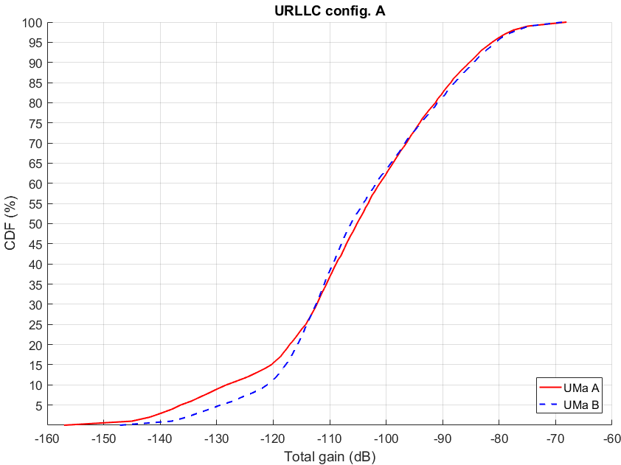

Figure 4

SINR distribution for urLLC configuration A

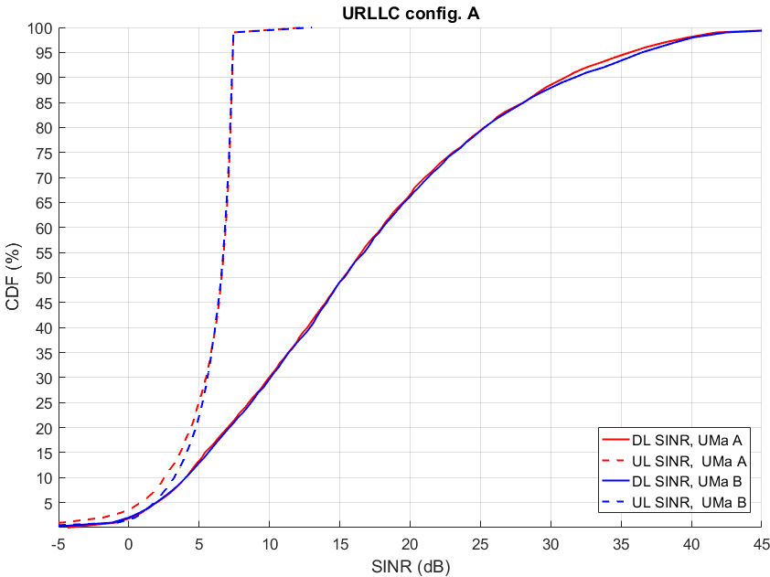

Figure 5

SINR distribution at 5th percentile for urLLC configuration A

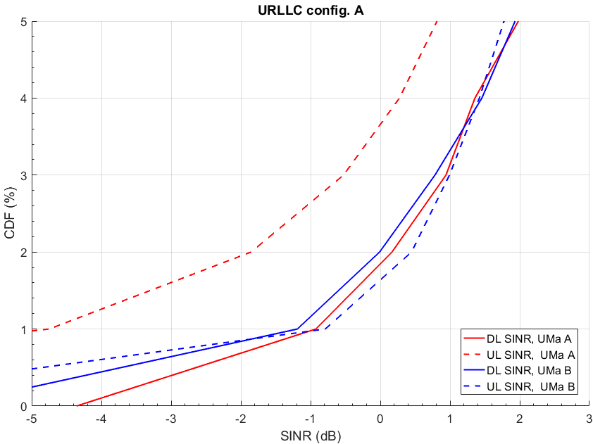

Observation 16 – The cell-edge SINR for URLLC Conf. A is approximately 1.98 dB (DL) and 0.81 dB (UL) for channel model UMa A, and 1.93 dB (DL) and 1.77 dB (UL) for channel model UMa B

Figure 6

Total gain for urLLC configuration B

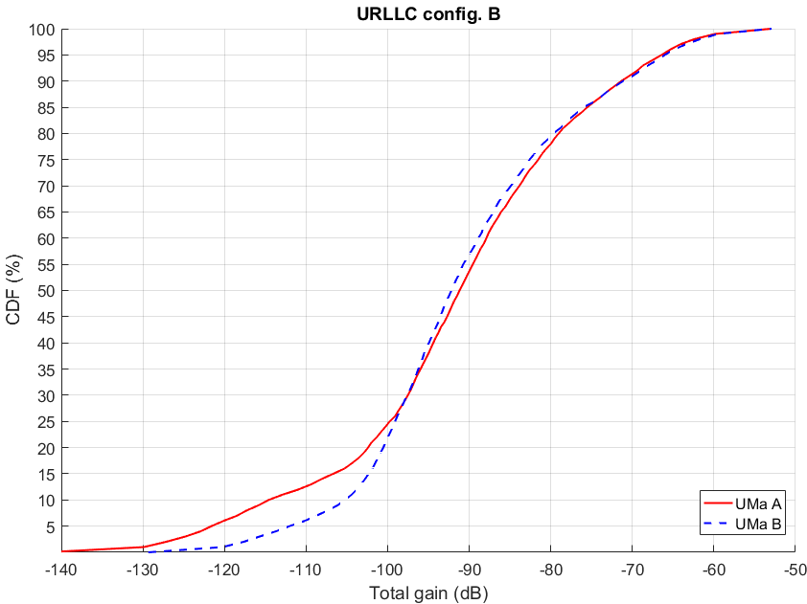

Figure 7

SINR distribution for urLLC configuration B

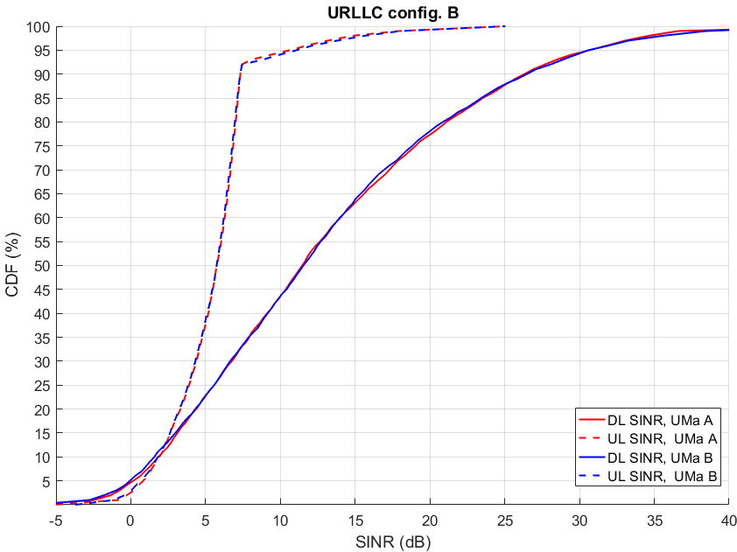

Figure 8

SINR distribution at 5th percentile for urLLC configuration B

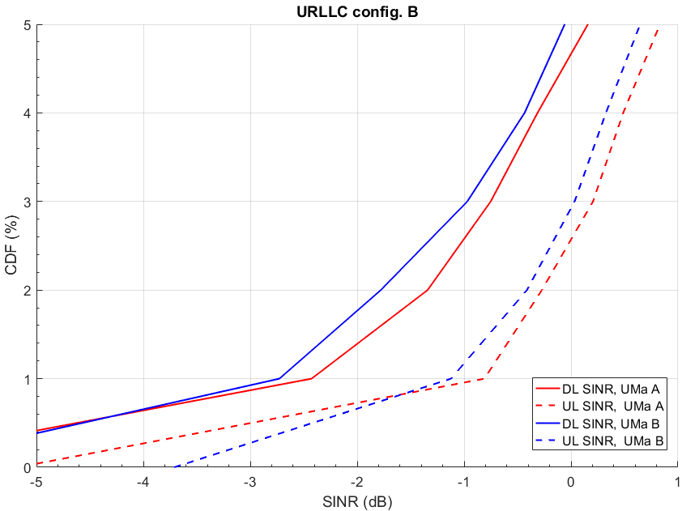

Observation 17 – The cell-edge SINR for URLLC Conf. B is approximately 0.16 dB (DL) and 0.83 dB (UL) for channel model UMa A, and -0.06 dB (DL) and 0.65 dB (UL) for channel model UMa B

## 6.3 Link-level simulations

The assumptions on the link-level simulations (LLS) are given in Table 29. Two different datasets are used for data and control channels. For PDCCH, a DCI of size 40 bits, excluding CRC, is assumed. For PUCCH a 1-bit UCI is assumed, carried by PUCCH format 0 with 2os (symbols) duration and frequency hopping.

The resulting BLER as a function of SNR for the control channels is shown in Figure 9, and for the data channels in Figure 10 and Figure 11.

Table 29

Assumptions on the link-level simulations

|  |  |
| --- | --- |
| Channel model | TDL-C with 300ns delay spread |
| Carrier | 700MHz |
| Bandwidth | 20 MHz |
| Subcarrier spacing | 30 kHz |
| Antenna setting | 2TX 2RX (data), 1TX 2RX (control) |
| Tx diversity | Rank 1 (TX diversity precoding based on CSI reports with 5 slots periodicity). |
| Speed | 3 km/h |
| Channel estimation | Practical:  4os mini-slot - 1os front-loaded DMRS type 2  7os mini-slot - 2os front-loaded DMRS type 2 |
| Frequency allocation | Frequency allocation type 1 (contiguous) |
| Time allocation | 4os and 7os allocations type B |
| PUCCH | 1 A/N bit, PUCCH format 0 with 2- symbol duration and frequency hopping between band edges |
| PDCCH | Polar codes, 40b payload excl. CRC. Distributed CCEs |
| Data | LDPC, BG2, 256b |

Figure 9

Sequence selection Short PUCCH and PDCCH BLER as function of SNR

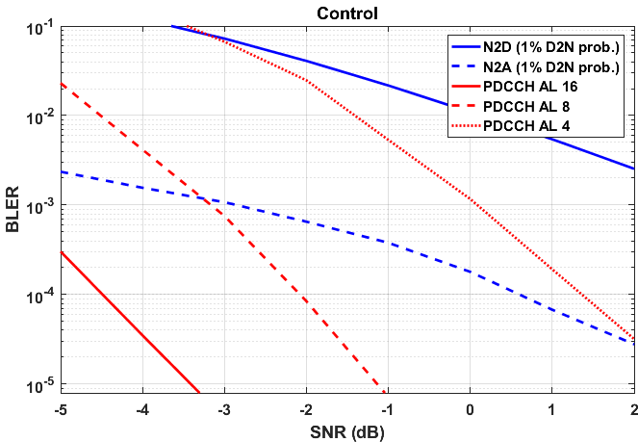

Figure 10

4OS-Data (1st attempt) LDPC BLER for QPSK with different MCS as function of SNR

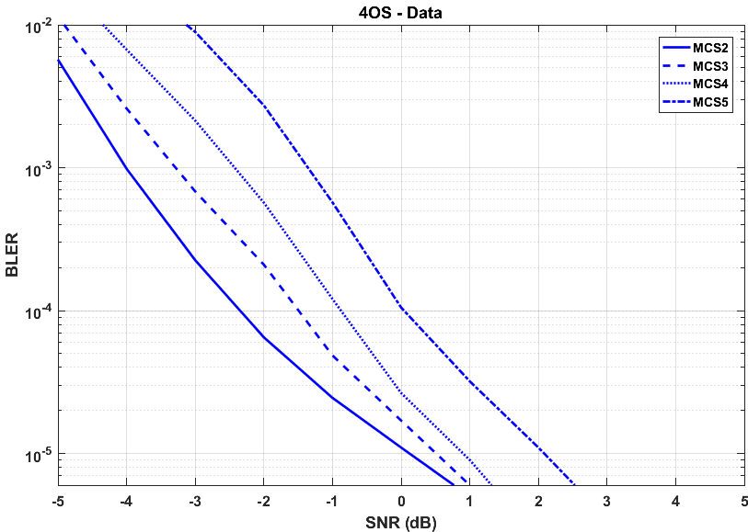

Figure 11

7OS-Data (1st attempt) LDPC BLER for QPSK with different MCS as function of SNR

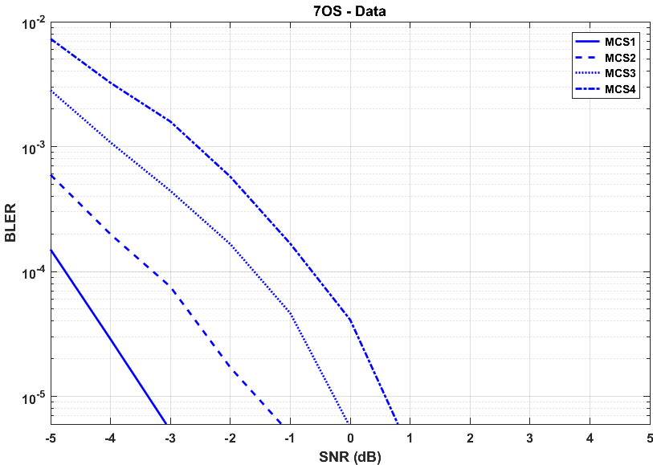

## 6.4 Total reliability

With some exceptions, the discussion here assumes that the retransmissions are uncorrelated, which is reasonable to assume if they are done on a different frequency allocation. In the following, the success probabilities are written on the channel level according to Table 30, and expressions found for the total success rate , where is the residual error rate.

Table 30

Success probabilities for calculating total reliability

|  |  |
| --- | --- |
| Probability | Description |
| p0 | SR |
| p1 | PDCCH |
| p2 | PDSCH/PUSCH |
| p3 | PUCCH NACK detection |
| p4 | PUCCH DTX detection |

DL data, HARQ-based

On the DL, the total reliability can be described after N transmissions as:

where for any positive integer k,   is the probability of a data block being correctly received after exactly k transmissions are soft-combined. In this expression, the DL control transmissions are seen as uncorrelated with each other and with data. This is an approximation, but can be motivated by, for example, moving the DL control between attempts. The data attempts are correlated with each other.

UL data, configured grant

With configured grant-based UL scheduling instead, the SR step and the first DL control can be removed, and the total reliability can be described as:

Here the PDCCH reliability starts from the first retransmission, assuming perfect energy detection performance on the PUSCH resource.

## 6.5 Reliability estimate urLLC configuration B, UMa B

Accordingly, based on the above expressions for DL and UL data, while considering the link-level simulation results, the total reliability can be evaluated. By observation at the lower percentiles of the SINR distributions for urLLC configuration B, UMa B, the channel BLER can be found at the corresponding DL and UL SINR points. The total error rates for DL and UL data, respectively, can then be computed.

The results are shown in Figure 12 through Figure 15.

AL16 is assumed for PDCCH and 1% D2A level for PUCCH. On the UL, SPS is assumed with a configured resource every TTI. For both DL and UL, 1-3 transmission attempts (including HARQ retransmissions) are considered. The data transmissions are assumed to be correlated and are soft-combined.

Figure 12

Total reliability for 4OS – DL data with 1-3 HARQ transmissions at lowest percentiles assuming correlated transmissions

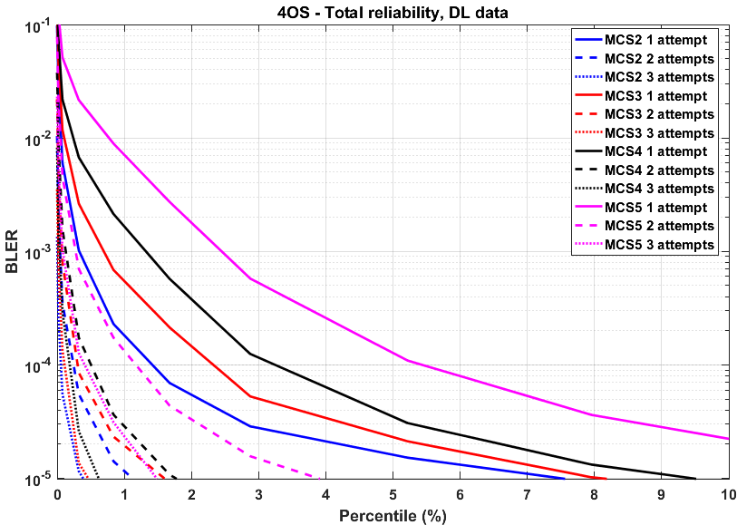

Figure 13

Total reliability for 7OS – DL data with 1-3 HARQ transmissions at lowest percentiles assuming correlated transmissions

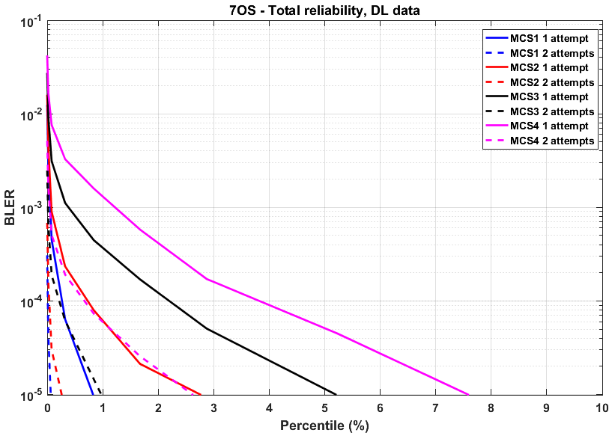

Figure 14

Total reliability for 4OS UL data with 1-2 HARQ transmissions at lowest percentiles with SPS-based scheduling assuming correlated transmissions

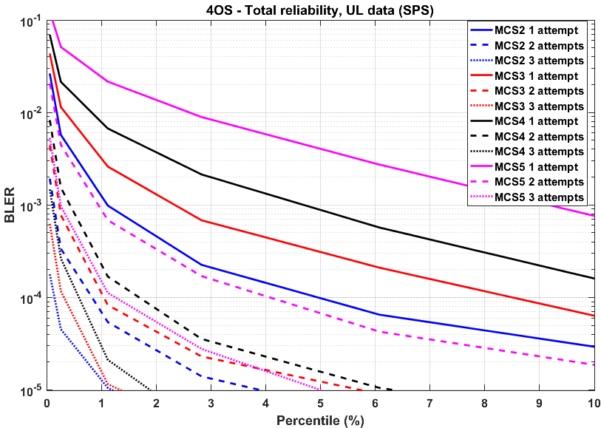

Figure 15

Total reliability for 7OS UL data with 1-2 HARQ transmissions at lowest percentiles with SPS-based scheduling assuming correlated transmissions

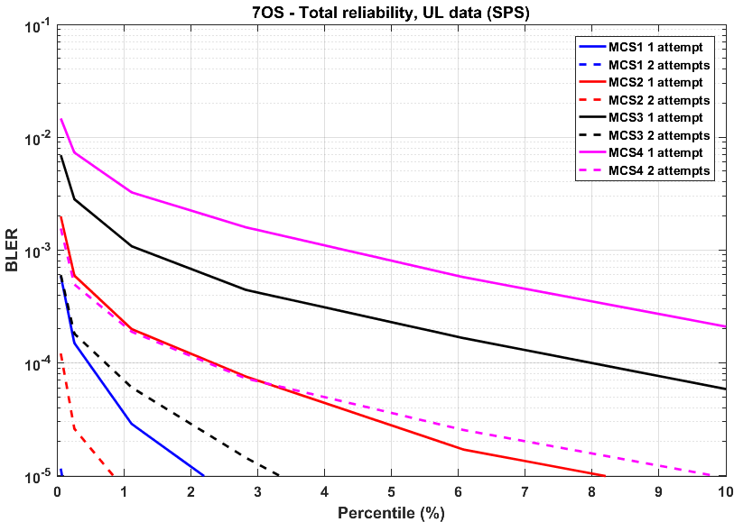

Observation 18 – With 1 transmission using MCS1, the reliability target of 10-5 error can be met on the DL and the UL with a configured grant.

## 6.6 Packet size

The ITU requirement calls for a packet size of 32B fulfilling the latency and reliability targets. With QPSK modulation and a coding rate from MCS1 to MCS5, along with an overhead of one OFDM symbol, the required number of PRBs is given in Table 31. Here, the TBS is assumed to be exactly 32B and CRC is not considered.

Table 31

Required #PRBs for 32B packet and 1 OFDM symbol overhead, at different coding rates.

|  |  |  |  |  |
| --- | --- | --- | --- | --- |
| #PRBs | 14-os TTI | 7-os TTI | 4-os TTI | 2-os TTI |
| **Code rate MCS1** | 22 | 46 | 92 | 274 |
| **Code rate MCS2** | 17 | 37 | 73 | 219 |
| **Code rate MCS3** | 14 | 29 | 57 | 171 |
| **Code rate MCS4** | 11 | 24 | 47 | 141 |
| **Code rate MCS5** | 9 | 19 | 37 | 111 |

Observation 19 – With MCS1 and a 7-os mini-slot, 46 PRBs are required for a 32B packet.

## 6.7 Total latency

The UP latency has been evaluated for a sequence of transmissions. It was found that DL and configured-grant UL transmissions with 7-os and 30 kHz SCS are possible within the latency bound of 1ms, as shown in Table 32. Thus, the ITU reliability of 10-5 error within 1 ms can be met.

Table 32

Maximum #transmissions, including retransmissions, in FDD within 1ms.

|  |  |  |  |  |  |  |  |  |  |  |  |  |
| --- | --- | --- | --- | --- | --- | --- | --- | --- | --- | --- | --- | --- |
| #TX within 1ms | 15kHz SCS | | | | 30kHz SCS | | | | 120kHz SCS | | | |
| 14-os TTI | 7-os TTI | 4-os TTI | 2-os TTI | 14-os TTI | 7-os TTI | 4-os TTI | 2-os TTI | 14-os TTI | 7-os TTI | 4-os TTI | 2-os TTI |
| **DL data** | 0 | 0 | 0 | 1 | 0 | 1 | 1 | 2 | 1 | 2 | 2 | 3 |
| **UL data (SPS)** | 0 | 0 | 0 | 1 | 0 | 1 | 1 | 2 | 1 | 1 | 1 | 2 |

Observation 20 – With 30 kHz SCS and 7-os mini-slot 1 transmission can be made in FDD mode within 1 ms.

## 6.8 Summary and conclusion

In this section, the following observations were made:

Observation 21 – The cell-edge SINR for urLLC configuration A is approximately 1.98 dB (DL) and 0.81 dB (UL) for channel model UMa A and 1.93 dB (DL) and 1.77 dB (UL) for channel model UMa B.

Observation 22 – The cell-edge SINR for urLLC configuration B is approximately 0.16 dB (DL) and 0.83 dB (UL) for channel model UMa A and -0.06 dB (DL) and 0.65 dB (UL) for channel model UMa B.

Observation 23 – With 1 transmission using MCS1, the reliability target of 10-5 error can be met on the DL and the UL (with a configured grant).

Observation 24 – With MCS1 and a 7-os mini-slot, 46 PRBs are required for a 32B packet.

Observation 25 – With 30 kHz SCS and 7-os mini-slot, 1 transmission can be made in FDD mode within 1 ms.

# 7 Evaluation of Urban Macro mMTC technical performance

The connection density criterion requires a candidate radio-interface technology (RIT) to provide a certain quality-of-service (QoS) to 1 000 000 devices per km2 at a grade-of-service (GoS) of 1 percent. Service is considered provided when a message latency of less than 10 seconds is supported for a user attempting to send an uplink data packet of 32 bytes defined at layer 2. Besides the supported connection density, it is encouraged to report the connection efficiency which is defined as the connection density normalized by the required system bandwidth.

Observation 26 – The connection density requirement requires 1% grade of service where acceptable quality-of-service is defined by a message latency of 10 seconds or less.

## 7.1 Connection density – Full Buffer

### 7.1.1 System simulation procedure

Report [1] outlines two system simulator procedures for evaluating connection density. The first is a non-full buffer system-level simulation that requires a state-of-the-art system simulator to perform the evaluations. The second is a full buffer system simulation that allows input based on a more rudimentary system simulator combined with post processing supported by link-level simulations.

Table 33

Full buffer system-level simulation procedure



### 7.1.2 Test environment

#### 7.1.2.1 System-level

Report [1] specifies the test environment to be used in the first step of the evaluations according to Table 34. The simulations presented in this section, to a large extent, follow this set of assumptions. Further detailed assumptions are outlined in section 7.1.3.

Table 34

Urban Macro-mMTC test environment definition

|  |  |  |
| --- | --- | --- |
| Parameters | Config. A | Config. B |
| Carrier frequency for evaluation | 700 MHz | 700 MHz |
| BS antenna height | 25 m | 25 m |
| Total transmit power per TRxP | 46 dBm for 10 MHz bandwidth | 46 dBm for 10 MHz bandwidth |
| UE power class | 23 dBm | 23 dBm |
| Percentage of high loss and low loss building type | 20% high loss, 80% low loss  Note: Applies only to Channel model B. | 20% high loss, 80% low loss  Note: Applies only to Channel model B. |
| Inter-site distance | 500 m | 1732 m |
| Number of antenna elements per TRxP | Up to 64 Tx/Rx | Up to 64 Tx/Rx |
| Number of UE antenna elements | Up to 2 Tx  Up to 2 Rx | Up to 2 Tx  Up to 2 Rx |
| Device deployment | 80% indoor, 20% outdoor Note: Randomly and uniformly distributed over the area | 80% indoor, 20% outdoor Note: Randomly and uniformly distributed over the area |
| UE mobility model | Fixed and identical speed |v| of all UEs of the same mobility class, randomly and uniformly distributed direction. | Fixed and identical speed |v| of all UEs of the same mobility class, randomly and uniformly distributed direction. |
| UE speeds of interest | 3 km/h for indoor and outdoor  Note: Corresponds to 2 Hz Doppler | 3 km/h for indoor and outdoor  Note: Corresponds to 2 Hz Doppler |
| Inter-site interference modeling | Explicitly modelled | Explicitly modelled |
| BS noise figure | 5 dB | 5 dB |
| UE noise figure | 7 dB | 7 dB |
| BS antenna element gain | 8 dBi | 8 dBi |
| UE antenna element gain | 0 dBi | 0 dBi |
| Thermal noise level | -174 dBm/Hz | -174 dBm/Hz |
| Traffic model | With layer 2 PDU(Protocol Data Unit) message size of 32 bytes:  1 message/day/device  or  1 message/2 hours/device  Note: Not modelled in the full buffer system-level simulation. | With layer 2 PDU(Protocol Data Unit) message size of 32 bytes:  1 message/day/device  or  1 message/2 hours/device  Note: Not modelled in the full buffer system-level simulation. |
| Simulation bandwidth | Up to 10 MHz | Up to 50 MHz |
| UE density | For full buffer system-level simulation followed by link-level simulation, 10 UEs per TRxP for SINR CDF distribution derivation | For full buffer system-level simulation followed by link-level simulation, 10 UEs per TR × P for SINR CDF distribution derivation |
| UE antenna height | 1.5 m | 1.5 m |

#### 7.1.2.2 Link-level

The second step of the full buffer evaluation requires link-level evaluations. The link-level assumptions for the Urban Macro-mMTC test environment are presented in Table 35.

Table 35

Urban Macro-mMTC link-level definition

|  |  |
| --- | --- |
| Parameters | Configuration |
| Evaluated service profiles | Full buffer best effort |
| Simulation bandwidth | For ISD = 500 m, up to 10 MHz;  For ISD = 1732 m, up to 50 MHz |
| Number of users in simulation | 1 |
| Packet size | 32 bytes at Layer 2 PDU |
| Inter-packet arrival time | 1 message/day/device  or  1 message/2 hours/device |
| Link-level Channel model | NLOS: TDL-iii  LOS: TDL-v  Note: Only NLOS is evaluated. |
| Delay spread | 363.1 ns |

### 7.1.3 Simulation Configurations

Table 36 presents the NR, LTE-M and NB-IoT system-level configurations, that override or are required in addition to those presented in Table 34.

Table 36

System-level simulation configuration

|  |  |  |  |
| --- | --- | --- | --- |
| Parameter | NR | LTE-M | NB-IoT |
| System bandwidth | 180kHz | 180kHz | 180 kHz |
| BS transmit power per PRB | 29 dBm | | |
| Number of BS antenna elements per TRxP | 16 Tx/Rx, (M,N,P,Mg,Ng) = (8,1,2,1,1), (dH,dV) = (N/A, 0.8)λ +45°, -45° polarization | | |
| Number of TXRU per TRxP | 2 TXRU, (Mp,Np,P,Mg,Ng) = (1,1,2,1,1) | | |
| Number of UE antenna elements | 1Tx/Rx 0° polarization | | |
| Number of TXRU per UE | 1 TXRU | | |
| UE antenna element pattern | Omni-directional | | |
| Channel model variant | Alt. 1: Channel model A Alt. 2: Channel model B | | |
| TRxP per site | 3 | | |
| Mechanic tilt | 90° in GCS (pointing to horizontal direction) | | |
| Electronic tilt | 99° for configuration A  93° for configuration B | | |
| Handover margin (dB) | 2 dB | | |
| TRxP boresight | 30 / 150 / 270 degrees | | |
| UT attachment | Based on RSRP (formula (8.1-1) in TR36.873) from port 0 | | |
| Wrapping around method | Radio distance-based wrapping | | |
| Minimum distance of TRxP and UE | 10 m | | |
| Polarized antenna model | Model-2 in TR36.873 | | |
| System layout | 7 sites, 3 sectors per site | | |
| UL Power control SINR target | 3 dB | 3 dB | Config A: 10 dB  Config B: 3 dB |

Table 37 presents the NR, LTE-M and NB-IoT link-level configurations, that override or are required in addition to those presented in Table 36.

Table 37

Link-level simulation configuration

|  |  |  |  |
| --- | --- | --- | --- |
| Parameter | NR | LTE-M | NB-IoT |
| Physical channel | PUSCH | PUSCH | NPUSCH F1 |
| Channel bandwidth | 180 kHz | 180 kHz | 15 kHz |
| Subcarrier spacing | 15 kHz | 15 kHz | 15 kHz |
| TBS | 32, 42, 48, 64, 80, 104, 144, 168, 184 bits | 144, 256 bits | 256 bits |
| Modulation | QPSK | 16QAM/QPSK | QPSK |
| # Resource units | - | - | 2, 3, 4, 5, 6, 8, 10 |
| # Repetitions | - | 1, 2, 4, 8, 16, 32 | 1, 2, 4, 8, 16 |
| HARQ | No | No | No |
| Scenario | Sensitivity limited | Sensitivity limited | Sensitivity limited |
| Channel estimation | Realistic | Realistic | Realistic |
| SNR range | -15…15 dB | -15…15 dB | -15…15 dB |

### 7.1.4 Connection density evaluation

#### 7.1.4.1 Full buffer system-level performance

Figures 16, 17 and 18 present the UL SINR distributions required in Step 1 in the full buffer system-level simulation. The NR and LTE-M distributions are identical due to similar channel bandwidths and uplink power control targets.

Figure 16

NR UL SINR CDFs

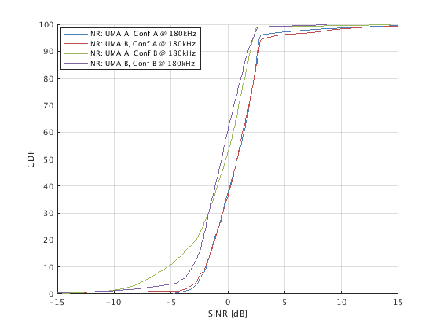

Figure 17

LTE-M UL SINR CDFs

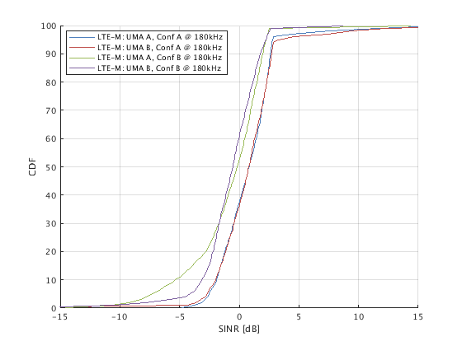

Figure 18

NB-IoT UL SINR CDFs

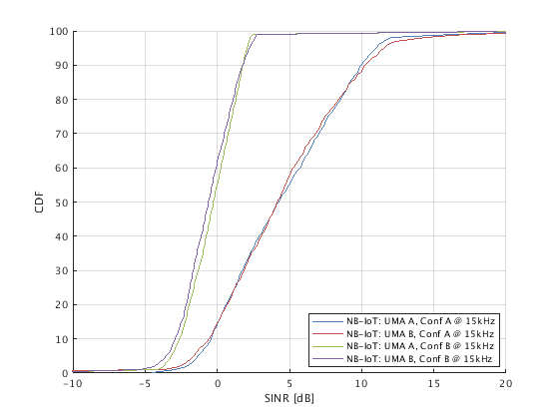

##### 7.1.4.1.1 Full buffer link-level performance

Figure 19 presents the NR, LTE-M and NB-IoT UL link spectral efficiencies required in Step 2 in the full buffer evaluation methodology. The SNR is defined for 15 kHz in the case of NB-IoT and 180 kHz for LTE-M and NR.

For NB-IoT, up to 16 repetitions were simulated to reach adequate performance in the low SINR domain. A fixed transport block size (TBS) of 256 bits was simulated, which exactly matches the agreed packet size of 32 bytes. The configured TBS was transmitted over 1 Resource Unit (RU), mapped over 8 ms. This fact was used in the eNB channel estimator, where an 8 ms cross-subframe channel estimation was performed.

For LTE-M, up to 32 repetitions were used. For the TBS of 256 bits, 16QAM modulation was employed, which explains the high link spectral efficiency (SPEFF) for LTE-M at good SINRs. The QPSK TBS of 144 bits contributes to the LTE-M throughput envelope for SINR below 4 dB. For LTE-M, channel estimation was performed on a per subframe basis. This explains why the LTE-M performance is slightly inferior to the NB-IoT performance for the SNR range below 5 dB.

For NR, a range of TBSs up to a size of 184 bits was simulated. This explains why the NR link adaptation curve is smoother than the LTE-M and NB-IoT curves. The limit of 184 bits also explains why the NR spectral efficiency flattens at 1 bit/s/Hz. Just as for LTE-M, the NR channel estimation was performed on a per subframe basis.

The differences in performance can partly be attributed to slightly different assumptions, e.g. in the channel estimation method, used when running the simulations for the three technologies. It should also be noticed that three different simulators were used to derive the results.

Figure 19

NR, LTE-M and NB-IoT link spectral efficiency (SPEFF)



##### 7.1.4.1.2 Performance

Based on the link- and system-level performances presented in sections 7.1.4.1 and 7.1.4.1.1, the 99th percentile delay and the connection densities, shown in Tables 38 and 39 respectively, were derived. The results are presented for a bandwidth of 180 kHz.

All three investigated solutions meet the IMT-2020 connection density target with either large or sufficient margins. NB-IoT offers the highest capacity due to its support of sub-carrier UL scheduling which allows the system to operate at a higher SNR in certain scenarios. The difference in delay and capacity between LTE-M and NR can be explained by the link-level spectral efficiency differences shown in Figure 19.

Table 38

99th percentile delay D recorded in Step 3

|  |  |  |  |  |
| --- | --- | --- | --- | --- |
|  | Conf A, UMA A | Conf A, UMA B | Conf B, UMA A | Conf B, UMA B |
| NR | 0,008 | 0,009 | 0,101 | 0,093 |
| LTE-M | 0,009 | 0,010 | 0,061 | 0,057 |
| NB-IoT | 0,077 | 0,090 | 0,099 | 0,126 |

Table 39

Connection density C recorded in Step 7

|  |  |  |  |  |
| --- | --- | --- | --- | --- |
|  | Conf A, UMA A | Conf A, UMA B | Conf B, UMA A | Conf B, UMA B |
| NR | 30 066 283 | 29 844 621 | 1 269 767 | 1 575 368 |
| LTE-M | 25 674 701 | 25 524 579 | 1 231 947 | 1 476 635 |
| NB-IoT | 46 058 578 | 45 272 306 | 2 237 326 | 2 103 872 |

##### 7.1.4.1.3 Conclusion

This section demonstrated that all three candidate radio interface technologies – NR, LTE-M and NB-IoT – fulfil the IMT-2020 full buffer connection density criterion of 1 000 000 devices/km2, with sufficient margins. Results were also presented on the corresponding connection efficiencies (# of devices/Hz) and spectral efficiencies (bits/s/Hz), but these are not part of the connection density technical performance requirement.

## 7.2 Connection density – Non-Full Buffer

### 7.2.1 System simulation procedure

Report [1] outlines two system simulator procedures for evaluating connection density. The first is a non-full buffer system-level simulation that requires a state-of-the-art system simulator to perform the evaluations. The second approach is for a full buffer system simulation that allows input based on a more rudimentary system simulator combined with post processing supported by link-level simulations. Both approaches have their merits and input is provided for the full-buffer methodology in 7.1.

Table 40

Non-full buffer system-level simulation procedure from ITU-R M.2412



NOTE: ITU-R M.[IMT-2020.TECH PERF REQ] referred to in **Error! Reference source not found.**

### 7.2.2 Test environment

Report [1] specifies the test environment to be used in the evaluations and this is reproduced in Table 41. The simulations presented in this section, to a large extent, follow this set of assumptions. Further detailed assumptions are outlined in section 7.1.3.

Table 41

Definition of mMTC-UMa test environment (from Report ITU-R M.2412)

|  |  |  |
| --- | --- | --- |
| Parameters | Config. A | Config. B |
| Carrier frequency for evaluation | 700 MHz | 700 MHz |
| BS antenna height | 25 m | 25 m |
| Total transmit power per TRxP | 46 dBm for 10 MHz bandwidth | 46 dBm for 10 MHz bandwidth |
| UE power class | 23 dBm | 23 dBm |
| Percentage of high loss and low loss building type | 20% high loss, 80% low loss  Note: Applies only to Channel model B. | 20% high loss, 80% low loss  Note: Applies only to Channel model B. |
| Inter-site distance | 500 m | 1732 m |
| Number of antenna elements per TRxP | Up to 64 Tx/Rx | Up to 64 Tx/Rx |
| Number of UE antenna elements | Up to 2 Tx  Up to 2 Rx | Up to 2 Tx  Up to 2 Rx |
| Device deployment | 80% indoor, 20% outdoor Note: Randomly and uniformly distributed over the area | 80% indoor, 20% outdoor Note: Randomly and uniformly distributed over the area |
| UE mobility model | Fixed and identical speed |v| of all UEs of the same mobility class, randomly and uniformly distributed direction. | Fixed and identical speed |v| of all UEs of the same mobility class, randomly and uniformly distributed direction. |
| UE speeds of interest | 3 km/h for indoor and outdoor  Note: Corresponds to 2 Hz Doppler | 3 km/h for indoor and outdoor  Note: Corresponds to 2 Hz Doppler |
| Inter-site interference modeling | Explicitly modelled | Explicitly modelled |
| BS noise figure | 5 dB | 5 dB |
| UE noise figure | 7 dB | 7 dB |
| BS antenna element gain | 8 dBi | 8 dBi |
| UE antenna element gain | 0 dBi | 0 dBi |
| Thermal noise level | -174 dBm/Hz | -174 dBm/Hz |
| Traffic model | With layer 2 PDU(Protocol Data Unit) message size of 32 bytes:  1 message/day/device  or  1 message/2 hours/device  Note: Only 1 message/2 hours/device  studied herein. | With layer 2 PDU(Protocol Data Unit) message size of 32 bytes:  1 message/day/device  or  1 message/2 hours/device  Note: Only 1 message/2 hours/device  studied herein. |
| Simulation bandwidth | Up to 10 MHz | Up to 50 MHz |
| UE antenna height | 1.5 m | 1.5 m |

### 7.2.3 Simulation Configuration

Table 42 presents the herein investigated LTE-M and NB-IoT system level configurations, that overrides or is in addition to those presented in Table 41.

Table 42

Simulation Configuration

|  |  |  |
| --- | --- | --- |
| Parameter | LTE-M | NB-IoT |
| Mode of operation | Inband | Inband |
| DL carrier configuration | NB not carrying SSS, PSS, PBCH or PDSCH containing SIB-BR transmission. | Non-anchor carrier not carrying NSSS, NPSS, NPBCH or NPDSCH containing SIB1-NB transmission. |
| UL carrier configuration | PRACH configured on 1 subframe in each radio frame corresponding to 10% overhead. | NPRACH configured on 7% of all UL resources. |
| (N)PRACH configuration | CE 0: 1 rep, 10 ms periodicity  CE 1: 4 rep, 40 ms periodicity,  -122 dBm CE threshold  CE 2: 16 rep, 160 ms periodicity,  -130 dBm CE threshold  CE 3: 64 rep, 640 ms periodicity,  -138 dBm CE threshold | CE 0: 2 rep, 160 ms periodicity  CE 1: 8 rep, 640 ms periodicity,  -126 dBm CE threshold  CE 2: 32 rep, 2560 ms periodicity,  -136 dBm CE threshold |
| Simulated system bandwidth | 1 NB (6 PRB) | 1 PRB |
| eNB total transmit power per TRxP | 29 dBm/PRB | 29 dBm/PRB  Note: Power boosting not applied. |
| eNB number of antenna elements per TRxP | 16 Tx/Rx, (M,N,P,Mg,Ng) = (8,1,2,1,1), (dH,dV) = (N/A, 0.8)λ +45°, -45° polarization | 16 Tx/Rx, (M,N,P,Mg,Ng) = (8,1,2,1,1), (dH,dV) = (N/A, 0.8)λ +45°, -45° polarization |
| eNB number of TXRU per TRxP | 2 TXRU, (Mp,Np,P,Mg,Ng) = (1,1,2,1,1) | 2 TXRU, (Mp,Np,P,Mg,Ng) = (1,1,2,1,1) |
| UE transmit power | 23 dBm | 23 dBm |
| UE number of TXRU | 1 TXRU | 1 TXRU |
| UE number of antenna elements | 1Tx/Rx 0° polarization | 1Tx/Rx 0° polarization |
| UE antenna element gain | 0 dBi | 0 dBi |
| UE antenna element pattern | Omni-directional | Omni-directional |
| Thermal noise level | -174 dBm/Hz | -174 dBm/Hz |
| Traffic model | With layer 2 PDU(Protocol Data Unit) message size of 32 bytes:  1 message/2 hours/device | With layer 2 PDU(Protocol Data Unit) message size of 32 bytes:  1 message/2 hours/device |
| Channel model variant | Alt. 1: Channel model A  Alt. 2: Channel model B | Alt. 1: Channel model A Alt. 2: Channel model B |
| Mechanic tilt | 90° in GCS (pointing to horizontal direction) | 90° in GCS (pointing to horizontal direction) |
| Electronic tilt | Conf A: 93° in LCS  Conf B: 99° in LCS  Note: Selected to optimize UL/DL SINR. | Conf A: 93° in LCS  Conf B: 99° in LCS  Note: Selected to optimize UL/DL SINR. |
| Handover margin (dB) | 2 dB (handover modelled explicitly) | 2 dB (handover modelled explicitly) |
| TRxP boresight | 30 / 150 / 270 degrees | 30 / 150 / 270 degrees |
| UT attachment | Based on RSRP (formula (8.1-1) in TR36.873) from port 0 | Based on RSRP (formula (8.1-1) in TR36.873) from port 0 |
| Wrapping around method | Radio distance-based wrapping | Radio distance-based wrapping |
| Minimum distance of TRxP and UE | 10 m | 10 m |
| Polarized antenna model | Model-2 in TR36.873 | Model-2 in TR36.873 |
| System layout | 7 sites, 3 sectors per site | 7 sites, 3 sectors per site |
| TRxP number per site | 3 | 3 |
| Scheduling strategy | Round robin | Round robin |
| (N)PDCCH, (N)PDSCH, (N)PUSCH Link to system (L2S) model | Based on Mutual information Effective SINR mapping. A doubling in the number of repetitions is modelled with a 3 dB Effective SINR gain. | Based on Mutual information Effective SINR mapping. A doubling in the number of repetitions is modelled with a 3 dB Effective SINR gain. |
| PUCCH, NPUSCH F2 | PUCCH is transmitted at the edges of the LTE system BW, i.e. outside of the NB. The PUCCH is therefore modelled as error free.  (See Annex.) | NPUSCH F2 is modelled as error free. |
| (N)PRACH L2S model | Access attempt failed in case of collision. | Access attempt failed in case of collision. |
| (N)PBCH L2S model | Average SINR to acquisition delay mapping.  (See Annex.) | Average SINR to acquisition delay mapping  (See Annex.) |
| (N)PSS/(N)SSS L2S model | Average SINR to acquisition delay mapping  (See Annex.) | Average SINR to acquisition delay mapping  (See Annex.) |
| Packet drop timer | 20 sec | 20 sec |
| RRC Connection setup procedure | CIoT UP Optimization (RRC Resume) | CIoT UP Optimization (RRC Resume) |
| RLC Mode | AM | AM |

The RCC Resume procedure modelled is aligned with the message flow presented in Figure 20.

Figure 20

Data and signalling flow used to model RRC Resume latency performance



The message sizes used in the RRC Resume procedure are summarised in Table 43.

Table 43

RRC Resume message sizes

|  |  |  |
| --- | --- | --- |
| **Message** | **LTE-M** | **NB-IoT** |
| Msg2: RAR | 7 bytes | 7 bytes |
| Msg3: RRC Connection Resume Request | 7 bytes | 11 bytes |
| Msg4: RRC Connection Resume | 19 bytes | 19 bytes |
| Msg5: RRC Connection Resume Comp + RLC Ack for Msg4 | 17 bytes | 16 bytes |
| RRC Connection Release | 18 bytes | 17 bytes |

### 7.2.4 Channel model

The coupling gain for the different configurations and channel models was recorded by the simulator and are shown in Figure 21 below. These include antenna gains, Urban Macro A and Urban Macro B stochastic channel models (SCMs) and outdoor-to-indoor losses. The large cell size of Configuration B leads to a higher coupling loss than for Configuration A. Channel model UMa-A contains aggressive assumptions for the indoor-to-outdoor loss which is also visible in Figure 21.

Figure 21

Coupling gain distribution for test environment Urban Macro mMTC based on the settings of Error! Reference source not found.

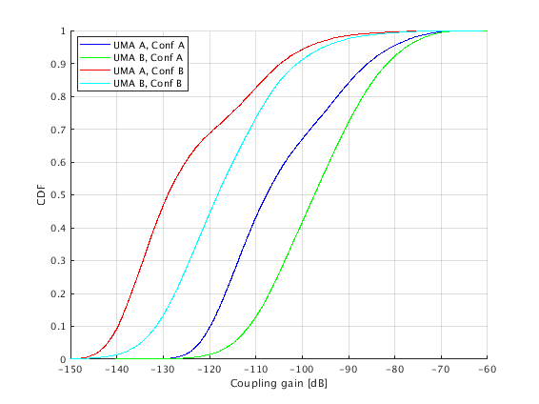

### 7.2.5 Connection density evaluation

The achieved latencies for LTE-M and NB-IoT are presented in Figure 22. The results are reported per cell and per resource block (RB). To translate the x-axis to arrival intensity per km2 the Configuration A results should be scaled by a factor of 1/0.072 and the Configuration B results by a factor of 1/0.866. To get the LTE-M results per narrowband, a scaling factor of 6 should be applied.

LTE-M offers a superior latency performance until the system reaches the point of congestion. This is thanks to its support of higher-order modulation and bandwidths up to 6 physical RBs (PRBs). NB-IoT offers a higher connection density partly thanks to its robust performance under low SINR. in the Annex: it is shown that LTE-M has a higher DL resource utilization than NB-IoT which is believed to be partly due to the use of higher bandwidth to facilitate low latency and high DL coverage. We show that the higher resource utilization leads to higher DL interference levels, which eventually limits the performance of the systems. We show the UL interference statistics for the devices in the worst-case radio conditions. For Configuration B a significant offset between LTE-M and NB-IoT UL interference levels are seen. This is explained by the minimal scheduling unit, which for NB-IoT is one subcarrier while for LTE-M it is 1 PRB. The LTE-M Release 15 feature for sub-PRB allocation is hence not supported in these simulations.

In absolute numbers, the highest connection density is supported by Configuration A. This, since the cell area is 12 times smaller for the 500 m ISD, compared to the 1 732 m ISD in Configuration B. This leads to a densification of the cell grid which, in turn, supports higher access loads.

It should be noted that the reported latency includes the time to synchronize and read the master information block.

Figure 22

LTE-M and NB-IoT service latency at the 99th percentile



In Table 44, the connection density is reported based on the results presented in Figure 22. Given the assumed cell size of 0.07 km2 in Configuration A and 0.86 km2 in Configuration B and the traffic model of 1 message/2 hours/device, the arrival intensity can be translated into the number of supported devices per km2.

Table 44 also presents the needed bandwidth to support the connection density target. In addition to the reported bandwidth, an NB is needed for LTE-M to carry synchronization and master/system information signaling. For NB-IoT, an additional anchor PRB is needed to carry synchronization and master/system information signalling. For completeness, the connection efficiency and spectral efficiency are presented.

Table 44

LTE-M and NB-IoT performance metrics

|  |  |  |  |  |
| --- | --- | --- | --- | --- |
|  | Connection density @ 99 percent GoS  (devices/NB or PRB) | Bandwidth to support 1 000 000 devices per km2  (NB or PRB) | Connection efficiency  (devices/Hz) | Spectral efficiency  (bits/s/Hz) |
| LTE-M: UMa A, Config. A | 6 279 280 devices/NB | 1 NB | 5.81 devices/Hz | 0.21 bits/s/Hz |
| LTE-M: UMa B, Config. A | 6 877 877 devices/NB | 1 NB | 6.37 devices/Hz | 0.23 bits/s/Hz |
| LTE-M: UMa A, Config. B | 320 268 devices /NB | 4 NB | 0.30 devices/Hz | 0.01 bits/s/Hz |
| LTE-M: UMa B, Config. B | 422 035 devices /NB | 3 NB | 0.39 devices/Hz | 0.01 bits/s/Hz |
| NB-IoT: UMa A, Config. A | 1 234 107 devices /1 PRB | 1 PRBs | 6.86 devices/Hz | 0.24 bits/s/Hz |
| NB-IoT: UMa B, Config. A | 1 421 667 devices/1 PRB | 1 PRBs | 7.90 devices/Hz | 0.28 bits/s/Hz |
| NB-IoT: UMa A, Config. B | 69 175 devices/1 PRB | 15 PRBs | 0.38 devices/Hz | 0.01 bits/s/Hz |
| NB-IoT: UMa B, Config. B | 86 303 devices/1 PRB | 12 PRBs | 0.48 devices/Hz | 0.02 bits/s/Hz |

### 7.2.6 Conclusion

This section discussed the IMT-2020 connection density requirement and showed that LTE-M and NB-IoT both fulfil the IMT-2020 connection density requirement. Results were also presented on the corresponding connection efficiencies (# of devices/Hz) and spectral efficiencies (bits/s/Hz), but these are not part of the technical performance requirements.

# 8 Mobility

In this section, we discuss the evaluation of the mobility performance indicator for the self-evaluation of NR for IMT-2020. Table 45 shows minimum requirements for spectra efficiency in each of the IMT-2020 evaluation environments. The residual BLER requirement is below 1%. This contribution is an updated version of R1-1907010.

Table 45

Spectral efficiency requirements in IMT-2020 for Mobility evaluations.

|  |  |  |
| --- | --- | --- |
| Environment | UE Speed | SE [bit/s/Hz] |
| Indoor Hotspot – eMBB | 10 km/h | 1.5 |
| Dense Urban – eMBB | 30 km/h | 1.12 |
| Rural – eMBB | 120 km/h  500km/h | 0.8  0.45 |

## 8.1 Discussion of Evaluation Methods

For the IMT-2020 self-evaluation of NR, the mobility performance indicator will be evaluated for the Indoor Hotspot – eMBB, Dense Urban – eMBB, and Rural – eMBB test environment. The evaluation methodology described by ITU-R in provides a 5-step process for evaluating the mobility in these three environments. A simplified version of these steps follows:

1 Run uplink system simulations using the same configurations used for average and 5th percentile spectral efficiency simulations, but using the appropriate speeds specified for mobility evaluation. From these simulations, obtain the CDF of the uplink SINR.

2 Extract the 50th percentile SINR values from the SINR CDF’s.

3 Run link simulations to obtain the link data rate and residual packet error rates as a function of SINR, covering the 50th percentile values extracted in step 2.

4 Calculate the uplink spectral efficiencies at the 50th percentile SINR values and compare with the requirements.

5 The requirements are met if the calculated uplink spectral efficiency is greater than the requirement and the residual packet error rate is less than 1%.

The evaluation methodology does not specify the exact SINR to use in the connection between the system and link level simulations. The pre-processing SINR was derived and considered to be used for this connection. This contribution also included a CDF for the Rural – eMBB environment at 700 MHz and 120 km/h outdoor users. Link level results were presented to indicate the required SINR’s for Rural – eMBB at 700 MHz and 4GHz for speeds of 120 km/h and 500 km/h, but without the corresponding system-level SINR CDF’s.

The use of the pre-processing SINR as proposed in raises concerns, particularly about its applicability to UL MU-MIMO. Since the link-level simulation simulates a single use, while the pre-processing SINR captures interference from other paired users, it does not take into account the effects of receiver processing of that interference. In addition, the interference seen on DM-RS symbols is different than the interference on data symbols, but the preprocessing SINR treats the interference the same in the link simulation context. Furthermore, use of the pre-processing SINR requires the link simulation to perform link adaptation to set the rank and precoding for the UE being simulated.

***Observation 1:*** Using the pre-processing SINR with MU-MIMO transmission does not properly account for interference experienced with MU-MIMO.

If the post-processing SINR is used in the system level CDF’s, the effect of processed MU-MIMO cross-talk is already included in the SINR. The UE simulated at link level will then use rank 1, assuming the post-processing SINR has been collected per data layer. In addition, the link simulation will be SISO since the effects of the antenna arrays have been taken into account during the system level simulation. The resulting throughput is then scaled by the average number of transmission layers.

For both SINR’s, the effect of the channel model, HARQ, and noise is included in the link simulation.

***Proposal 1:*** Use the post-processing SINR distribution as the interface between the system and link simulations for evaluating the mobility performance.

## 8.2 Results

Using the above methodology, we performed system simulations for the three eMBB test environments using the configurations and the simulation parameters shown in Table 47. The indoor and dense urban simulations were performed at the required UE speeds of 10 km/h and 30 km/h (for outdoor users), respectively. The rural simulations were performed using both 120 km/h and 500 km/h (for outdoor users). The post-processing per layer SINR distributions are shown in Figure 23 through Figure 25 for the three environments. Step 2 above indicates that the 50th percentile SINR is required as input to the link simulations. The extracted 50th percentile SINR values are tabulated in Table 46.

***Observation 2:*** The Indoor Hotspot – eMBB, Dense Urban – eMBB, and Rural – eMBB test environments have post-processing SINR 50th percentile values of 8.65 dB (Indoor, 10 km/h), 6.51 dB (Dense Urban, 30 km/h), 5.58 dB (Rural, 120 km/h), and 3.07 dB (Rural, 500 km/h).

Figure 23

Indoor Hotspot – eMBB post-processing SINR distribution at 10 km/h (4 GHz carrier frequency).

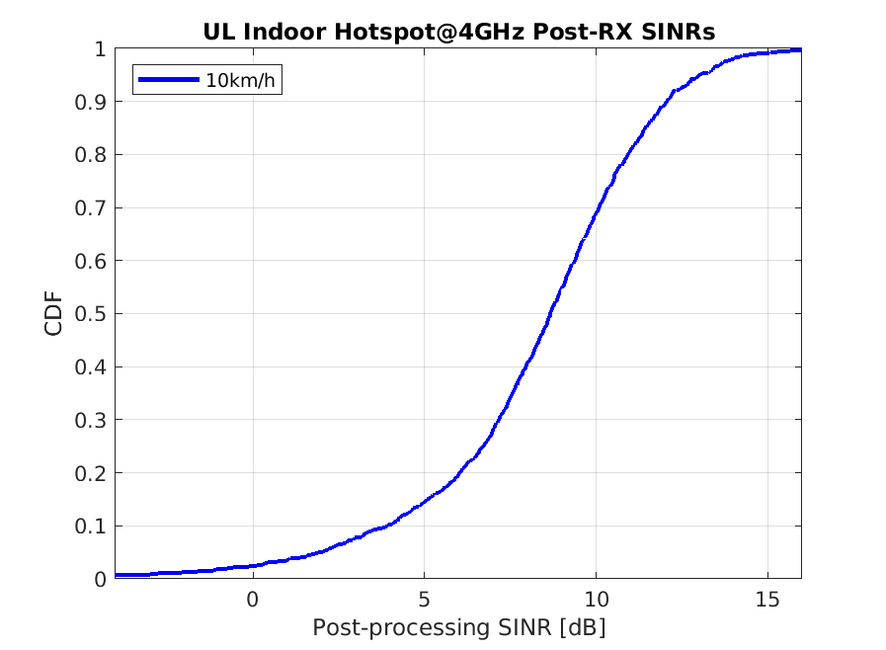

Figure 24

Dense Urban – eMBB post-processing SINR distribution at 30 km/h (4 GHz carrier frequency).

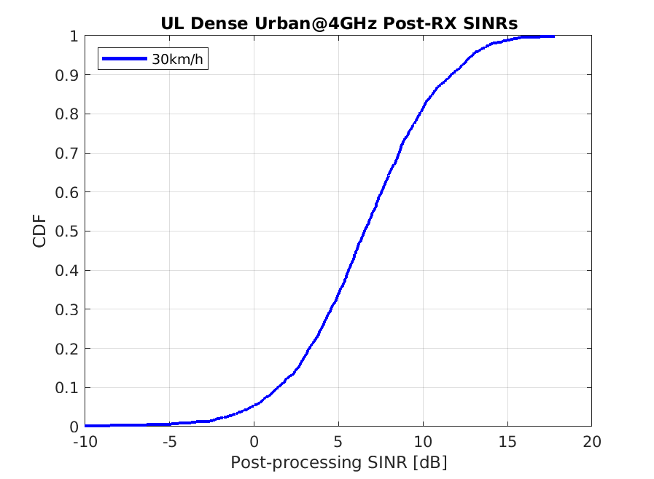

Figure 25

Rural – eMBB post-processing SINR distribution for 700 MHz and 4 GHz carrier frequencies.

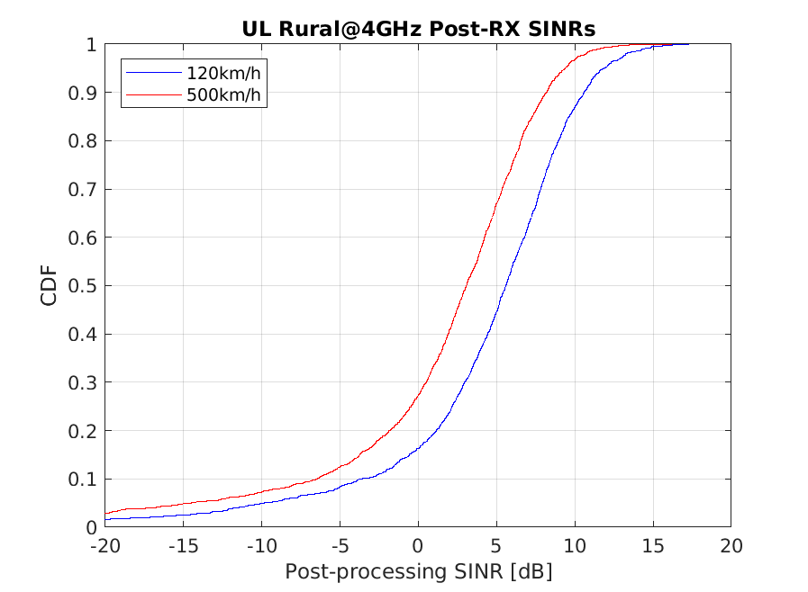

In Step 3 and Step 4, link simulations are performed according to simulation assumptions shown in Table 46. Spectral efficiency (SE) values from link simulations for each scenario are included in Table 45 with the corresponding residual BLER. The link simulations are conducted with the FDD duplex mode. The link spectral efficiency values in the FDD case include two symbols overhead due to DMRS and one symbol additional overhead for control in the Indoor Hotspot-eMBB and Dense Urban-eMBB scenarios. In the Rural-eMBB scenario, it is assumed that two double-symbol DMRSs’ are needed to support MU-MIMO transmission up to 12 layers with high mobility. Furthermore one symbol additional overhead for control is assumed also in the Rural-eMBB scenario. Thus, in the FDD case 11 symbols out of 14 symbols are available for data transmission in the Indoor Hotspot-eMBB and Dense Urban-eMBB scenarios, while 9 symbols out of 14 symbols are available in the Rural-eMBB scenario. Link spectral efficiency values for the TDD case are calculated assuming that only 9 symbols out of 14 symbols are available for data transmission in the Indoor Hotspot-eMBB and Dense Urban-eMBB scenarios, while only 7 symbols out of 14 symbols are available for data transmission in the Rural-eMBB scenario.

In Step 5 we compare Spectral Efficiency values from Table 46 against the Table 45 requirements and we can conclude that NR meets requirements in all evaluated environments, in both FDD and TDD modes. Furthermore it is noted that the residual BLER is well below 1%.

***Proposal 2:*** IMT-2020 requirements for spectral efficiency, and residual BLER are met in both FDD and TDD with the Indoor Hotspot – eMBB, Dense Urban – eMBB, and Rural – eMBB test environments.

Table 46

Extracted 50th Percentile SINR , Link SE, and Residual BLER Values

|  |  |  |  |  |  |
| --- | --- | --- | --- | --- | --- |
| Environment | UE Speed | 50th Percentile SINR | Link SE [bit/s/Hz] | | Residual BLER [%] |
| FDD | TDD |
| Indoor Hotspot – eMBB | 10 km/h | 8.65 dB | 2.18 | 1.78 | < 0.1 |
| Dense Urban – eMBB  (1,4,2) Rx Config | 30 km/h | 6.51 dB | 1.56 | 1.28 | < 0.1 |
| Rural – eMBB | 120 km/h  500km/h | 5.58 dB 3.07 dB | 1.32  0.82 | 1.02  0.64 | < 0.1  < 0.1 |

## 8.3 System Simulation Parameters

Table 47

System Simulation Parameters

| Parameter | Value |
| --- | --- |
| Environments | Indoor Hotspot – eMBB, Configuration A (4GHz), Channel model A, 12 TRxP’s  Dense Urban – eMBB, Configuration A (4GHz), Channel model A  Rural – eMBB, Configuration B (4GHz/1732m), Channel model A  Rural – eMBB, Configuration A (700MHz/1732m), Channel model A |
| System bandwidth | 10MHz |
| Subcarrier spacing | 15kHz |
| Duplex mode | FDD |
| Traffic model | Full buffer |
| UE transmit power | 23 dBm |
| gNB antenna element configuration | (M,N,P) = (8,8,2). (dV,dH) = ( 0.5, 0.5 ) λ, 180° mechanical tilt in GCS  (M,N,P) = (16,8,2), (dV,dH) = ( 0.8, 0.5 ) λ, 90° mechanical tilt in GCS  (M,N,P) = (8,16,2), (dV,dH) = ( 0.8, 0.5 ) λ, 90° mechanical tilt in GCS  (M,N,P) = (8,16,2), (dV,dH) = ( 0.8, 0.5 ) λ, 90° mechanical tilt in GCS  +45°, -45° polarization in all cases |
| gNB antenna virtualization | (M,N,P) = (8,8,2), Electrical tilt = 90° in LCS  (M,N,P) = (2,8,2), Electrical tilt = 100° in LCS  (M,N,P) = (1,16,2), Electrical tilt = 100° in LCS  (M,N,P) = (1,16,2), Electrical tilt = 100° in LCS |
| UE antenna config. | (M,N,P) = (1,2,2), dH = 0.5 λ, 0°, 90° polarization for all environments |
| UE antenna pattern | Omni |
| UL power control | and |
| Receiver | MMSE with channel estimation error and interference modeling. |
| CSI feedback | Codebook-based transmission, CSI feedback period is 10ms, CSI feedback delay is 5 ms |
| MIMO transmission scheme | MU-MIMO with maximum UE rank of 2 and maximum number of paired users is 6 (Rural) or 3 (Indoor, Dense Urban) |
| Scheduler | PF with wideband scheduling |

Table 48

Link Simulation Parameters

| Parameter | Value |
| --- | --- |
| System bandwidth | 10MHz (52RBs with 15kHz, 24RBs with 30kHz) |
| Channel model | Indoor Hotspot - eMBB: TDL-i 39ns, 10 km/h  Dense Urban – eMBB: TDL-iii 363ns, 30 km/h  Rural – eMBB: TDL-v 32ns, 120 km/h  Rural – eMBB: TDL-v 32ns, 500km/h |
| Subcarrier spacing | 30kHz (4GHz) |
| Waveform | CP-OFDMA |
| Duplex mode | FDD |
| gNB antenna element configuration | 1 RX antenna |
| UE antenna config. | 1 TX antenna |
| Channel coder | LDPC |
| Receiver | MMSE with channel estimation error |
| HARQ | max. 4 HARQ transmissions |
| Link adaptation | yes |
| Rank | 1 |
| DMRS | 2 symbols, config. 1 with 3dB power boost, except as noted in the text |
| Additional overhead | 1 symbol |

## 8.4 Conclusions

In this section, we have discussed the evaluation methods to use for evaluating the mobility performance indicator for the IMT-2020 self-evaluation of NR and provided simulation results using the proposed methods. The observations and proposals in this contribution may be summarized as:

***Observation 1:*** Using the pre-processing SINR with MU-MIMO transmission does not properly account for interference experienced with MU-MIMO.

***Proposal 1:*** Use the post-procesing SINR distribution as the interface between the system and link simulations for evaluating the mobility performance.

***Observation 2:*** The Indoor Hotspot – eMBB, Dense Urban – eMBB, and Rural – eMBB test environments have post-processing SINR 50th percentile values of 8.65 dB (Indoor, 10 km/h), 6.51 dB (Dense Urban, 30 km/h), 5.58 dB (Rural, 120 km/h), and 3.07 dB (Rural, 500 km/h).

***Proposal 2:*** IMT-2020 requirements for spectral efficiency and residual BLER are met in FDD and TDD with the Indoor Hotspot – eMBB, Dense Urban – eMBB, and Rural – eMBB test environments.

# 9 TPR (Technical Performance Requirements – General)

*This section evaluates TPR and Other Requirements via inspection of the 3GPP submission to IMT‑2020.*

|  |
| --- |
| ***TPR (General)*** |
| *Bandwidth* |
| *Energy Efficiency* |
| ***Other Requirements*** |
| *Support of wide range of services* |
| *Supported spectrum band(s)/ranges(s)* |

## 9.1 TPR (Technical Performance Requirements - General)

|  |  |  |  |
| --- | --- | --- | --- |
| Reference | Bandwidth | SRIT (NR + LTE) | RIT (NR) |
| From Doc. [5D/1216!P1](https://www.itu.int/md/R15-WP5D-C-1216/en)  Section 5.2.3.2.8.4 | What is the minimum amount of spectrum required to deploy a contiguous network, including guardbands (MHz)? | The NR minimum amount of paired spectrum is 2 x 5 MHz. The minimum amount of unpaired spectrum is 5 MHz.  The LTE minimum amount of paired spectrum is 2 x 1.4 MHz, and the minimum amount of unpaired spectrum is 1.4 MHz, except for NB-IoT.  For NB-IoT, the minimum amount of unpaired spectrum is 0.2 MHz. | The NR minimum amount of paired spectrum is 2 x 5 MHz. The minimum amount of unpaired spectrum is 5 MHz. |
| From Doc. 5D/1216!P1  Section:  5.2.3.2.8.5 | What are the minimum and maximum transmission bandwidth (MHz) measured at the 3 dB down points? | The 3 dB bandwidth is not part of the specifications, however:  The minimum 99% channel bandwidth (occupied bandwidth of single component carrier) is 1.4 MHz.  The maximum 99% channel bandwidth (occupied bandwidth of single component carrier) is 20 MHz.  Multiple component carriers can be aggregated to achieve up to 640 MHz of transmission bandwidth.  For NB-IoT, the 99% channel bandwidth is 0.2 MHz. | The 3 dB bandwidth is not part of the specifications, however:  The minimum 99% channel bandwidth (occupied bandwidth of single component carrier) is  5 MHz for frequency range 450 – 6000 MHz;  50 MHz for frequency range 24250 – 52600 MHz  The maximum 99% channel bandwidth (occupied bandwidth of single component carrier) is  100 MHz for frequency range 450 – 6000 MHz;  400 MHz for frequency range 24250 – 52600 MHz.  Multiple component carriers can be aggregated to achieve up to 6.4 GHz of transmission bandwidth. |
|  | Energy Efficiency | SRIT (NR + LTE) | RIT (NR) |
| *From Doc.* [*5D/1216!P1*](https://www.itu.int/md/R15-WP5D-C-1216/en)  *Section:*  *5.2.3.2.25* | ***From : RP-18Energy Efficiency***  *Describe how the RIT/SRIT supports a high sleep ratio and long sleep duration.*  *Describe other mechanisms of the RIT/SRIT that improve the support of energy efficiency operation for both network and device.* | ***Network***  *In LTE system the capacity boosting cells can be distinguished from cells providing basic coverage. This can be used to enhance network energy efficiency by switching off LTE or EN-DC cells providing additional capacity when its capacity is not needed, and re-activate the cells on a need basis.*  *The eNB owning a capacity booster cell can autonomously decide to switch-off such cell to lower energy consumption (dormant state). The decision is typically based on cell load information, consistently with configured information. The switch-off decision may also be taken by O&M. The eNB may initiate handover actions in order to off-load the cell being switched off and may indicate the reason for handover with an appropriate cause value to support the target node in taking subsequent actions, e.g. when selecting the target cell for subsequent handovers. All peer eNBs are informed by the eNB owning the concerned cell about the switch-off actions over the X2 interface with the eNB Configuration Update procedure. The eNB indicates the switch-off action to a GERAN and/or UTRAN node with the eNB Direct Information Transfer procedure over S1. All informed nodes maintain the cell configuration data, e.g., neighbour relationship configuration, also when a certain cell is dormant. If basic coverage is ensured by E-UTRAN cells, eNBs owning non-capacity boosting cells may request a re-activation over the X2 interface if capacity needs in such cells demand to do so. This is achieved via the Cell Activation procedure. If basic coverage is ensured by UTRAN or GERAN cells, the eNB owning the capacity booster cell may receive a re-activation request from a GERAN or UTRAN node with the MME Direct Information Transfer procedure over S1. The eNB owning the capacity booster cell may also receive from the sending GERAN or UTRAN node the minimum time before that cell switches off; during this time, the same eNB may prevent idle mode UEs from camping on the cell and may prevent incoming handovers to the same cell.*  ***Device***  *Multiple features facilitating device energy efficiency:*   * *Discontinuous reception (DRX) in RRC connected mode* * *Discontinuous reception (DRX) in RRC idle mode* * *Extended Discontinuous reception (DRX) in RRC idle mode* * *Paging with Wake-Up Signal in idle mode* | ***Network***  *The fundamental always-on transmission that must take place is the periodic SS/PBCH block. The SS/PBCK block is used for the UE to detect the cell, obtain basic information of it on PBCH, and maintain synchronization to it. The duration, number and frequency of the SS/PBCH block transmission depends on the network setup. For the purposes of blind initial access the UE may assume that there is an SS/PBCH block once every 20 ms. If the network is configured to transmit the SS/PBCH block less frequently, that will improve the network energy efficiency at the cost of increased the initial cell detection time, but after the initial connection has been established, the UE may be informed of the configured SS/PBCH block periodicity in the cell from set of {5, 10, 20, 40, 80, 160} ms. If the cell set up uses analogue beamformer component, it may provide several SS/PBCH blocks multiplexed in time-domain fashion within one SS/PBCH block period.*  *Remaining minimum system information carried over SIB1 needs to be broadcast at least in the cells in which the UEs are expected to be able to set up the connection to the network. There is no specific rate at which the SIB1 needs to be repeated in the cell, and once the UE acquires the SIB1, it does not need to read it again. SIB1 could be time or frequency multiplexed with the SS/PBCH block. In the frequency multiplexing case, there would be no additional on-time for the gNB transmitter. In the time multiplexing case, having a lower rate for SIB1 than for SS/PBCH block would suffice at least for higher SS/PBCH repetition frequencies.*  *The sleep ratio under the above mechanism is evaluated in 3GPP TR37.910v1.1.0.*  ***Device***  *Multiple features facilitating device energy efficiency :*   * *Discontinuous reception (DRX****)*** *inRRC_CONNECTED, RRC_INACTIVE and RRC_IDLE* * *Bandwidth part (BWP) adaptation* * *RRC_INACTIVE state* * *Frequency-first mapping of data bits to physical resources allows for the channel decoder to operate in a pipelined fashion, starting to decode the data block immediately when the first symbol has been received enabling micro-sleep within slots in which the UE is not scheduled* |

## 9.2 Other Requirements (From: Annex 1 – Modifications to Compliance template for SRIT and NR RIT)

|  |  |  |  |
| --- | --- | --- | --- |
|  | Service Requirements | SRIT (NR + LTE) | RIT (NR) |
| [*5D/1216!P2*](https://www.itu.int/md/R15-WP5D-C-1216/en)  *5.2.4.1.1* | ***Support for wide range of services***  *Is the proposal able to support a range of services across different usage scenarios (eMBB, URLLC, and mMTC)* | *The SRIT supports all three useage scenarios (eMBB, URLLC, and MTC)* | *The RIT supports all three useage scenarios (eMBB, URLLC, and MTC)* |
|  | ***Spectrum Requirements*** | ***SRIT (NR + LTE)*** | ***RIT (NR)*** |
| *5D/1216!P2*  *5.2.4.2.1* | ***Frequency bands identified for IMT***  *Is the proposal able to utilize at least one frequency band identified for IMT in the ITU Radio Regulations?*  *Specify in which band(s) the candidate RIT or candidate SRIT can be deployed.* | *The SRIT supports the IMT bands. (See details in Appendix)*  *Requirements throughout the RF specifications are in many cases defined separately for different frequency ranges (FR). The frequency ranges in which NR and LTE can operate*   |  |  | | --- | --- | | *Frequency range designation* | *Corresponding frequency range* | | *FR1* | *450 MHz – 6000 MHz* |   *The present specification covers FR1 operating bands.* | *The RIT supports the IMT bands. (See details in Appendix)*  *NR supports the IMT band Requirements throughout the RF specifications are in many cases defined separately for different frequency ranges (FR). The frequency ranges in which NR can operate*   |  |  | | --- | --- | | *Frequency range designation* | *Corresponding frequency range* | | *FR1* | *450 MHz – 6000 MHz* | | *FR2* | *24250 MHz – 52600 MHz* |   *The present specification covers FR1 operating bands.* |
| *5D/1216!P2*  *5.2.4.2.2* | ***Higher Frequency range/band(s)***  *Is the proposal able to utilize the higher frequency range/band(s) above 24.25 GHz?*  *Specify in which band(s) the candidate RIT or candidate SRIT can be deployed.*  *NOTE 1 – In the case of the candidate SRIT, at least one of the component RITs need to fulfil this requirement.* | *Requirements throughout the RF specifications are in many cases defined separately for different frequency ranges (FR). The frequency ranges in which NR and LTE can operate*   |  |  | | --- | --- | | *Frequency range designation* | *Corresponding frequency range* | | *FR1* | *450 MHz – 6000 MHz* | | *FR2* | *24250 MHz – 52600 MHz* |   *The present specification covers FR1 operating bands.*  *The SRIT supports bands above 24.25 GHz (See details in Appendix in this document)* | *Requirements throughout the RF specifications are in many cases defined separately for different frequency ranges (FR). The frequency ranges in which NR can operate*   |  |  | | --- | --- | | *Frequency range designation* | *Corresponding frequency range* | | *FR1* | *450 MHz – 6000 MHz* | | *FR2* | *24250 MHz – 52600 MHz* |   *The present specification covers FR1 operating bands.*  *The RIT supports bands above 24.25 GHz. (See details in Appendix in this document)* |

## 9.3 Additional Frequency Bands

|  |  |  |  |  |  |  |  |  |  |  |  |  |  |  |  |  |  |  |  |  |  |  |  |  |  |  |  |  |  |  |  |  |  |  |  |  |  |  |  |  |  |  |  |  |  |  |  |  |  |  |  |  |  |  |  |  |  |  |  |  |  |  |  |  |  |  |  |  |  |  |  |  |  |  |  |  |  |  |  |  |  |  |  |  |  |  |  |  |  |  |  |  |  |  |  |  |  |  |  |  |  |  |  |  |  |  |  |  |  |  |  |  |  |  |  |  |  |  |  |  |  |  |  |  |  |  |  |  |  |  |  |  |  |  |  |  |  |  |  |  |  |  |  |  |  |  |  |  |  |  |  |  |  |  |  |  |  |  |  |  |  |  |  |  |  |  |  |  |  |  |  |  |  |  |  |  |  |  |  |  |  |  |  |  |  |  |  |  |  |  |  |  |  |  |  |  |  |  |  |  |  |  |  |  |  |  |  |  |  |  |  |  |  |  |  |  |  |  |  |  |  |  |  |  |  |  |  |  |  |  |  |  |  |  |  |  |  |  |  |  |  |  |  |  |  |  |  |  |  |  |  |  |  |  |  |  |  |  |  |  |  |  |  |  |  |  |  |  |  |  |  |  |  |  |  |  |  |  |  |  |  |  |  |  |  |  |  |  |  |  |  |  |  |  |  |  |  |  |  |  |  |  |  |  |  |  |  |  |  |  |  |  |  |  |  |  |  |  |  |  |  |  |  |  |  |  |  |  |  |  |  |  |  |  |  |  |  |  |  |  |  |  |  |  |  |  |  |  |  |  |  |  |  |  |  |  |  |  |  |  |  |  |  |  |  |  |  |  |  |  |  |  |  |  |  |  |  |  |  |  |  |  |  |  |  |  |  |  |  |  |  |  |  |  |  |  |  |  |  |  |  |  |  |  |  |  |  |  |  |  |  |  |  |  |  |  |  |  |  |  |  |  |  |  |  |  |  |  |  |  |  |  |  |  |  |  |  |  |  |  |  |  |  |  |  |  |  |  |  |  |  |  |  |  |  |  |  |  |  |  |  |  |  |  |  |  |  |  |  |  |  |  |  |  |  |  |  |  |  |  |  |  |  |  |  |  |  |  |  |  |  |  |  |  |  |  |  |  |  |  |  |  |  |  |  |  |  |  |  |  |  |  |  |  |  |  |  |  |  |  |  |  |  |  |  |  |  |  |  |  |  |  |  |  |  |  |  |  |  |  |  |  |  |  |  |  |  |  |  |  |  |  |  |  |  |  |  |  |  |  |  |  |  |  |  |  |  |  |  |  |  |  |  |  |  |  |  |  |  |  |  |  |  |  |  |  |  |  |  |  |  |  |  |  |  |  |  |  |  |  |  |  |  |  |  |  |  |  |  |  |  |  |  |  |  |  |  |  |  |  |  |  |  |  |  |  |  |  |  |  |  |  |  |  |  |  |  |  |  |  |  |  |  |  |  |  |  |  |  |  |  |  |  |  |  |  |  |  |  |  |  |  |  |  |  |  |  |  |  |  |  |  |  |  |  |  |  |  |  |  |  |  |  |  |  |  |  |  |  |  |  |  |  |  |  |  |  |  |  |  |  |  |  |  |  |  |  |  |  |  |  |  |  |  |  |  |  |  |  |  |  |  |  |  |  |  |  |  |  |  |  |  |  |  |  |  |  |  |  |  |  |  |  |  |  |  |  |  |  |  |  |  |  |  |  |  |  |  |  |  |  |  |  |  |  |  |  |  |  |  |  |  |  |  |  |  |  |  |  |  |  |  |  |  |  |  |  |  |  |  |  |  |  |  |  |  |  |  |  |  |  |  |  |  |  |  |  |  |  |  |  |  |  |  |  |  |  |  |  |  |  |  |  |  |  |  |  |  |  |  |  |  |  |  |  |  |  |  |  |  |  |  |  |  |  |  |  |  |  |  |  |  |  |  |  |  |  |  |  |  |  |  |  |  |  |  |  |  |  |  |  |  |  |  |  |  |  |  |  |  |  |  |  |  |  |  |  |  |  |  |  |  |  |  |  |  |  |  |  |  |  |  |  |  |  |  |  |  |  |  |  |  |  |  |  |  |  |  |  |  |  |  |  |  |  |  |  |  |  |  |  |  |  |  |  |  |  |  |  |  |  |  |  |  |  |  |  |  |  |  |  |  |  |  |  |  |  |  |  |  |  |  |  |  |  |  |  |  |  |  |  |  |  |  |  |  |  |  |  |  |  |  |  |  |  |  |  |  |  |  |  |  |  |  |  |  |  |  |  |  |  |  |
| --- | --- | --- | --- | --- | --- | --- | --- | --- | --- | --- | --- | --- | --- | --- | --- | --- | --- | --- | --- | --- | --- | --- | --- | --- | --- | --- | --- | --- | --- | --- | --- | --- | --- | --- | --- | --- | --- | --- | --- | --- | --- | --- | --- | --- | --- | --- | --- | --- | --- | --- | --- | --- | --- | --- | --- | --- | --- | --- | --- | --- | --- | --- | --- | --- | --- | --- | --- | --- | --- | --- | --- | --- | --- | --- | --- | --- | --- | --- | --- | --- | --- | --- | --- | --- | --- | --- | --- | --- | --- | --- | --- | --- | --- | --- | --- | --- | --- | --- | --- | --- | --- | --- | --- | --- | --- | --- | --- | --- | --- | --- | --- | --- | --- | --- | --- | --- | --- | --- | --- | --- | --- | --- | --- | --- | --- | --- | --- | --- | --- | --- | --- | --- | --- | --- | --- | --- | --- | --- | --- | --- | --- | --- | --- | --- | --- | --- | --- | --- | --- | --- | --- | --- | --- | --- | --- | --- | --- | --- | --- | --- | --- | --- | --- | --- | --- | --- | --- | --- | --- | --- | --- | --- | --- | --- | --- | --- | --- | --- | --- | --- | --- | --- | --- | --- | --- | --- | --- | --- | --- | --- | --- | --- | --- | --- | --- | --- | --- | --- | --- | --- | --- | --- | --- | --- | --- | --- | --- | --- | --- | --- | --- | --- | --- | --- | --- | --- | --- | --- | --- | --- | --- | --- | --- | --- | --- | --- | --- | --- | --- | --- | --- | --- | --- | --- | --- | --- | --- | --- | --- | --- | --- | --- | --- | --- | --- | --- | --- | --- | --- | --- | --- | --- | --- | --- | --- | --- | --- | --- | --- | --- | --- | --- | --- | --- | --- | --- | --- | --- | --- | --- | --- | --- | --- | --- | --- | --- | --- | --- | --- | --- | --- | --- | --- | --- | --- | --- | --- | --- | --- | --- | --- | --- | --- | --- | --- | --- | --- | --- | --- | --- | --- | --- | --- | --- | --- | --- | --- | --- | --- | --- | --- | --- | --- | --- | --- | --- | --- | --- | --- | --- | --- | --- | --- | --- | --- | --- | --- | --- | --- | --- | --- | --- | --- | --- | --- | --- | --- | --- | --- | --- | --- | --- | --- | --- | --- | --- | --- | --- | --- | --- | --- | --- | --- | --- | --- | --- | --- | --- | --- | --- | --- | --- | --- | --- | --- | --- | --- | --- | --- | --- | --- | --- | --- | --- | --- | --- | --- | --- | --- | --- | --- | --- | --- | --- | --- | --- | --- | --- | --- | --- | --- | --- | --- | --- | --- | --- | --- | --- | --- | --- | --- | --- | --- | --- | --- | --- | --- | --- | --- | --- | --- | --- | --- | --- | --- | --- | --- | --- | --- | --- | --- | --- | --- | --- | --- | --- | --- | --- | --- | --- | --- | --- | --- | --- | --- | --- | --- | --- | --- | --- | --- | --- | --- | --- | --- | --- | --- | --- | --- | --- | --- | --- | --- | --- | --- | --- | --- | --- | --- | --- | --- | --- | --- | --- | --- | --- | --- | --- | --- | --- | --- | --- | --- | --- | --- | --- | --- | --- | --- | --- | --- | --- | --- | --- | --- | --- | --- | --- | --- | --- | --- | --- | --- | --- | --- | --- | --- | --- | --- | --- | --- | --- | --- | --- | --- | --- | --- | --- | --- | --- | --- | --- | --- | --- | --- | --- | --- | --- | --- | --- | --- | --- | --- | --- | --- | --- | --- | --- | --- | --- | --- | --- | --- | --- | --- | --- | --- | --- | --- | --- | --- | --- | --- | --- | --- | --- | --- | --- | --- | --- | --- | --- | --- | --- | --- | --- | --- | --- | --- | --- | --- | --- | --- | --- | --- | --- | --- | --- | --- | --- | --- | --- | --- | --- | --- | --- | --- | --- | --- | --- | --- | --- | --- | --- | --- | --- | --- | --- | --- | --- | --- | --- | --- | --- | --- | --- | --- | --- | --- | --- | --- | --- | --- | --- | --- | --- | --- | --- | --- | --- | --- | --- | --- | --- | --- | --- | --- | --- | --- | --- | --- | --- | --- | --- | --- | --- | --- | --- | --- | --- | --- | --- | --- | --- | --- | --- | --- | --- | --- | --- | --- | --- | --- | --- | --- | --- | --- | --- | --- | --- | --- | --- | --- | --- | --- | --- | --- | --- | --- | --- | --- | --- | --- | --- | --- | --- | --- | --- | --- | --- | --- | --- | --- | --- | --- | --- | --- | --- | --- | --- | --- | --- | --- | --- | --- | --- | --- | --- | --- | --- | --- | --- | --- | --- | --- | --- | --- | --- | --- | --- | --- | --- | --- | --- | --- | --- | --- | --- | --- | --- | --- | --- | --- | --- | --- | --- | --- | --- | --- | --- | --- | --- | --- | --- | --- | --- | --- | --- | --- | --- | --- | --- | --- | --- | --- | --- | --- | --- | --- | --- | --- | --- | --- | --- | --- | --- | --- | --- | --- | --- | --- | --- | --- | --- | --- | --- | --- | --- | --- | --- | --- | --- | --- | --- | --- | --- | --- | --- | --- | --- | --- | --- | --- | --- | --- | --- | --- | --- | --- | --- | --- | --- | --- | --- | --- | --- | --- | --- | --- | --- | --- | --- | --- | --- | --- | --- | --- | --- | --- | --- | --- | --- | --- | --- | --- | --- | --- | --- | --- | --- | --- | --- | --- | --- | --- | --- | --- | --- | --- | --- | --- | --- | --- | --- | --- | --- | --- | --- | --- | --- | --- | --- | --- | --- | --- | --- | --- | --- | --- | --- | --- | --- | --- | --- | --- | --- | --- | --- | --- | --- | --- | --- | --- | --- | --- | --- | --- | --- | --- | --- | --- | --- | --- | --- | --- | --- | --- | --- | --- | --- | --- | --- | --- | --- | --- | --- | --- | --- | --- | --- | --- | --- | --- | --- | --- | --- | --- | --- | --- | --- | --- | --- | --- | --- | --- | --- | --- | --- | --- | --- | --- | --- | --- | --- | --- | --- | --- | --- | --- | --- | --- | --- | --- | --- | --- | --- | --- | --- | --- | --- | --- | --- | --- | --- | --- | --- | --- | --- | --- | --- | --- | --- | --- | --- | --- | --- | --- | --- | --- | --- | --- | --- | --- | --- | --- | --- | --- | --- | --- | --- | --- | --- | --- | --- | --- | --- | --- | --- | --- | --- | --- | --- | --- | --- | --- | --- | --- | --- | --- | --- | --- | --- | --- | --- | --- | --- | --- | --- | --- | --- | --- | --- | --- | --- | --- | --- | --- | --- | --- | --- | --- | --- | --- | --- | --- | --- | --- | --- | --- | --- | --- | --- |
| *What are the frequency bands supported by the RIT/SRIT? Please list.*  *For NR component RIT:*  *The following frequency bands will be supported, in accordance with spectrum requirements defined by Report ITU-R M.2411-0. Introduction of other ITU-R IMT identified bands are not precluded in the future. 3GPP technologies are also defined as appropriate to operate in other frequency arrangements and bands.*  *410 – 6000 MHz:*   |  |  |  |  | | --- | --- | --- | --- | | *NR operating band* | *Uplink (UL) operating band BS receive / UE transmit*  *FUL_low – FUL_high* | *Downlink (DL) operating band BS transmit / UE receive*  *FDL_low – FDL_high* | *Duplex Mode* | | *n1* | *1 920 MHz-1 980 MHz* | *2 110 MHz-2 170 MHz* | *FDD* | | *n2* | *1 850 MHz-1 910 MHz* | *1 930 MHz-1 990 MHz* | *FDD* | | *n3* | *1 710 MHz-1 785 MHz* | *1 805 MHz-1 880 MHz* | *FDD* | | *n5* | *824 MHz-849 MHz* | *869 MHz-894 MHz* | *FDD* | | *n7* | *2 500 MHz-2 570 MHz* | *2 620 MHz-2 690 MHz* | *FDD* | | *n8* | *880 MHz-915 MHz* | *925 MHz-960 MHz* | *FDD* | | *n12* | *699 MHz-716 MHz* | *729 MHz-746 MHz* | *FDD* | | *n20* | *832 MHz-862 MHz* | *791 MHz-821 MHz* | *FDD* | | *n25* | *1 850 MHz-1 915 MHz* | *1 930 MHz-1 995 MHz* | *FDD* | | *n28* | *703 MHz-748 MHz* | *758 MHz-803 MHz* | *FDD* | | *n34* | *2 010 MHz-2 025 MHz* | *2 010 MHz-2 025 MHz* | *TDD* | | *n38* | *2 570 MHz-2 620 MHz* | *2 570 MHz-2 620 MHz* | *TDD* | | *n39* | *1 880 MHz-1 920 MHz* | *1 880 MHz-1 920 MHz* | *TDD* | | *n40* | *2 300 MHz-2 400 MHz* | *2 300 MHz-2 400 MHz* | *TDD* | | *n41* | *2 496 MHz-2 690 MHz* | *2 496 MHz-2 690 MHz* | *TDD* | | *n50* | *1 432 MHz-1 517 MHz* | *1 432 MHz-1 517 MHz* | *TDD* | | *n51* | *1 427 MHz-1 432 MHz* | *1 427 MHz-1 432 MHz* | *TDD* | | *n66* | *1 710 MHz-1 780 MHz* | *2 110 MHz-2 200 MHz* | *FDD* | | *n70* | *1 695 MHz-1 710 MHz* | *1 995 MHz-2 020 MHz* | *FDD* | | *n71* | *663 MHz-698 MHz* | *6 17 MHz-652 MHz* | *FDD* | | *n74* | *1427 MHz-1 470 MHz* | *1 475 MHz-1 518 MHz* | *FDD* | | *n75* | *N/A* | *1 432 MHz-1 517 MHz* | *SDL* | | *n76* | *N/A* | *1 427 MHz-1 432 MHz* | *SDL* | | *n77* | *3 300 MHz-4 200 MHz* | *3 300 MHz-4 200 MHz* | *TDD* | | *n78* | *3 300 MHz-3 800 MHz* | *3 300 MHz-3 800 MHz* | *TDD* | | *n79* | *4 400 MHz-5 000 MHz* | *4 400 MHz-5 000 MHz* | *TDD* | | *n80* | *1 710 MHz-1 785 MHz* | *N/A* | *SUL* | | *n81* | *880 MHz-915 MHz* | *N/A* | *SUL* | | *n82* | *832 MHz-862 MHz* | *N/A* | *SUL* | | *n83* | *703 MHz-748 MHz* | *N/A* | *SUL* | | *n84* | *1 920 MHz-1 980 MHz* | *N/A* | *SUL* | | *n86* | *1 710 MHz-1 780 MHz* | *N/A* | *SUL* |   *24 250-52 600 MHz:*   |  |  |  | | --- | --- | --- | | *NR operating band* | *Uplink (UL) and Downlink (DL) operating band BS transmit/receive UE transmit/receive*  *FUL_low – FUL_high*  *FDL_low – FDL_high* | *Duplex Mode* | | *n257* | *26 500 MHz-29500 MHz* | *TDD* | | *n258* | *24 250 MHz-27 500 MHz* | *TDD* | | *n260* | *37 000 MHz-40 000 MHz* | *TDD* | | *n261* | *27 500 MHz-28 350 MHz* | *TDD* |   *Additional frequency bands can be introduced in the future in release independent manner. Support for frequency bands above 52600 MHz is under study, and the support for frequency bands within 6000 MHz to 24250 MHz is planned to be studied.*  *For LTE component RIT:*  *The following frequency bands are currently specified, in accordance with spectrum requirements defined by Report ITU-R M.2411-0. Introduction of other ITU-R IMT identified bands are not precluded in the future. 3GPP technologies are also defined as appropriate to operate in other frequency arrangements and bands. Detailed information on the following bands can be found in 3GPP [36.101] sub-clause 5.5.*  *450-6000 MHz:*   | *LTE (E‑UTRA) Operating Band* | | *Uplink (UL) operating band BS receive UE transmit* | | | | | *Downlink (DL) operating band BS transmit  UE receive* | | | | | *Duplex Mode* | | --- | --- | --- | --- | --- | --- | --- | --- | --- | --- | --- | --- | --- | | *FUL_low – FUL_high* | | | | | *FDL_low – FDL_high* | | | | | | *1* | | *1920 MHz* | | *–* | | *1980 MHz* | *2110 MHz* | | *–* | | *2170 MHz* | *FDD* | | *2* | | *1850 MHz* | | *–* | | *1910 MHz* | *1930 MHz* | | *–* | | *1990 MHz* | *FDD* | | *3* | | *1710 MHz* | | *–* | | *1785 MHz* | *1805 MHz* | | *–* | | *1880 MHz* | *FDD* | | *4* | | *1710 MHz* | | *–* | | *1755 MHz* | *2110 MHz* | | *–* | | *2155 MHz* | *FDD* | | *5* | | *824 MHz* | | *–* | | *849 MHz* | *869 MHz* | | *–* | | *894MHz* | *FDD* | | *61* | | *830 MHz* | | *–* | | *840 MHz* | *875 MHz* | | *–* | | *885 MHz* | *FDD* | | *7* | | *2500 MHz* | | *–* | | *2570 MHz* | *2620 MHz* | | *–* | | *2690 MHz* | *FDD* | | *8* | | *880 MHz* | | *–* | | *915 MHz* | *925 MHz* | | *–* | | *960 MHz* | *FDD* | | *9* | | *1749.9 MHz* | | *–* | | *1784.9 MHz* | *1844.9 MHz* | | *–* | | *1879.9 MHz* | *FDD* | | *10* | | *1710 MHz* | | *–* | | *1770 MHz* | *2110 MHz* | | *–* | | *2170 MHz* | *FDD* | | *11* | | *1427.9 MHz* | | *–* | | *1447.9 MHz* | *1475.9 MHz* | | *–* | | *1495.9 MHz* | *FDD* | | *12* | | *699 MHz* | | *–* | | *716 MHz* | *729 MHz* | | *–* | | *746 MHz* | *FDD* | | *13* | | *777 MHz* | | *–* | | *787 MHz* | *746 MHz* | | *–* | | *756 MHz* | *FDD* | | *14* | | *788 MHz* | | *–* | | *798 MHz* | *758 MHz* | | *–* | | *768 MHz* | *FDD* | | *17* | | *704 MHz* | | *–* | | *716 MHz* | *734 MHz* | | *–* | | *746 MHz* | *FDD* | | *18* | | *815 MHz* | | *–* | | *830 MHz* | *860 MHz* | | *–* | | *875 MHz* | *FDD* | | *19* | | *830 MHz* | | *–* | | *845 MHz* | *875 MHz* | | *–* | | *890 MHz* | *FDD* | | *20* | | *832 MHz* | | *–* | | *862 MHz* | *791 MHz* | | *–* | | *821 MHz* | *FDD* | | *21* | | *1447.9 MHz* | | *–* | | *1462.9 MHz* | *1495.9 MHz* | | *–* | | *1510.9 MHz* | *FDD* | | *22* | | *3410 MHz* | | *–* | | *3490 MHz* | *3510 MHz* | | *–* | | *3590 MHz* | *FDD* | | *231* | | *2000 MHz* | | *–* | | *2020 MHz* | *2180 MHz* | | *–* | | *2200 MHz* | *FDD* | | *24* | | *1626.5 MHz* | | *–* | | *1660.5 MHz* | *1525 MHz* | | *–* | | *1559 MHz* | *FDD* | | *25* | | *1850 MHz* | | *–* | | *1915 MHz* | *1930 MHz* | | *–* | | *1995 MHz* | *FDD* | | *26* | | *814 MHz* | | *–* | | *849 MHz* | *859 MHz* | | *–* | | *894 MHz* | *FDD* | | *27* | | *807 MHz* | | *–* | | *824 MHz* | *852 MHz* | | *–* | | *869 MHz* | *FDD* | | *28* | | *703 MHz* | | *–* | | *748 MHz* | *758 MHz* | | *–* | | *803 MHz* | *FDD* | | *29* | | *N/A* | | | | | *717 MHz* | | *–* | | *728 MHz* | *FDD1* | | *3015* | | *2305 MHz* | | *–* | | *2315 MHz* | *2350 MHz* | | *–* | | *2360 MHz* | *FDD* | | *31* | | *452.5 MHz* | | *–* | | *457.5 MHz* | *462.5 MHz* | | *–* | | *467.5 MHz* | *FDD* | | *32* | |  | | *N/A* | |  | *1452 MHz* | | *–* | | *1496 MHz* | *FDD1* | | *33* | | *1900 MHz* | | *–* | | *1920 MHz* | *1900 MHz* | | *–* | | *1920 MHz* | *TDD* | | *34* | | *2010 MHz* | | *–* | | *2025 MHz* | *2010 MHz* | | *–* | | *2025 MHz* | *TDD* | | *35* | | *1850 MHz* | | *–* | | *1910 MHz* | *1850 MHz* | | *–* | | *1910 MHz* | *TDD* | | *36* | | *1930 MHz* | | *–* | | *1990 MHz* | *1930 MHz* | | *–* | | *1990 MHz* | *TDD* | | *37* | | *1910 MHz* | | *–* | | *1930 MHz* | *1910 MHz* | | *–* | | *1930 MHz* | *TDD* | | *38* | | *2570 MHz* | | *–* | | *2620 MHz* | *2570 MHz* | | *–* | | *2620 MHz* | *TDD* | | *39* | | *1880 MHz* | | *–* | | *1920 MHz* | *1880 MHz* | | *–* | | *1920 MHz* | *TDD* | | *40* | | *2300 MHz* | | *–* | | *2400 MHz* | *2300 MHz* | | *–* | | *2400 MHz* | *TDD* | | *41* | | *2496 MHz* | |  | | *2690 MHz* | *2496 MHz* | |  | | *2690 MHz* | *TDD* | | *42* | | *3400 MHz* | | *–* | | *3600 MHz* | *3400 MHz* | | *–* | | *3600 MHz* | *TDD* | | *43* | | *3600 MHz* | | *–* | | *3800 MHz* | *3600 MHz* | | *–* | | *3800 MHz* | *TDD* | | *44* | | *703 MHz* | | *–* | | *803 MHz* | *703 MHz* | | *–* | | *803 MHz* | *TDD* | | *45* | | *1447 MHz* | | *–* | | *1467 MHz* | *1447 MHz* | | *–* | | *1467 MHz* | *TDD* | | *46* | | *5150 MHz* | | *–* | | *5925 MHz* | *5150 MHz* | | *–* | | *5925 MHz* | *TDD1* | | *47* | | *5855 MHz* | | *–* | | *5925 MHz* | *5855 MHz* | | *–* | | *5925 MHz* | *TDD1* | | *48* | | *3550 MHz* | | *–* | | *3700 MHz* | *3550 MHz* | | *–* | | *3700 MHz* | *TDD* | | *49* | | *3550 MHz* | | *–* | | *3700 MHz* | *3550 MHz* | | *–* | | *3700 MHz* | *TDD1* | | *50* | | *1432 MHz* | | *-* | | *1517 MHz* | *1432 MHz* | | *-* | | *1517 MHz* | *TDD1* | | *51* | | *1427 MHz* | | *-* | | *1432 MHz* | *1427 MHz* | | *-* | | *1432 MHz* | *TDD1* | | *52* | | *3300 MHz* | | *-* | | *3400 MHz* | *3300 MHz* | | *-* | | *3400 MHz* | *TDD* | | *65* | *1920 MHz* | | *–* | | *2010 MHz* | | *2110 MHz* | *–* | | *2200 MHz* | | *FDD* | | *66* | *1710 MHz* | | *–* | | *1780 MHz* | | *2110 MHz* | *–* | | *2200 MHz* | | *FDD1* | | *67* |  | | *N/A* | |  | | *738 MHz* | *–* | | *758 MHz* | | *FDD1* | | *68* | *698 MHz* | | *–* | | *728 MHz* | | *753 MHz* | *–* | | *783 MHz* | | *FDD* | | *69* | *N/A* | | | | | | *2570 MHz* | *–* | | *2620 MHz* | | *FDD1* | | *70* | *1695 MHz* | | *–* | | *1710 MHz* | | *1995 MHz* | *–* | | *2020 MHz* | | *FDD1* | | *71* | *663 MHz* | | *–* | | *698 MHz* | | *617 MHz* | *–* | | *652 MHz* | | *FDD* | | *72* | *451 MHz* | | *–* | | *456 MHz* | | *461 MHz* | *–* | | *466 MHz* | | *FDD* | | *73* | *450 MHz* | | *–* | | *455 MHz* | | *460 MHz* | *–* | | *465 MHz* | | *FDD* | | *74* | *1427 MHz* | | *–* | | *1470 MHz* | | *1475 MHz* | *–* | | *1518 MHz* | | *FDD* | | *75* |  | | *N/A* | |  | | *1432 MHz* | *–* | | *1517 MHz* | | *FDD1* | | *76* |  | | *N/A* | |  | | *1427 MHz* | *–* | | *1432 MHz* | | *FDD1* | | *85* | *698 MHz* | | *–* | | *716 MHz* | | *728 MHz* | *–* | | *746 MHz* | | *FDD* | | *NOTE 1: See details in Table 8.2.2-1 in 3GPP TS 36.101.* | | | | | | | | | | | | |   For NB IoT, Category NB1 and NB2 are designed to operate in the E-UTRA operating bands 1, 2, 3, 4, 5, 7, 8, 11, 12, 13, 14, 17, 18, 19, 20, 21, 25, 26, 28, 31, 41, 42, 43, 65, 66, 70, 71, 72, 73, and 74 in the above table. See more details in 3GPP [36.101] sub clause 5.5F.  For eMTC, UE category M1 and M2 is designed to operate in bands 1, 2, 3, 4, 5, 7, 8, 11, 12, 13, 14, 18, 19, 20, 21, 25, 26, 27, 28, 31, 66, 71, 72, 73, and 74 in the above table. See more details in 3GPP [36.101] sub clause 5.5E  *For V2X communication, the bands can be found in 3GPP [36.101] sub-clause 5.5G.* |

## 9.4 Energy Efficiency (NR)

Energy efficiency, as pointed out in [2], for both network and device, is verified by inspection by demonstrating that the candidate RITs/SRITs can support high sleep ratio and long sleep duration as defined in [1], when there is no user-plane data being transmitted over the network.

Inspection can also be used to describe other mechanisms of the candidate RITs/SRITs that improve energy efficient operations for both network and device.

### 9.4.1 Power model

Figure 26 depicts the behaviour of the power consumption of a radio base-station as a function of the RF output power. This simple model is surprisingly accurate given proper parameterization and was used extensively in the European EARTH project when evaluating network power consumption.

Figure 26

Principle of the power model used in this evaluation

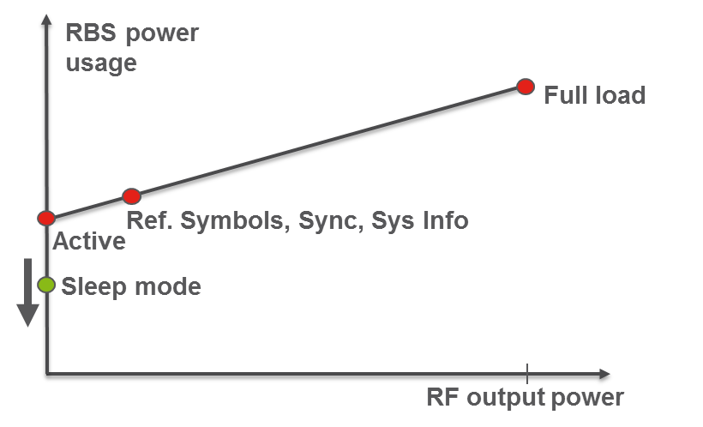

This evaluation employs the power model shown in Figure 27 for base-stations of type 2 × 2 macro, 4 × 4 macro, pico, femto, and LSAS (large scale antenna system). The model defines 4 sleep modes with activation times of, respectively, 71.4 µs (1 OFDM symbol in 15 kHz numerology), 1 ms, 10 ms, and 1 second. Note that the macro power models (2x2 macro and 4x4 macro) provide power consumption numbers per sector and in this evaluation, it is assumed that each macro base-station consist of 3 sectors, while the pico, femto, and LSAS base-stations each consist of 1 sector only. The LSAS (large scale antenna system) power model corresponds to a massive-MIMO base-station with a single antenna panel composed of 200 antenna elements having a total maximum RF transmission power of 41 dBm.

It should be noted that the macro base-station power models use large power amplifiers that dominate their power consumption, whereas for the low power base-stations (pico/femto), the baseband processing components utilise the largest fraction of power consumed. For small cells, discontinuous *reception* (DRX)[5] and de-activation of baseband processors will also have a significant impact on the power consumption. When coupled with discontinuous *transmission* (DTX), the relative gain can be expected to be larger for macro base-stations.

Figure 27

Power models including sleep states for different base-station types

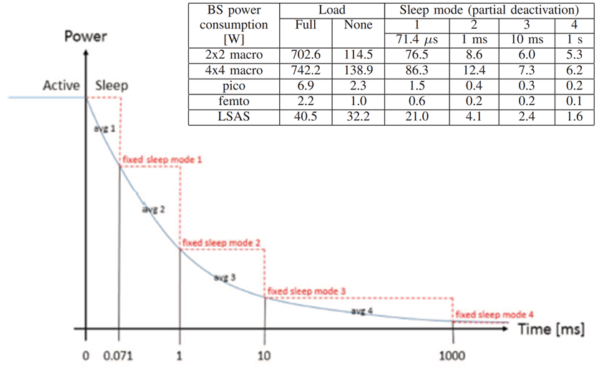

An examination of the relative numbers in the power model is depicted in Figure 28. Note that for the macro models (macro 2 × 2 and macro 4 × 4), the difference between the P0 and Sleep 1 is relatively small and that the largest benefits from sleep duration are obtained in the Sleep 2 state. Additional gains by going to deeper sleep (Sleep 3 and Sleep 4) states are relatively minor for the macro power models.

Figure 28

An examination of the relative numbers in the power model

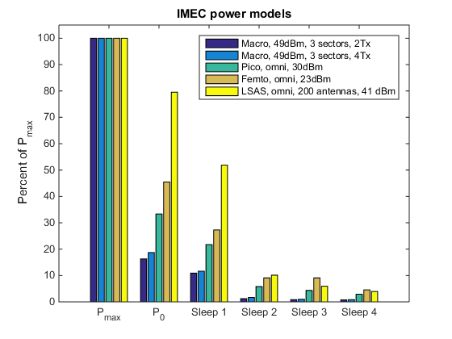

### 9.4.2 LTE idle-mode reference case

The EARTH project defined an energy efficiency evaluation framework (E3F) for radio networks consisting of base-station power models, traffic models, and deployment models. Whilst using that model, it was discovered that the traffic had a very minor impact on the network energy consumption, being of the order of a lower single digit percentage range.

The idle-mode signals that need to be transmitted from an LTE cell are depicted in Figure 29. All sub-frames contain CRS transmissions. Sub-frame 0 contains the PSS, SSS, and PBCH in addition. System information is assumed to be transmitted in sub-frame 5.

Figure 29

The instantaneous load of the power amplifier (PA) in an “empty” LTE radio frame (i.e. a radio frame with no user plane data)

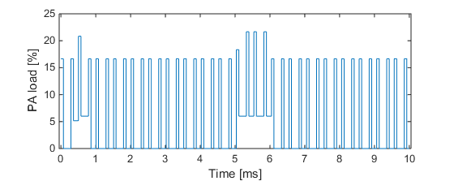

With the load profile from Figure 30 one of the power models depicted in Figure 26 can be applied. Using the macro 2 × 2 power model, the instantaneous power consumption profile for an empty LTE cell, as depicted in Figure 29, is obtained.

Figure 30

Instantaneous power consumption of a 3-sector “macro 2 × 2” base-station using the power model depicted in Figure 26

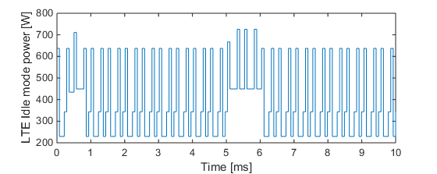

In Figure 30, the power consumption peaks reach 725 W. One symbol before each transmission, the base-station needs to become active (consuming 3 x 114.5 = 343.5 W, see Figure 26). The base-station is able to sleep for a few of the OFDM symbols, but it can only reach “sleep mode 1” where the consumption is 3 × 76.5 = 229.5 W. The average power consumption in an “empty” radio frame (with no user-plane data transmissions) is approximately 400 W when using the macro 2 × 2 power model in Figure 29.

### 9.4.3 DTX duration and DTX ratio comparison between LTE and NR

DTX is the time duration when the base-station is not transmitting any RF power. As a simple example, consider two base-stations with the same DTX ratio of 50%. The first base-station is transmitting every even symbol and is in DTX every odd OFDM symbol (i.e. transmitting according to a pattern [1 0 1 0 1 0 1 0 1 0]). The second base-station is transmitting for 5 consecutive OFDM symbols and is then in DTX for 5 consecutive OFDM symbols (i.e. transmitting according to the pattern [1 1 1 1 1 0 0 0 0 0]). The longer DTX duration (5 versus 1) of the latter base-station) and the power models used accordingly lead to the expectation that the second base-station consumes less energy.

The power consumption benefits of NR compared to LTE are significant. The long periods of DTX that NR enables in the base-station mean that the hardware components can be put into very low-power consuming sleep states in between the mandatory transmissions. NR supports SSB transmissions as seldom as every 20 ms for stand-alone operation. The corresponding DTX time for LTE (which is the time in between consecutive CRSs) is approximately 0.2 ms. The DTX duration of NR is thus approximately 100 times longer than that of LTE.

In addition to DTX duration, NR also supports significantly better DTX ratios. While an LTE base-station needs to be active and transmits approximately 50% of the time in idle-mode (see Figure 29), the corresponding number for NR is significantly lower. The exact value depends on the number of SSBs and the sub-carrier spacing. With 1 SSB every 20 ms and 15 kHz SCS, the DTX ratio of NR becomes approximately 1.7%, which is approximately 30 times lower than for LTE.

### 9.4.4 NR idle-mode power consumption

The idle-mode power consumption for NR depends on the number of SSBs that are used, the sub-carrier spacing, etc. In order to perform a reasonably fair comparison, the same sub-carrier spacing for NR as for the LTE reference case, i.e. 15 kHz, is selected.

An optimized network energy consumption configuration is to operate NR with a single wide-beam transmitted SSB. A further assumption is that the system information transmission can occur in the same symbols as the SSB, using frequency multiplexing. The final assumption is that the power consumption required to transmit the SSB and the system information corresponds to 25% of the total base-station power.

In Figure 30, the instantaneous power consumption in the base-station when applying the “macro 2x2” power model defined above, can be seen. The SSB periodicity used in this example is 20 ms. The NR base-station can enter both sleep mode 3 (with an activation delay of 10 ms) and sleep mode 2 (with a 1 ms activation delay). The peak power consumption is higher for NR than for LTE (approximately 785 W in Figure 29) but the average power is significantly lower (approximately 45 W) due to the long sleep modes that are accessible for NR.

Comparing the peak power for LTE (Figure 29) and NR (Figure 31) it should be noted that the peak consumption for NR is higher. This is because for NR, the system information is transmitted at the same time as the SSB (frequency multiplexed), while for LTE the system information is not transmitted at the same time as the corresponding LTE signals (i.e. system information transmission in LTE is time-multiplexed with PSS/SSS/PBCH). For this reason, the transmission power when actually transmitting is slightly higher for NR compared to LTE.

Figure 31

Instantaneous power consumption for NR with a 1 SSB configuration, 20 ms SSB periodicity using the power model “macro 2 × 2”

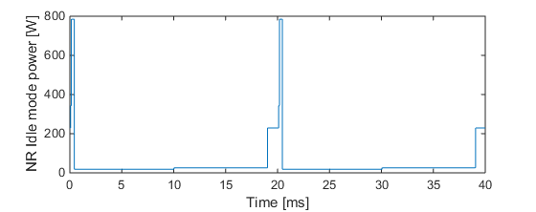

Figure 32 depicts the average power consumption for NR for all different power models and for the relevant SSB periodicities supported in the NR standard (5, 10, 20 40, 80, and 160 ms). As a reference, note that the corresponding LTE power consumption models are {401, 461, 2.2692, 0.92, 28.7} W for the base-stations {macro 2 × 2, macro 4 × 4, pico, femto, LSAS} respectively.

Figure 32

Average idle power consumption for NR when applying the power models in Figure 26 as function of the SSB periodicity

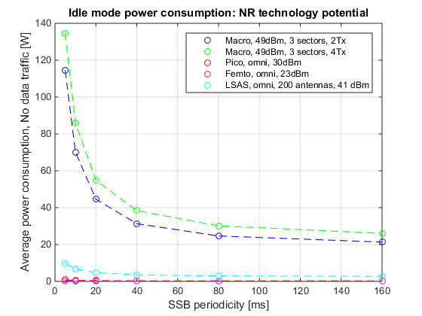

Figure 33 shows the power consumption gain of NR compared to LTE expressed as Paverage,LTE / Paverage,NR. Note that for 20 ms SSB periodicity and using the macro 2 × 2 power model, NR is capable of operating at 9 times lower average power consumption than LTE. The LSAS power model result is a factor of 6 times lower power consumption for NR than LTE for an SSB periodicity of 20 ms and more than 10 times lower for an SSB periodicity of 160 ms.

Figure 33

Power consumption gain with NR versus LTE for different power consumption models and SS Block periodicities

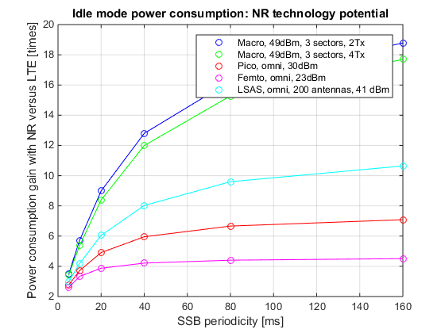

In addition to extended sleep time and sleep ratio, there are additional benefits from NR that are not addressed here. In LTE, the CRS transmissions cover the whole system bandwidth and they are always transmitted from all antenna ports (up to 4 ports) with which the base-station is equipped. The SSB and system information transmissions in NR are only defined for one antenna port covering a limited part of the overall system bandwidth, which makes it possible to adapt both the bandwidth as well as the number of active antenna ports in NR in a more flexible and energy efficient way. These potential additional benefits are not considered in this assessment.

### 9.4.5 Conclusion

LTE networks are dominated by idle-mode power consumption. NR supports significantly longer network DTX durations. We conclude that longer DTX durations lead to lower idle-mode power consumption as well. An example of LSAS base-stations was provided, its power consumption shown to be lower by a factor of 6 times when using NR (as compared to LTE), assuming 20 ms SSB periodicity, increasing to a factor of 10 times for larger SSB periodicities. A further example of 2x2 macro base-stations was provided where the energy savings with NR was even greater – 9 times in a stand-alone case (20 ms SSB periodicity) and 19 times in a non-stand-alone case (160 ms SSB periodicity).

The energy savings enabled by NR could help reduce the carbon footprints of cellular networks. Other benefits include smaller-sized backup batteries, reduced heat dissipation and off-grid areas where base-stations are powered on-site (by solar panels, for example).

# 10 Link Budget Analysis

This section provides the link budget analysis of the 3GPP SRIT and RIT. Templates corresponding to Channel Model A and B respectively are provided separately.

The 3GPP SRIT submission has the LTE, eMTC, and NB-IoT complementary RITs for NR. The 3GPP RIT submission has NR RIT covering all the required test environments. The following link budget analysis covers both 3GPP submissions.

One of the main development targets of the 3GPP based NR technology was to match or exceed the link budget of IMT-Advanced technologies, with the new spectral efficiencies’ requirements. As part of the ATIS Evaluation Group study, the calculations provided by 3GPP have been verified to determine whether the IMT-2020 targets would be met by the NR technology. Verification of the mMTC and NB-IoT have been performed as well as part of the 3GPP SRIT submission with their particular requirements.

Inspection of the link budget template tables provided by 3GPP clearly shows that they are well prepared, cover the considered deployment scenarios and are appropriate for link budget evaluation. Further, it has been verified that all setup parameters for the deployment scenarios under consideration are within the ranges suggested by the ITU-R WP5D in the M.2411 and M.2412 documents.

Focus of the verification efforts was centred on deriving the shadow fading margins, penetration margins and data rate to signal to interference (SINR) mapping. For both considered channel models (Channel Model A and B), the theoretical derivation and numerical calculations, confirm that the shadowing margins, coverage areas and receiver sensitivity points all either match or are sufficiently close in value to what has been provided by 3GPP. Furthermore, in the instances where a small difference was observed the 3GPP was found to have utilized more conservative values.

The analysis is a summary of the results presented by contributing companies at the ATIS meetings.

Shadow fading margin (SFM) derivation methodology

For each of the deployment scenarios under consideration the cell area coverage for a single omnidirectional site has been considered to substantially reduce the complexity of the problem.

Starting with the following cell area coverage probability integral

= (1)

where the probability of coverage at a distance *r* from the site with the pathloss can be expressed as:

(2)

after substituting and resolving the integral, the cell coverage probability becomes:

(3)

where:

***Q-function*** is the tail distribution function of the standard normal distribution.

In all eMBB and URLLC deployment scenarios, the cell coverage probability of 90% and 95% have been considered for data and control channels, respectively.

For the mMTC deployment scenarios, 99% cell area coverage was considered for both data and control channels.

Using the above cell coverage area coverage probability functional points along with the pathloss equations for Channel Model A and B, the SFM was derived as a function of the pathloss exponent and shadow fading margin.

Shadow Fading Standard Deviation considerations:

The eMBB and URLLC deployment scenarios were considered to be the most challenging cases, particularly the NLOS, NLOS-Outdoor-Indoor and NLOS In-Car scenarios, with = 5, and the outdoor σ having a different value.

Since there is only a single σ value that can be inserted into the calculation equation, scenarios with two independent standard deviations combined them using the following rule:

σ = (4)

For NLOS cases of eMBB and URLLC:

a =

b =

and for NLOS-O-I cases:

a =

b =

For Channel Model A, where an explicit value is not defined, the is derived and approximated using a generic uniform distribution of a variable into an interval (a, b), U (a, b), with the following characteristics:

The median u is defined as follows

u = (a + b)/2 (5)

while the standard deviation σ is derived as follows:

= (6)

The pathloss exponent it is determined by the applicable pathloss equations found in the Report ITU-R M.2412 document along with the rest of the used shadow fading margin σ for each specific scenario.

The summary of the results for SFM values are presented in the following tables for each Channel Model. They all fall well within the values from 3GPP self-evaluation template.

|  |  |  |  |  |  |  |  |  |  |  |
| --- | --- | --- | --- | --- | --- | --- | --- | --- | --- | --- |
|  | SFM eMBB - Channel Model A | | | | | | | | | |
| Scenario | InH (4GHz) | | DU (4GHz) | | | | Rural(700MHz) | | | |
| Results  origin | **3GPP** | **ATIS** | **3GPP** | | **ATIS** | | **3GPP** | | **ATIS** | |
| Control Channel  SFM  (95%) | 2.80 | 2.84 | NLOS | NLOS O-I | NLOS | NLOS O-I | NLOS | NLOS O-I | NLOS | NLOS O-I |
| 8.07 | 6.95 | 8.12 | 6.97 | 10.45 | 8.45 | 10.01 | 8.24 |
| Data Channel  SFM (90%) | O.91 | 0.94 | NLOS | NLOS O-I | NLOS | NLOS O-I | NLOS | NLOS O-I | NLOS | NLOS O-I |
| 4.85 | 4.03 | 4.89 | 4.04 | 6.61 | 5.13 | 6.24 | 4.86 |

|  |  |  |  |  |  |  |  |  |  |  |
| --- | --- | --- | --- | --- | --- | --- | --- | --- | --- | --- |
|  | SFM eMBB - Channel Model B | | | | | | | | | |
| Scenario | InH (4GHz) | | DU (4GHz) | | | | Rural(700MHz) | | | |
| Results  origin | **3GPP** | **ATIS** | **3GPP** | | **ATIS** | | **3GPP** | | **ATIS** | |
| Control Channel  SFM  (95%) | 8.50 | 8.49 | NLOS | NLOS O-I | NLOS | NLOS O-I | NLOS | NLOS O-I | NLOS | NLOS O-I |
| 8.07 | 9.04 | 8.12 | 9.59 | 10.45 | 10 | 10.01 | 9.66 |
| Data Channel  SFM  (90%) | 5.20 | 5.20 | NLOS | NLOS O-I | NLOS | NLOS O-I | NLOS | NLOS O-I | NLOS | NLOS O-I |
| 4.85 | 5.60 | 4.89 | 5.99 | 6.61 | 6.30 | 6.24 | 5.92 |

|  |  |  |  |  |
| --- | --- | --- | --- | --- |
|  | SFM URLLC - Channel Model B | | | |
| Scenario | UMa (700MHz) | | | |
| Results  origin | **3GPP** | | **ATIS** | |
| Control Channel  SFM  (95%) | NLOS | NLOS O-I | NLOS | NLOS O-I |
| 8.11 | 8.30 | 8.12 | 7.59 |
| Data Channel  SFM  (90%) | NLOS | NLOS O-I | NLOS | NLOS O-I |
| 4.89 | 5.10 | 4.89 | 4.50 |

|  |  |  |  |  |
| --- | --- | --- | --- | --- |
|  | SFM URLLC - Channel Model A | | | |
| Scenario | UMa (700MHz) | | | |
| Results  origin | **3GPP** | | **ATIS** | |
| Control Channel  SFM  (95%) | NLOS | NLOS O-I | NLOS | NLOS O-I |
| 8.11 | 7 | 8.12 | 7.28 |
| Data Channel  SFM  (90%) | NLOS | NLOS O-I | NLOS | NLOS O-I |
| 4.89 | 4.08 | 4.89 | 4.15 |

|  |  |  |  |  |  |  |  |  |  |  |  |  |
| --- | --- | --- | --- | --- | --- | --- | --- | --- | --- | --- | --- | --- |
|  | SFM mMTC - Channel Model A | | | | | | | | | | | |
| Scenario | UMa NB-IoT (700MHz) | | | | | | UMa eMTC (700MHz) | | | | | |
| Results  origin | **3GPP** | | | **ATIS** | | | **3GPP** | | | **ATIS** | | |
| Control Channel  SFM  (99%) | LOS | NLOS | NLOS O-I | LOS | NLOS | NLOS O-I | LOS | NLOS | NLOS O-I | LOS | NLOS | NLOS O-I |
| 6.30 | 10.26 | 12.22 | 6.24 | 10.26 | 12.32 | 6.30 | 10.26 | 12.22 | 6.24 | 10.26 | 12.32 |
| Data Channel  SFM  (99%) | LOS | NLOS | NLOS O-I | LOS | NLOS | NLOS O-I | LOS | NLOS | NLOS O-I | LOS | NLOS | NLOS O-I |
| 6.30 | 10.26 | 12.22 | 6.24 | 10.26 | 12.32 | 6.30 | 10.26 | 12.22 | 6.24 | 10.26 | 12.32 |

|  |  |  |  |  |  |  |  |  |  |  |  |  |
| --- | --- | --- | --- | --- | --- | --- | --- | --- | --- | --- | --- | --- |
|  | SFM mMTC - Channel Model B | | | | | | | | | | | |
| Scenario | UMa NB-IoT (700MHz) | | | | | | UMa eMTC (700MHz) | | | | | |
| Results  origin | **3GPP** | | | **ATIS** | | | **3GPP** | | | **ATIS** | | |
| Control Channel  SFM (99%) | LOS | NLOS | NLOS O-I | LOS | NLOS | NLOS O-I | LOS | NLOS | NLOS O-I | LOS | NLOS | NLOS O-I |
| 6.3 | 10.26 | 17 | 6.24 | 10.26 | 16.18 | 6.3 | 10.26 | 17 | 6.24 | 10.26 | 16.18 |
| Data Channel  SFM (99%) | LOS | NLOS | NLOS O-I | LOS | NLOS | NLOS O-I | LOS | NLOS | NLOS O-I | LOS | NLOS | NLOS O-I |
| 6.3 | 10.26 | 17 | 6.24 | 10.26 | 16.18 | 6.3 | 10.26 | 17 | 6.24 | 10.26 | 16.18 |

Penetration Margin derivation

The penetration margin calculations were performed using the instructions and information from Report ITU-R M.2412 for both Channel Model A and B. On the other hand, the car penetration part utilized a conducted study on LTE mobiles mounted on various car models that verified the values agreed on for NLOS eMBB scenarios.

Also, for mMTC scenarios the high loss equations for building penetration loss were used due to the 99% cell area coverage requirement which is considered to be the most conservative case.

The tables below detail and compare the derived penetration loss values for all scenarios with 3GPP derived values. All derived values are within a 1dB range or less.

|  |  |  |  |  |  |  |  |  |  |  |
| --- | --- | --- | --- | --- | --- | --- | --- | --- | --- | --- |
|  | Penetration Margin eMBB - Channel Model A | | | | | | | | | |
| Scenario | InH (4GHz) | | DU (4GHz) | | | | Rural(700MHz) | | | |
| Results  origin | **3GPP** | **ATIS** | **3GPP** | | **ATIS** | | **3GPP** | | **ATIS** | |
| Penetration  Margin | 0 | 0 | NLOS | NLOS O-I | NLOS | NLOS O-I | NLOS | NLOS O-I | NLOS | NLOS O-I |
| 9 | 26.25 | 9 | 26.25 | 9 | 12.5 | 9 | 12.5 |

|  |  |  |  |  |  |  |  |  |  |  |
| --- | --- | --- | --- | --- | --- | --- | --- | --- | --- | --- |
|  | Penetration Margin eMBB - Channel Model B | | | | | | | | | |
| Scenario | InH (4GHz) | | DU (4GHz) | | | | Rural(700MHz) | | | |
| Results  origin | **3GPP** | **ATIS** | **3GPP** | | **ATIS** | | **3GPP** | | **ATIS** | |
| Penetration  Margin | 0 | 0 | NLOS | NLOS O-I | NLOS | NLOS O-I | NLOS | NLOS O-I | NLOS | NLOS O-I |
| 9 | 17.98 | 9 | 17.98 | 9 | 11.90 | 9 | 11.96 |

|  |  |  |  |  |
| --- | --- | --- | --- | --- |
|  | Penetration Margin  URLLC - Channel Model A | | | |
| Scenario | **UMa (700MHz)** | | | |
| Results  origin | **3GPP** | | **ATIS** | |
| Penetration  Margin | NLOS | NLOS O-I | NLOS | NLOS O-I |
| 9 | 26.25 | 9 | 26.25 |

|  |  |  |  |  |
| --- | --- | --- | --- | --- |
|  | Penetration Margin  URLLC - Channel Model B | | | |
| Scenario | UMa (700MHz) | | | |
| Results  origin | **3GPP** | | **ATIS** | |
| Penetration  Margin | NLOS | NLOS O-I | NLOS | NLOS O-I |
| 9 | 14.41 | 9 | 14.46 |

|  |  |  |  |  |  |  |  |  |  |  |  |  |
| --- | --- | --- | --- | --- | --- | --- | --- | --- | --- | --- | --- | --- |
|  | Penetration Margin mMTC - Channel Model A | | | | | | | | | | | |
| Scenario | UMa NB-IoT (700MHz) | | | | | | UMa eMTC (700MHz) | | | | | |
| Results  origin | **3GPP** | | | **ATIS** | | | **3GPP** | | | **ATIS** | | |
| Penetration  Margin | LOS | NLOS | NLOS O-I | LOS | NLOS | NLOS O-I | LOS | NLOS | NLOS O-I | LOS | NLOS | NLOS O-I |
| 0 | 0 | 26.25 | 0 | 0 | 26.25 | 0 | 0 | 26.25 | 0 | 0 | 26.25 |

|  |  |  |  |  |  |  |  |  |  |  |  |  |
| --- | --- | --- | --- | --- | --- | --- | --- | --- | --- | --- | --- | --- |
|  | Penetration Margin mMTC - Channel Model B | | | | | | | | | | | |
| Scenario | UMa NB-IoT (700MHz) | | | | | | UMa eMTC (700MHz) | | | | | |
| Results  origin | **3GPP** | | | **ATIS** | | | **3GPP** | | | **ATIS** | | |
| Penetration  Margin | LOS | NLOS | NLOS O-I | LOS | NLOS | NLOS O-I | LOS | NLOS | NLOS O-I | LOS | NLOS | NLOS O-I |
| 0 | 0 | 21.92 | 0 | 0 | 22.01 | 0 | 0 | 21.92 | 0 | 0 | 22.01 |

SNR verification

SNR verification was done using link level simulations. The methodology used was based on maintaining the same spectrum efficiency from 3GPP self-evaluation templates and computing the equivalent channel overhead for each specified bandwidth. The number of antennas and all other RF characteristics was maintained to provide a correct verification of the proposed results.

The simulations verified that all suggested SNR values in the 3GPP link budget templates were within 1-2 dB margin from the simulated values, which is below the receiver implementation loss of 2 dB. For this reason, and acknowledging the simulators implementation margins, it is concluded that the proposed SNR values are correct.

Annex A

Detailed Simulation Results

*Company A*

|  |  |  |  |  |  |
| --- | --- | --- | --- | --- | --- |
| FR2 - TDD | | Target | | Sim. BW = 80 MHz | |
| Avg | 5%-ile | Avg | 5%-ile |
| Indoor Hotspot (30GHz) | DL | 9 | 0.3 | 13.37 | 0.54 |
| UL | 6.75 | 0.21 | 6.9 | 0.3 |

|  |  |  |  |  |  |
| --- | --- | --- | --- | --- | --- |
| FR1 - TDD | | Target | | Sim. BW = 20 MHz | |
| Avg | 5%-ile | Avg | 5%-ile |
| Dense Urban (4GHz) | DL | 7.8 | 0.225 | 11.06 | 0.371 |
| UL | 5.4 | 0.15 | 5.756 | 0.182 |
| Rural (4GHz) | DL | 3.3 | 0.12 | 10.633 | 0.132 |
| UL | 1.6 | 0.045 | 9.610 | 0.116 |
| Rural (700MHz) | DL | 3.3 | 0.12 | 6.78 | 0.138 |
| UL | 1.6 | 0.045 | 4.375 | 0.233 |

*Company B*

FDD - DL

|  |  |  |  |  |  |  |
| --- | --- | --- | --- | --- | --- | --- |
| Test Environment | Average Cell SE | | | 5th Percentile User SE | | |
| Simulated | Required | Units | Simulated | Required | Units |
| Indoor Hotspot – eMBB, 4GHz | **10.55** | 9 | bits/s/Hz/TR × P | **0.363** | 0.30 | bits/s/Hz |
| Dense Urban – eMBB, 4GHz: | **11.83** | 7.8 | bits/s/Hz/TR × P | **0.334** | 0.225 | bits/s/Hz |
| (1,4,2) Rx antennas  (1,2,2) Rx antennas |
| **9.73** | 7.8 | bits/s/Hz/TR × P | **0.290** | 0.225 | bits/s/Hz |
| Rural – eMBB, 4GHz/1732m | **15.32** | 3.3 | bits/s/Hz/TR × P | **0.267** | 0.12 | bits/s/Hz |
| Rural – eMBB, 700MHz/6000m | **8.15** | 3.3 | bits/s/Hz/TR × P | **0.265** | NA | bits/s/Hz |

FDD - UL

|  |  |  |  |  |  |  |
| --- | --- | --- | --- | --- | --- | --- |
| Test Environment | Average Cell SE | | | 5th Percentile User SE | | |
| Simulated | Required | Units | Simulated | Required | Units |
| Indoor Hotspot – eMBB, 4GHz | **7.20** | 6.75 | bits/s/Hz/TR × P | **0.270** | 0.21 | bits/s/Hz |
| Dense Urban – eMBB, 4GHz | **7.15** | 5.4 | bits/s/Hz/TR × P | **0.246** | 0.15 | bits/s/Hz |
| Rural – eMBB, 4GHz/1732m | **9.96** | 1.6 | bits/s/Hz/TR × P | **0.083** | 0.045 | bits/s/Hz |
| Rural – eMBB, 700MHz/6000m | **5.27** | 1.6 | bits/s/Hz/TR × P | **0.132** | NA | bits/s/Hz |

*Company C*

|  |  |  |  |  |  |
| --- | --- | --- | --- | --- | --- |
| Scenario | Setup | Average SE  [bps/Hz/TR × P] | | 5th percentile SE  [bps/Hz/TR × P] | |
| Simulated | *Requirement* | Simulated | *Requirement* |
| **5G Dense Urban** | **Downlink** | 12.99 | *7.8* | 0.315 | *0.225* |
| **Uplink** | 7.53 | *5.4* | 0.169 | *0.15* |
| **5G Rural** | **Downlink** | 18.5 | *3.3* | 0.453 | *0.12* |
| **Uplink** | 11.1 | *1.5* | 0.076 | *0.045* |
| **5G Indoor Hotspot** | **Downlink** | 14.8 | *9* | 0.37 | *0.3* |
| **Uplink** | 10.54 | *6.75* | 0.323 | *0.2* |
| **5G LMLC** | **Downlink** | 6.4 | *3.3* | --- | *---* |
| **Uplink** | 4.99 | *1.5* | --- | *---* |

*Company D*

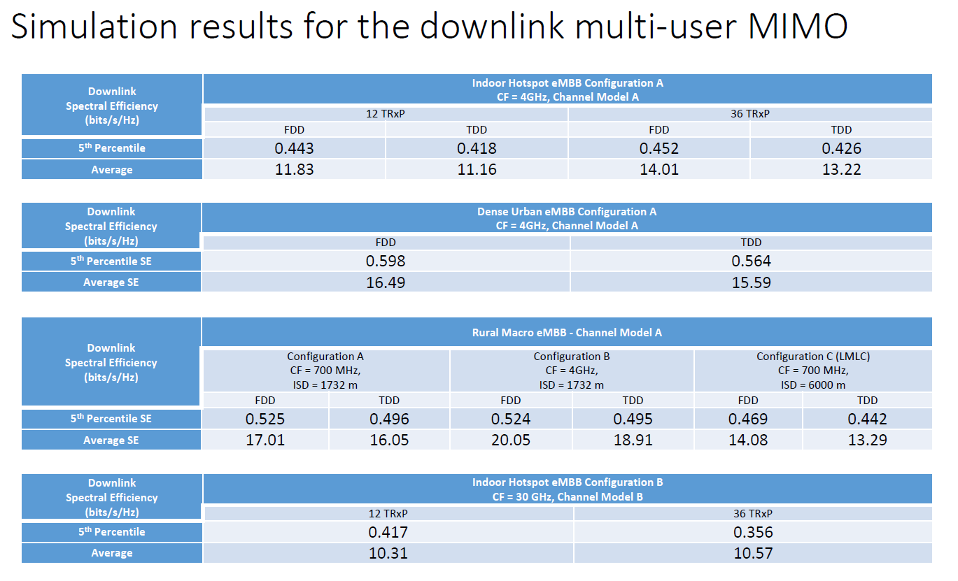

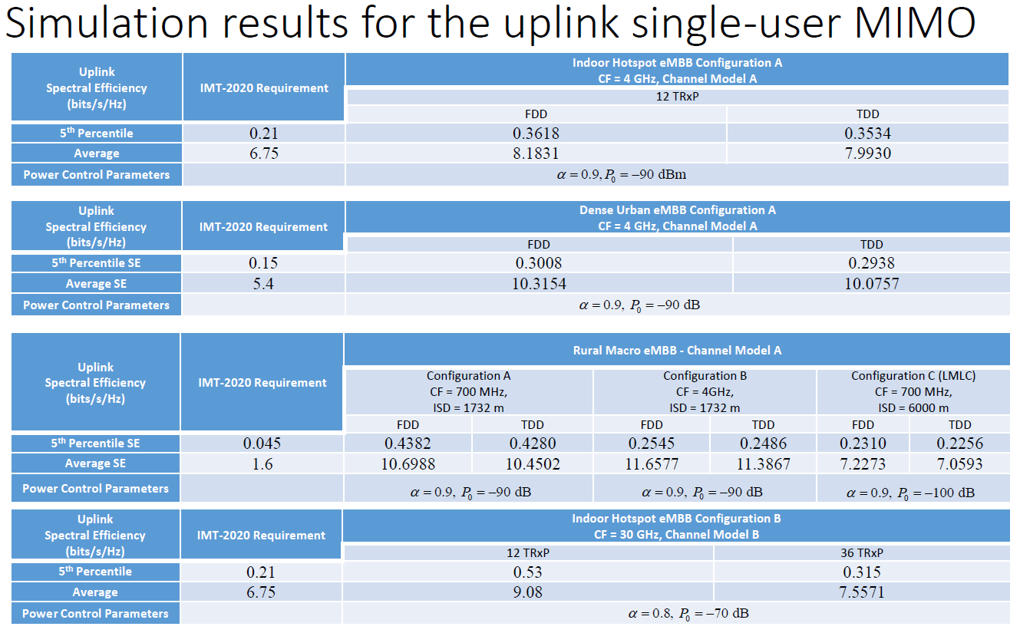

Company E

**Indoor Hotspot**

Config. A (4 GHz)

*DL*

FDD

|  |  |  |  |  |  |  |  |  |  |  |
| --- | --- | --- | --- | --- | --- | --- | --- | --- | --- | --- |
| Evaluation config. | TXRU config. | SCS  (kHz) | ITU requirement | | Channel model A | | | Channel model B | | |
| BW= 10 MHz | BW= 20 MHz | BW= 40 MHz | BW= 10 MHz | BW= 20 MHz | BW= 40 MHz |
| Config. A (12TR × P) | 32T4R  MU-MIMO | 15 | Average [bit/s/Hz/TRxP] | 9 | 11.287 | 12.806 | 13.71 | 11.307 | 12.828 | 13.734 |
| 5th-tile [bit/s/Hz] | 0.3 | 0.356 | 0.404 | 0.432 | 0.344 | 0.39 | 0.418 |
| Config. A (36TR × P) | 15 | Average [bit/s/Hz/TRxP] | 9 | 13.34 | 15.135 | 16.203 | 13.499 | 15.315 | 16.396 |
| 5th-tile [bit/s/Hz] | 0.3 | 0.312 | 0.354 | 0.379 | 0.319 | 0.362 | 0.387 |

TDD   
(Frame structure: DDDSU)

|  |  |  |  |  |  |  |  |  |  |  |
| --- | --- | --- | --- | --- | --- | --- | --- | --- | --- | --- |
| Evaluation config. | TXRU config. | SCS  (kHz) | ITU requirement | | Channel model A | | | Channel model B | | |
| BW= 20 MHz | BW= 40 MHz | BW= 100 MHz | BW= 20 MHz | BW= 40 MHz | BW= 100 MHz |
| Config. A (12 TR × P) | 32T4R  MU-MIMO | 30 | Average [bit/s/Hz/TR × P] | 9 | 12.966 | 15.205 | 16.726 | 13.021 | 15.27 | 16.798 |
| 5th-tile [bit/s/Hz] | 0.3 | 0.377 | 0.442 | 0.486 | 0.392 | 0.46 | 0.506 |
| 15 | Average [bit/s/Hz/TR × P] | 9 | 12.773 | 14.648 | / | 12.766 | 14.641 | / |
| 5th-tile [bit/s/Hz] | 0.3 | 0.394 | 0.452 | / | 0.401 | 0.46 | / |
| Config. A (36 TR × P) | 32T4R  MU-MIMO | 30 | Average [bit/s/Hz/TR × P] | 9 | 14.218 | 16.68 | 18.353 | 14.332 | 16.814 | 18.5 |
| 5th-tile [bit/s/Hz] | 0.3 | 0.35 | 0.411 | 0.452 | 0.357 | 0.418 | 0.46 |
| 15 | Average [bit/s/Hz/TR × P] | 9 | 14.563 | 16.71 | / | 14.675 | 16.839 | / |
| 5th-tile [bit/s/Hz] | 0.3 | 0.385 | 0.442 | / | 0.394 | 0.452 | / |

*--------*

*UL*

FDD

|  |  |  |  |  |  |  |
| --- | --- | --- | --- | --- | --- | --- |
| Evaluation config. | TXRU config. | SCS  (kHz) | ITU requirement | | Channel model A | Channel model B |
| BW=10 MHz | BW=10 MHz |
| Config. A (12 TR × P) | 2T32R  SU-MIMO | 15 | Average [bit/s/Hz/TR × P] | 6.75 | 8.833 | 8.869 |
| 5th-tile [bit/s/Hz] | 0.21 | 0.554 | 0.551 |
| Config. A (12 TR × P) | 4T32R  SU-MIMO | 15 | Average [bit/s/Hz/TR × P] | 6.75 | 9.397 | 9.439 |
| 5th-tile [bit/s/Hz] | 0.21 | 0.586 | 0.587 |

TDD   
(Frame structure: DDDSU)

|  |  |  |  |  |  |  |
| --- | --- | --- | --- | --- | --- | --- |
| Evaluation config. | TXRU config. | SCS  (kHz) | ITU requirement | | Channel model A | Channel model B |
| BW=20 MHz | BW=20 MHz |
| Config. A (12 TR × P) | 2T32R  SU-MIMO | 30 | Average [bit/s/Hz/TR × P] | 6.75 | 6.955 | 7.003 |
| 5th-tile [bit/s/Hz] | 0.21 | 0.387 | 0.39 |
| Config. A (12 TR × P) | 15 | Average [bit/s/Hz/TR × P] | 6.75 | 7.174 | 7.256 |
| 5th-tile [bit/s/Hz] | 0.21 | 0.398 | 0.407 |
| Config. A (12 TR × P) | 4T32R  SU-MIMO | 30 | Average [bit/s/Hz/TR × P] | 6.75 | 7.584 | 7.623 |
| 5th-tile [bit/s/Hz] | 0.21 | 0.434 | 0.432 |
| Config. A (12 TR × P) | 15 | Average [bit/s/Hz/TR × P] | 6.75 | 7.872 | 7.952 |
| 5th-tile [bit/s/Hz] | 0.21 | 0.436 | 0.453 |

Config. B (30GHz)

DL – TDD  
(Frame structure: DDDSU)

|  |  |  |  |  |  |  |
| --- | --- | --- | --- | --- | --- | --- |
| Evaluation config. | TXRU config. | SCS  (kHz) | ITU requirement | | Channel model A/B | |
| BW= 80 MHz | BW= 200 MHz |
| Config. B (12 TR × P) | 32T8R  MU-MIMO | 60 | Average [bit/s/Hz/TR × P] | 9 | 11.599 | 13.346 |
| 5th-tile [bit/s/Hz] | 0.3 | 0.308 | 0.354 |

UL – TDD   
(Frame structure: DDDSU)

|  |  |  |  |  |  |  |
| --- | --- | --- | --- | --- | --- | --- |
| Evaluation config. | TXRU config. | SCS  (kHz) | ITU requirement | | Channel model A/B | |
| BW= 80 MHz | BW= 200 MHz |
| Config. B (12 TR × P) | 8T16R  SU-MIMO | 60 | Average [bit/s/Hz/TR × P] | 6.75 | 6.075 | / |
| 5th-tile [bit/s/Hz] | 0.21 | 0.233 | / |
| Config. B (12 TR × P) | 8T32R  SU-MIMO | 60 | Average [bit/s/Hz/TR × P] | 6.75 | 7.037 | / |
| 5th-tile [bit/s/Hz] | 0.21 | 0.405 | / |

Dense Urban

Config. A (4GHz)

*DL*

FDD

|  |  |  |  |  |  |  |  |  |  |  |
| --- | --- | --- | --- | --- | --- | --- | --- | --- | --- | --- |
| Evaluation config. | TXRU config. | SCS  (kHz) | ITU requirement | | Channel model A | | | Channel model B | | |
| BW= 10 MHz | BW= 20 MHz | BW= 40 MHz | BW= 10 MHz | BW= 20 MHz | BW= 40 MHz |
| Config. A | 32T4R  MU-MIMO | 15 | Average [bit/s/Hz/TR × P] | 7.8 | 11.45 | 12.943 | 13.834 | 11.417 | 12.905 | 13.794 |
| 5th-tile [bit/s/Hz] | 0.225 | 0.376 | 0.425 | 0.454 | 0.379 | 0.428 | 0.458 |

TDD   
(Frame structure: DDDSU)

|  |  |  |  |  |  |  |  |  |  |  |
| --- | --- | --- | --- | --- | --- | --- | --- | --- | --- | --- |
| Evaluation config. | TXRU config. | SCS  (kHz) | ITU requirement | | Channel model A | | | Channel model B | | |
| BW= 20 MHz | BW= 40 MHz | BW= 100 MHz | BW= 20 MHz | BW= 40 MHz | BW= 100 MHz |
| Config. A | 32T4R  MU-MIMO | 30 | Average [bit/s/Hz/TR × P] | 7.8 | 13.042 | 15.186 | 16.647 | 12.818 | 14.926 | 16.362 |
| 5th-tile [bit/s/Hz] | 0.225 | 0.382 | 0.445 | 0.488 | 0.392 | 0.457 | 0.501 |
| 15 | Average [bit/s/Hz/TR × P] | 7.8 | 12.951 | 14.78 | / | 12.742 | 14.541 | / |
| 5th-tile [bit/s/Hz] | 0.225 | 0.388 | 0.443 | / | 0.402 | 0.459 | / |
| 64T4R  MU-MIMO | 30 | Average [bit/s/Hz/TR × P] | 7.8 | 16.098 | 18.838 | 20.702 | 15.835 | 18.531 | 20.364 |
| 5th-tile [bit/s/Hz] | 0.225 | 0.494 | 0.578 | 0.635 | 0.484 | 0.566 | 0.622 |
| 15 | Average [bit/s/Hz/TR × P] | 7.8 | 15.708 | 18.017 | / | 15.458 | 17.731 | / |
| 5th-tile [bit/s/Hz] | 0.225 | 0.484 | 0.555 | / | 0.492 | 0.564 | / |

*--------*

*UL*

FDD

|  |  |  |  |  |  |  |
| --- | --- | --- | --- | --- | --- | --- |
| Evaluation config. | TXRU config. | SCS  (kHz) | ITU requirement | | Channel model A | Channel model B |
| BW=10 MHz | BW=10 MHz |
| Config. A | 2T16R  SU-MIMO | 15 | Average [bit/s/Hz/TR × P] | 5.4 | 6.772 | 6.669 |
| 5th-tile [bit/s/Hz] | 0.15 | 0.254 | 0.219 |
| 2T32R  SU-MIMO | 15 | Average [bit/s/Hz/TR × P] | 5.4 | 8.117 | 8.080 |
| 5th-tile [bit/s/Hz] | 0.15 | 0.388 | 0.323 |
| 4T32R  SU-MIMO | 15 | Average [bit/s/Hz/TR × P] | 5.4 | 8.824 | 8.792 |
| 5th-tile [bit/s/Hz] | 0.15 | 0.452 | 0.375 |

TDD   
(Frame structure: DDDSU)

|  |  |  |  |  |  |  |
| --- | --- | --- | --- | --- | --- | --- |
| Evaluation config. | TXRU config. | SCS  (kHz) | ITU requirement | | Channel model A | Channel model B |
| BW=20 MHz | BW=20 MHz |
| Config. A | 2T32R  SU-MIMO | 30 | Average [bit/s/Hz/TR × P] | 5.4 | 6.136 | 6.105 |
| 5th-tile [bit/s/Hz] | 0.15 | 0.276 | 0.250 |
| 15 | Average [bit/s/Hz/TR × P] | 5.4 | 6.570 | 6.478 |
| 5th-tile [bit/s/Hz] | 0.15 | 0.278 | 0.246 |
| 2T64R  SU-MIMO | 30 | Average [bit/s/Hz/TR × P] | 5.4 | 7.030 | 7.001 |
| 5th-tile [bit/s/Hz] | 0.15 | 0.356 | 0.325 |
| 15 | Average [bit/s/Hz/TR × P] | 5.4 | 7.489 | 7.475 |
| 5th-tile [bit/s/Hz] | 0.15 | 0.358 | 0.295 |
| 4T32R  SU-MIMO | 30 | Average [bit/s/Hz/TR × P] | 5.4 | 6.734 | 6.750 |
| 5th-tile [bit/s/Hz] | 0.15 | 0.331 | 0.309 |
| 15 | Average [bit/s/Hz/TR × P] | 5.4 | 7.198 | 7.183 |
| 5th-tile [bit/s/Hz] | 0.15 | 0.323 | 0.288 |

Rural

Config. A

*DL*

FDD

|  |  |  |  |  |  |  |  |  |  |  |
| --- | --- | --- | --- | --- | --- | --- | --- | --- | --- | --- |
| Evaluation config. | TXRU config. | SCS  (kHz) | ITU requirement | | Channel model A | | | Channel model B | | |
| BW= 10 MHz | BW= 20 MHz | BW= 40 MHz | BW= 10 MHz | BW= 20 MHz | BW= 40 MHz |
| Config. A  (RIT: NR) | 8T2R  MU-MIMO | 15 | Average [bit/s/Hz/TR × P] | 3.3 | 6.594 | 7.384 | 7.861 | 6.537 | 7.32 | 7.793 |
| 5th-tile [bit/s/Hz] | 0.12 | 0.138 | 0.155 | 0.165 | 0.13 | 0.146 | 0.155 |
| Config. A  (RIT: NR) | 16T2R  MU-MIMO | 15 | Average [bit/s/Hz/TR × P] | 3.3 | 7.476 | 8.392 | 8.943 | 7.456 | 8.369 | 8.919 |
| 5th-tile [bit/s/Hz] | 0.12 | 0.151 | 0.169 | 0.181 | 0.156 | 0.175 | 0.187 |

TDD   
(Frame structure: DDDSU)

|  |  |  |  |  |  |  |  |  |  |  |
| --- | --- | --- | --- | --- | --- | --- | --- | --- | --- | --- |
| Evaluation config. | TXRU config. | SCS  (kHz) | ITU requirement | | Channel model A | | | Channel model B | | |
| BW= 20 MHz | BW= 40 MHz | BW= 100 MHz | BW= 20 MHz | BW= 40 MHz | BW= 100 MHz |
| Config. A  (RIT: NR) | 8T2R  MU-MIMO | 30 | Average [bit/s/Hz/TR × P] | 3.3 | 7.817 | 9.011 | 9.828 | 7.747 | 8.931 | 9.741 |
| 5th-tile [bit/s/Hz] | 0.12 | 0.193 | 0.222 | 0.242 | 0.188 | 0.217 | 0.237 |
| 15 | Average [bit/s/Hz/TR × P] | 3.3 | 7.657 | 8.628 | / | 7.573 | 8.534 | / |
| 5th-tile [bit/s/Hz] | 0.12 | 0.164 | 0.185 | / | 0.159 | 0.179 | / |
| 16T2R  MU-MIMO | 30 | Average [bit/s/Hz/TR × P] | 3.3 | 9.212 | 10.637 | 11.612 | 9.22 | 10.647 | 11.622 |
| 5th-tile [bit/s/Hz] | 0.12 | 0.214 | 0.247 | 0.27 | 0.219 | 0.253 | 0.276 |
| 15 | Average [bit/s/Hz/TR ×P] | 3.3 | 8.897 | 10.077 | / | 8.949 | 10.136 | / |
| 5th-tile [bit/s/Hz] | 0.12 | 0.177 | 0.201 | / | 0.183 | 0.208 | / |

*--------*

*UL*

FDD

|  |  |  |  |  |  |  |
| --- | --- | --- | --- | --- | --- | --- |
| Evaluation config. | TXRU config. | SCS  (kHz) | ITU requirement | | Channel model A | Channel model B |
| BW=10 MHz | BW=10 MHz |
| Config. A  (RIT: NR) | 1T8R  SU-MIMO | 15 | Average [bit/s/Hz/TR × P] | 1.6 | 4.279 | 4.294 |
| 5th-tile [bit/s/Hz] | 0.045 | 0.138 | 0.128 |
| 2T8R  SU-MIMO | 15 | Average [bit/s/Hz/TR × P] | 1.6 | 6.343 | 6.366 |
| 5th-tile [bit/s/Hz] | 0.045 | 0.144 | 0.136 |

TDD   
(Frame structure: DDDSU)

|  |  |  |  |  |  |  |
| --- | --- | --- | --- | --- | --- | --- |
| Evaluation config. | TXRU config. | SCS  (kHz) | ITU requirement | | Channel model A | Channel model B |
| BW=20 MHz | BW=20 MHz |
| Config. A | 2T8R  SU-MIMO | 30 | Average [bit/s/Hz/TR × P] | 1.6 | 4.751 | 4.763 |
| 5th-tile [bit/s/Hz] | 0.045 | 0.104 | 0.099 |
| 15 | Average [bit/s/Hz/TR × P] | 1.6 | 5.081 | 5.050 |
| 5th-tile [bit/s/Hz] | 0.045 | 0.096 | 0.087 |

Config. B

*DL*

FDD

|  |  |  |  |  |  |  |  |  |  |  |
| --- | --- | --- | --- | --- | --- | --- | --- | --- | --- | --- |
| Evaluation config. | TXRU config. | SCS  (kHz) | ITU requirement | | Channel model A | | | Channel model B | | |
| BW= 10 MHz | BW= 20 MHz | BW= 40 MHz | BW= 10 MHz | BW= 20 MHz | BW= 40 MHz |
| Config. B  (RIT: NR) | 32T4R  MU-MIMO | 15 | Average [bit/s/Hz/TR × P] | 3.3 | 13.6 | 15.376 | 16.436 | 13.533 | 15.3 | 16.355 |
| 5th-tile [bit/s/Hz] | 0.12 | 0.354 | 0.4 | 0.428 | 0.345 | 0.39 | 0.417 |

TDD   
(Frame structure: DDDSU)

|  |  |  |  |  |  |  |  |  |  |  |
| --- | --- | --- | --- | --- | --- | --- | --- | --- | --- | --- |
| Evaluation config. | TXRU config. | SCS  (kHz) | ITU requirement | | Channel model A | | | Channel model B | | |
| BW= 20 MHz | BW= 40 MHz | BW= 100 MHz | BW= 20 MHz | BW= 40 MHz | BW= 100 MHz |
| Config. B  (RIT: NR) | 32T4R  MU-MIMO | 30 | Average [bit/s/Hz/TR × P] | 3.3 | 15.346 | 17.909 | 19..654 | 15.228 | 17.772 | 19.504 |
| 5th-tile [bit/s/Hz] | 0.12 | 0.381 | 0.445 | 0.488 | 0.377 | 0.44 | 0.483 |
| 15 | Average [bit/s/Hz/TR × P] | 3.3 | 15.31 | 17.475 | / | 15.182 | 17.329 | / |
| 5th-tile [bit/s/Hz] | 0.12 | 0.368 | 0.42 | / | 0.366 | 0.418 | / |

*--------*

*UL*

FDD

|  |  |  |  |  |  |  |
| --- | --- | --- | --- | --- | --- | --- |
| Evaluation config. | TXRU config. | SCS  (kHz) | ITU requirement | | Channel model A | Channel model B |
| BW=10 MHz | BW=10 MHz |
| Config. B  (RIT: NR) | 1T32R  SU-MIMO | 15 | Average [bit/s/Hz/TR × P] | 1.6 | 4.364 | 4.270 |
| 5th-tile [bit/s/Hz] | 0.045 | 0.167 | 0.146 |
| 4T32R  SU-MIMO | 15 | Average [bit/s/Hz/TR × P] | 1.6 | 7.694 | 7.557 |
| 5th-tile [bit/s/Hz] | 0.045 | 0.260 | 0.214 |

TDD   
(Frame structure: DDDSU)

|  |  |  |  |  |  |  |
| --- | --- | --- | --- | --- | --- | --- |
| Evaluation config. | TXRU config. | SCS  (kHz) | ITU requirement | | Channel model A | Channel model B |
| BW=20 MHz | BW=20 MHz |
| Config. B | 1T32R  SU-MIMO | 30 | Average [bit/s/Hz/TR × P] | 1.6 | 3.184 | 3.117 |
| 5th-tile [bit/s/Hz] | 0.045 | 0.113 | 0.095 |
| 15 | Average [bit/s/Hz/TR × P] | 1.6 | 3.500 | 3.429 |
| 5th-tile [bit/s/Hz] | 0.045 | 0.119 | 0.098 |
| 4T32R  SU-MIMO | 30 | Average [bit/s/Hz/TR × P] | 1.6 | 5.728 | 5.763 |
| 5th-tile [bit/s/Hz] | 0.045 | 0.178 | 0.130 |
| 15 | Average [bit/s/Hz/TR × P] | 1.6 | 6.237 | 5.976 |
| 5th-tile [bit/s/Hz] | 0.045 | 0.184 | 0.1s48 |

Config. C

*DL*

FDD

|  |  |  |  |  |  |  |  |  |  |  |
| --- | --- | --- | --- | --- | --- | --- | --- | --- | --- | --- |
| Evaluation config. | TXRU config. | SCS  (kHz) | ITU requirement | | Channel model A | | | Channel model B | | |
| BW= 10 MHz | BW= 20 MHz | BW= 40 MHz | BW= 10 MHz | BW= 20 MHz | BW= 40 MHz |
| Config. C  (RIT: NR) | 8T4R  MU-MIMO | 15 | Average [bit/s/Hz/TR × P] | 3.3 | 7.597 | 8.511 | 9.062 | 7.607 | 8.522 | 9.074 |
| 5th-tile [bit/s/Hz] | 0.12 | 0.18 | 0.202 | 0.215 | 0.183 | 0.205 | 0.218 |
| Config. C  (RIT: NR) | 16T4R  MU-MIMO | 15 | Average [bit/s/Hz/TR × P] | 3.3 | 8.134 | 9.127 | 9.726 | 7,137 | 9.131 | 9.729 |
| 5th-tile [bit/s/Hz] | 0.12 | 0.203 | 0.228 | 0.243 | 0.201 | 0.226 | 0.24 |

TDD   
(Frame structure: DDDSU)

|  |  |  |  |  |  |  |  |  |  |  |
| --- | --- | --- | --- | --- | --- | --- | --- | --- | --- | --- |
| Evaluation config. | TXRU config. | SCS  (kHz) | ITU requirement | | Channel model A | | | Channel model B | | |
| BW= 20 MHz | BW= 40 MHz | BW= 100 MHz | BW= 20 MHz | BW= 40 MHz | BW= 100 MHz |
| Config. C  (RIT: NR) | 8T4R  MU-MIMO | 30 | Average [bit/s/Hz/TR × P] | 3.3 | 7.774 | 9.003 | 9.842 | 7.785 | 9.016 | 9.85 |
| 5th-tile [bit/s/Hz] | 0.12 | 0.213 | 0.247 | 0.27 | 0.181 | 0.21 | 0.23 |
| 15 | Average [bit/s/Hz/TR × P] | 3.3 | 8.005 | 9.024 | / | 8.017 | 9.037 | / |
| 5th-tile [bit/s/Hz] | 0.12 | 0.196 | 0.221 | / | 0.196 | 0.221 | / |
| 16T4R  MU-MIMO | 30 | Average [bit/s/Hz/TR × P] | 3.3 | 8.606 | 9.975 | 10.909 | 8.588 | 9.954 | 10.886 |
| 5th-tile [bit/s/Hz] | 0.12 | 0.199 | 0.23 | 0.252 | 0.194 | 0.224 | 0.245 |
| 15 | Average [bit/s/Hz/TR × P] | 3.3 | 8.833 | 9.982 | / | 8.816 | 9.963 | / |
| 5th-tile [bit/s/Hz] | 0.12 | 0.219 | 0.248 | / | 0.215 | 0.243 | / |

*--------*

*UL*

FDD

|  |  |  |  |  |  |  |
| --- | --- | --- | --- | --- | --- | --- |
| Evaluation config. | TXRU config. | SCS  (kHz) | ITU requirement | | Channel model A | Channel model B |
| BW=10 MHz | BW=10 MHz |
| Config. C  (RIT: NR) | 2T8R  SU-MIMO | 15 | Average [bit/s/Hz/TR × P] | 1.6 | 4.144 | 4.104 |
| 5th-tile [bit/s/Hz] | 0.045 | 0.083 | 0.075 |
| 4T8R  SU-MIMO | 15 | Average [bit/s/Hz/TR × P] | 1.6 | 4.808 | 0.797 |
| 5th-tile [bit/s/Hz] | 0.045 | 0.103 | 0.093 |

TDD   
(Frame structure: DDDSU)

|  |  |  |  |  |  |  |
| --- | --- | --- | --- | --- | --- | --- |
| Evaluation config. | TXRU config. | SCS  (kHz) | ITU requirement | | Channel model A | Channel model B |
| BW=20 MHz | BW=20 MHz |
| Config. C | 2T8R  SU-MIMO | 30 | Average [bit/s/Hz/TR × P] | 1.6 | 3.334 | 3.309 |
| 5th-tile [bit/s/Hz] | 0.045 | 0.061 | 0.054 |
| 15 | Average [bit/s/Hz/TR × P] | 1.6 | 3.527 | 3.530 |
| 5th-tile [bit/s/Hz] | 0.045 | 0.049 | 0.042 |
| 4T8R  SU-MIMO | 30 | Average [bit/s/Hz/TR × P] | 1.6 | 3.837 | 3.825 |
| 5th-tile [bit/s/Hz] | 0.045 | 0.073 | 0.065 |
| 15 | Average [bit/s/Hz/TR ×P] | 1.6 | 4.031 | 4.040 |
| 5th-tile [bit/s/Hz] | 0.045 | 0.059 | 0.053 |

Company F

Downlink multi-user MIMO



Key System Simulation Assumptions



_______________

1. Document [5D/1215](https://www.itu.int/md/R15-WP5D-C-1215/en) “3GPP final technology submission – Overview of 3GPP 5G Solutions for IMT-2020” and Document [5D/1216](https://www.itu.int/md/R15-WP5D-C-1216/en) “3GPP 5G candidate for inclusion in IMT-2020: Submission 1 (SRIT)”.
2. Document [5D/1215](https://www.itu.int/md/R15-WP5D-C-1215/en) “3GPP final technology submission – Overview of 3GPP 5G Solutions for IMT-2020” and Document [5D/1217](https://www.itu.int/md/R15-WP5D-C-1217/en) “3GPP 5G candidate for inclusion in IMT-2020: Submission 2 for IMT-2020 (RIT)”.
3. In NR Rel. 15 no value (lower than for Capability 1) for 120 kHz SCS was agreed.
4. In NR Rel. 15 no value (lower than for Capability 1) for 120 kHz SCS was agreed.
5. Generally, DRX and DTX refer to the user equipment/device.